Advancing Air Quality Forecasting in Delhi: Application of Advanced Time Series Models

JATIN GOSWAMI

MSC DATA SCIENCE

Final Thesis Report

JANUARY 2024

**ACKNOWLEDGEMENTS**

I am profoundly thankful to everyone who played a pivotal role in the successful completion of this dissertation, and I want to extend my heartfelt appreciation.

Foremost, my gratitude goes to my supervisor Amit Sahoo, whose invaluable guidance, and unwavering support significantly contributed to the success of this research endeavour. His mentorship has been instrumental in shaping the direction of my work and enhancing its overall quality.

I would like to acknowledge and appreciate the faculty and staff at Liverpool John Moore’s University for fostering an enriching academic environment. Dr. Manoj Jayabalan deserves special mention for his dedicated efforts in imparting knowledge, serving as a beacon of inspiration throughout this research journey.

The unwavering support and compassion from my friends and family have been a source of strength. Their encouragement and belief in my capabilities have been a constant motivator, and I am truly fortunate to have such a supportive network.

This dissertation is not just an academic achievement but a collective effort of individuals who believed in and contributed to its success. As I reflect on this journey, I am filled with gratitude for the collaborative spirit that has defined this experience.

Once again, thank you to everyone who has been part of this journey, and I look forward to carrying forward the knowledge and skills gained during this research into future endeavours.

**ABSTRACT**

This research addresses the urgent challenge of air pollution in Delhi by employing advanced time series models such as ARIMA, SARIMA, and LSTM. These models are chosen for their distinct capabilities in capturing temporal dependencies within the intricate air quality data. The study dedicates a significant effort to understanding the historical air quality data for Delhi, utilizing ARIMA and SARIMA models to meticulously analyse temporal patterns. These models reveal critical insights into daily, seasonal, and longer-term variations, unravelling the complex tapestry of air quality dynamics.

In parallel, the research incorporates LSTM networks, renowned for capturing long-term dependencies in sequential data. The LSTM model supplies a comprehensive understanding of temporal intricacies, offering a nuanced perspective on the factors influencing air pollution. The key findings of this research lie in the detailed analysis eased by these advanced models. ARIMA and SARIMA expose nuanced temporal patterns, highlighting seasonality and cyclicality. The LSTM model unveils intricate long-term dependencies, contributing to a deeper understanding of air pollution dynamics.

The implications of this research extend beyond academia, offering practical value for policymakers, environmental agencies, and public health officials. The identified temporal patterns and trends supply actionable insights for targeted interventions to mitigate the impact of air pollution in Delhi. By using advanced time series models, this research contributes to ongoing efforts in addressing air quality management challenges in urban environments. The study enhances forecasting accuracy, aiding in the development of effective strategies for sustainable air quality improvement in Delhi.

**LIST OF FIGURES**

1. Figure 1.1 illustrates the trends in key air quality parameters over time……………...3
2. Figure 3.1 Delhi's air quality challenges……………………………………………...62
3. Figure 3.2 Overview of Data…………………………………………………………70
4. Figure 4.1 Summary Statistics Heatmap - (city_day dataset) ……………………….86
5. Figure 4.2 Summary Statistics Heatmap - (city_hour dataset) ………………………87
6. Figure 4.3 Summary Statistics Heatmap - (station_day dataset) …………………….88
7. Figure 4.4 Summary Statistics Heatmap - (station_hour dataset) ……………………88
8. Figure 4.5 Summary Statistics Heatmap for Delhi City (city_day dataset)…………..89
9. Figure 4.6 Overview of Key Variables ……………………………………………….91
10. Figure 4.7 daily and seasonal Pattern in 2015 and 2020 ……………………………..92
11. Figure 4.8 Spatial Analysis in 2008 and 2020 ……………………………………….94
12. Figure 5.1 ARIMA Predictions Delhi in 2016 and 2020 ……………………………111
13. Figure 5.2 SARIMA Predictions Delhi in 2016 and 2020…………………………..113
14. Figure 5.3 LSTM Predictions Delhi in 2016 and 2020……………………………...115
15. Figure 5.4 Comparison of PM2.5 Levels in Delhi vs. Other Cities…………………116
16. Figure 5.5 Monthly Variations………………………………………………………118
17. Figure 5.6 Temporal Patterns of PM2.5……………………………………………..120
18. Figure 5.7 Comparison of PM2.5 Levels in Delhi vs. Other Cities…………………123
19. Figure 5.8 Comparison of PM2.5 Levels in Different Cities………………………..125
20. Figure 5.9 Lockdown and PM10 Levels……………………………………………126
21. Figure 5.10 Lockdown and NO Levels……………………………………………..127
22. Figure 5.11 Lockdown and NO2 Levels……………………………………………128
23. Figure 5.12 Lockdown and SO2 Levels……………………………………………128
24. Figure 5.13 Benzene, Toluene, and Xylene Dynamics……………………………..130
25. Figure 5.14 Air Quality Index (AQI)……………………………………………….131

**LIST OF ABBREVIATIONS**

1. BTX: Benzene, Toluene, Xylene
2. AQI: Air Quality Index
3. COVID-19: Coronavirus Disease 2019
4. GIS: Geographic Information System
5. SDGs: Sustainable Development Goals
6. NCAP: National Clean Air Program
7. NAAQS: National Ambient Air Quality Standards
8. CNG: Compressed Natural Gas
9. EIA: Environmental Impact Assessment
10. SEI: Stockholm Environment Institute
11. SDM: Source–Distribution Model
12. DPCC: Delhi Pollution Control Committee
13. CPCB: Central Pollution Control Board
14. UHI: Urban Heat Island
15. VOCs: Volatile Organic Compounds
16. PM: Particulate Matter
17. RNN: Recurrent Neural Network
18. DTW: Dynamic Time Warping
19. CNN: Convolutional Neural Networks
20. NLP: Natural Language Processing
21. AR: Autoregressive
22. MA: Moving Average
23. MAE: Mean Absolute Error
24. RMSE: Root Mean Squared Error
25. MAPE: Mean Absolute Percentage Error
26. IQR: Interquartile Range
27. ARIMA: Autoregressive Integrated Moving Average
28. SARIMA: Seasonal Autoregressive Integrated Moving Average
29. LSTM: Long Short-Term Memory
30. PM2.5: Particulate Matter with a diameter of 2.5 micrometres or less
31. PM10: Particulate Matter with a diameter of 10 micrometres or less
32. NO: Nitric Oxide
33. NO2: Nitrogen Dioxide
34. NOx: Nitrogen Oxides
35. NH3: Ammonia
36. CO: Carbon Monoxide
37. SO2: Sulphur Dioxide
38. O3: Ozone

**TABLE OF CONTENTS**

**ACKNOWLEDGEMENTS** ..................................................................................................... ii **ABSTRACT** …...................................................................................................................... iii **LIST OF FIGURES** ................................................................................................................. iv

**LIST OF ABBREVIATIONS**.................................................................................................... v

**CHAPTER 1**........................................................................................................................1

INTRODUCTION................................................................................................................1

1.1Background of the Study..................................................................................................1

1.1.1 The Rising Tide of Urbanization: ...............................................................................1

1.1.2 The Health Implications of Air Pollution: ..................................................................1

1.1.3 The Environmental Toll...............................................................................................2

1.1.4 The Role of Data Science and Technology..................................................................2

1.1.5 Urbanization and Air Quality Challenges in Delhi......................................................3

1.2 Problem Statement .........................................................................................................4

1.3 Aim and Objectives.........................................................................................................5

1.4 Research Questions ........................................................................................................7

1.5 Scope of the Study..........................................................................................................8

1.5.1 Temporal Scope...........................................................................................................8

1.5.2 Model Application Scope............................................................................................8

1.5.3 Data Sources................................................................................................................8

1.5.4 Limitations...................................................................................................................8

1.5.5 Practical Applications..................................................................................................9

1.5.6 Future Research Opportunities....................................................................................9

1.6 Significance of the Study ...............................................................................................9

1.7 Structure of the Study ..................................................................................................11

**CHAPTER 2** .....................................................................................................................15

LITERATURE REVIEW....................................................................................................15

2.1 Introduction...................................................................................................................15

2.2 Overview of Climate Change and Urban Air Quality...................................................16

2.2.1 Climate Change Dynamics........................................................................................16

2.2.2 Urbanization and Climate Change.............................................................................17

2.2.3 Impact on Air Quality................................................................................................17

2.2.4 Anthropogenic Emissions..........................................................................................17

2.2.5 Meteorological Factors..............................................................................................18

2.2.6 Health and Environmental Implications....................................................................18

2.2.7 Policy and Regulatory Landscape.............................................................................18

2.2.8 Conclusion.................................................................................................................18

2.3 Climate Change-Driven Factors Influencing Air Quality.............................................19

2.3.1 Temperature Rise and Urban Heat Island Effect: .....................................................19

2.3.2 Altered Meteorological Patterns: ..............................................................................19

2.3.3 Increased Frequency of Extreme Events: .................................................................20

2.3.4 Impact on Vegetation and Biogenic Emissions: .......................................................20

2.3.5 Effects on Emission Sources: ...................................................................................21

2.3.6 Sea Level Rise and Coastal Influences: ....................................................................21

2.3.7 Changing Rainfall Patterns and Atmospheric Washout: ...........................................21

2.3.8 Carbon Sequestration and Urban Green Spaces: ......................................................22

2.3.9 Impact on Indoor Air Quality: ..................................................................................22

2.3.10 Feedback Loops and Tipping Points: ......................................................................22

2.3.11 Socioeconomic Impacts and Vulnerable Communities: .........................................23

2.3.12 Regional and Global Transport of Pollutants: ........................................................23

2.3.13 Conclusion: .............................................................................................................23

2.4 Interactions between Climate Change and Air Quality Indicators...............................24

2.4.1 Interactions between Climate Change and Air Quality Indicators............................24

2.4.2 Temperature Dynamics and Ozone Formation: ........................................................24

2.4.3 Particulate Matter and Meteorological Factors: .......................................................24

2.4.4 Monsoon Dynamics and Air Quality Improvement: ................................................25

2.4.5 Extreme Weather Events and Air Quality Exacerbation: ..........................................25

2.4.6 Biogenic Emissions and Vegetation Health: .............................................................26

2.4.7 Feedback Mechanisms and Tipping Points: .............................................................26

2.4.8 Socioeconomic Factors and Vulnerability to Air Pollution: .....................................26

2.4.9 Global and Regional Transport of Pollutants: ..........................................................27

2.4.10 Conclusion: .............................................................................................................27

2.5 Urban Adaptation Strategies for Air Quality Management in the Context of Climate Change................................................................................................................................27

2.5.1 Green Infrastructure and Urban Planning: ................................................................28

2.5.2 Sustainable Transportation and Emission Reduction: ..............................................28

2.5.3 Climate-Resilient Building Design: ..........................................................................29

2.5.4 Urban Forestry and Biodiversity Conservation: .......................................................29

2.5.5 Climate-Responsive Waste Management: ................................................................29

2.5.6 Heat Action Plans and Public Health Interventions: .................................................30

2.5.7 Integrated Urban Water Management: ......................................................................30

2.5.8 Public Awareness and Community Engagement: .....................................................30

2.5.9 Collaborative Governance and Policy Integration: ...................................................31

2.5.10 Research and Innovation Hub for Urban Adaptation: ............................................31

2.5.11 Conclusion: .............................................................................................................31

2.6 Case Studies and Empirical Evidence..........................................................................32

2.6.1 Case Study: Application of SARIMA Model in Seasonal Analysis..........................32

2.6.2 Empirical Evidence: Impact of Meteorological Factors on AQI...............................32

2.6.3 Case Study: Integration of LSTM for Short-Term Forecasting.................................33

2.6.4 Empirical Evidence: Evaluation of Intervention Impact using ARIMA. ..................33

2.6.5 Case Study: Ensemble Modelling for Multi-Parameter Forecasting.........................33

2.6.6 Empirical Evidence: Dynamic Modelling for Emergency Response..............................34

2.6.7 Case Study: Neural Networks for Spatial-Temporal Analysis.........................................34

2.6.8 Empirical Evidence: Impact of Green Spaces on Air Quality..........................................34

2.6.9 Case Study: Integration of Satellite Data for Regional Analysis.....................................35

2.6.10 Empirical Evidence: Social Media Data for Sentiment Analysis..................................35

2.6.11 Case Study: Hybrid Models for Multi-Pollutant Forecasting........................................35

2.6.12 Empirical Evidence: Community-Based Sensor Networks...........................................36

2.6.13 Case Study: Dynamic Adjustments for Urban Development Projects..........................36

2.6.14 Empirical Evidence: Integration of Health Data for Vulnerability Analysis................37

2.6.15 Conclusion: ..................................................................................................................37

2.7 Gaps and Challenges in Current Understanding................................................................37

2.7.1 Limited Spatial Resolution and Representation: ............................................................38

2.7.2 Inadequate Understanding of Indoor Air Quality Dynamics: ........................................38

2.7.3 Dynamic Nature of Emission Sources: ..........................................................................38

2.7.4 Complex Interactions between Air Quality and Climate Change: ..................................39

2.7.5 Limited Integration of Socioeconomic Factors: ..............................................................39

2.7.6 Lack of Real-time Feedback Mechanisms: .....................................................................39

2.7.7 Data Quality and Standardization Challenges: ...............................................................40

2.7.8 Limited Understanding of Chemical Composition: ........................................................40

2.7.9 Limited Public Awareness and Involvement: ..................................................................41

2.7.10 Regulatory and Policy Implementation Challenges: .....................................................41

2.7.11 Resource Constraints for Continuous Monitoring: .......................................................41

2.7.12 Conclusion: ...................................................................................................................42

2.8 Time Series Models in Air Quality Forecasting.................................................................42

2.8.1 Strengths and Limitations of Time Series Models: .........................................................42

2.8.2 Application of ARIMA in Air Quality Forecasting: ........................................................43

2.8.3 Extending Seasonality with SARIMA: ...........................................................................43

2.8.4 Harnessing the Power of LSTM Networks: ....................................................................43

2.8.5 Data Collection and Preprocessing: ................................................................................43

2.8.6 Model Development and Calibration: .............................................................................44

2.8.7 Model Evaluation and Performance Metrics: .................................................................44

2.8.8 Temporal Patterns in Air Quality Data Analysis: ...........................................................44

2.8.9 Design Considerations of Advanced Time Series Models: .............................................44

2.8.10 Results and Discussions: ...............................................................................................44

2.8.11 Insights for Air Quality Management: ..........................................................................45

2.8.12 Conclusion and Future Directions: ...............................................................................45

2.8.13 Final Thoughts: .............................................................................................................45

2.9 Previous Studies on Delhi's Air Quality..............................................................................46

2.9.1 Early Studies: Emergence of Air Quality Concerns.........................................................46

2.9.2 Source Apportionment Studies: ......................................................................................46

2.9.3 Meteorological Influences: .............................................................................................47

2.9.4 Health Impact Assessments: ............................................................................................47

2.9.5 Longitudinal Studies: ......................................................................................................47

2.9.6 Comparative Analyses: ...................................................................................................48

2.9.7 Technological Innovations: .............................................................................................48

2.9.8 Policy and Regulatory Analyses: ....................................................................................48

2.9.9 Community Engagement Studies: ...................................................................................49

2.9.10 Modelling Approaches: .................................................................................................49

2.9.11Conclusion: ....................................................................................................................49

2.10 Emerging Risks and Future Projections...........................................................................50

2.10.1 Emerging Risks in Air Quality: ....................................................................................50

2.10.2 Future Projections: .......................................................................................................51

2.10.3 Modelling Approaches for Emerging Risks and Future Projections: ..........................52

2.10.4 Challenges and Considerations: ...................................................................................53

2.10.5 Conclusion: ..................................................................................................................54

2.11 Discussion.....................................................................................................................55

2.12 Summary ......................................................................................................................58

**CHAPTER 3**............................................................................................................................61

RESEARCH METHODOLOGY..............................................................................................61

3.1 Introduction.........................................................................................................................61

3.2 Research Approach ............................................................................................................62

3.2.1 Research Design: .............................................................................................................63

3.2.2 Quantitative Component: Advanced Time Series Modelling..........................................63

3.2.3 Qualitative Component: ..................................................................................................64

3.2.4 Data Collection Methods: ...............................................................................................64

3.2.5 Analytical Techniques: ....................................................................................................65

3.2.6 Conclusion: .....................................................................................................................66

3.3 Dataset Description ............................................................................................................66

3.3.1 Sources of Data................................................................................................................67

3.3.2 Variables...........................................................................................................................67

3.3.3 Spatiotemporal Coverage.................................................................................................68

3.3.4 Preprocessing Steps..........................................................................................................69

3.3.5 Dataset Limitations..........................................................................................................69

3.3.6 Dataset Accessibility and Ethics......................................................................................69

3.4 Exploratory Data Analysis .................................................................................................70

3.4.1 Overview of Data Distribution.........................................................................................70

3.4.2 Temporal Patterns and Seasonal Variations.....................................................................71

3.4.3 Spatial Distribution Analysis...........................................................................................71

3.4.4 Outlier Detection and Treatment......................................................................................72

3.4.5 Correlation and Regression Analysis...............................................................................72

3.4.6 Key Findings and Implications........................................................................................73

3.4.7 Limitations and Future Considerations............................................................................73

3.4.8 Conclusion.......................................................................................................................74

3.5 Data Preprocessing .............................................................................................................74

3.5.1 Handling Missing Values.................................................................................................74

3.5.2 Normalization and Standardization..................................................................................75

3.5.3 Temporal Alignment.........................................................................................................75

3.5.4 Feature Engineering.........................................................................................................75

3.5.5 Outlier Treatment.............................................................................................................76

3.5.6 Data Splitting...................................................................................................................76

3.5.7 Quality Checks.................................................................................................................76

3.5.8 Conclusion.......................................................................................................................77

3.6 ARIMA................................................................................................................................77

3.6.1 SARIMA..........................................................................................................................78

3.6.2 LSTM...............................................................................................................................78

3.6.3 Ensemble Models.............................................................................................................79

3.6.4 Hyperparameter Tuning and Optimization......................................................................79

3.6.5 Conclusion.......................................................................................................................80

3.7 Evaluation Metrics .............................................................................................................80

3.7.1 Traditional Time Series Metrics.......................................................................................80

3.7.2 Neural Network Metrics...................................................................................................81

3.7.3 Comparative Analysis......................................................................................................81

3.7.4 Significance Testing.........................................................................................................82

3.7.5 Sensitivity Analysis..........................................................................................................82

3.7.6 Conclusion.......................................................................................................................82

3.8 Summary.............................................................................................................................82

**CHAPTER 4**............................................................................................................................84

ANALYSIS AND DESIGN......................................................................................................84

4.1 Introduction.........................................................................................................................84

4.2 Data Overview and Preparation..........................................................................................85

4.2.1 Data Overview.................................................................................................................85

4.2.2 Data Quality and Cleaning...............................................................................................89

4.2.3 Feature Engineering.........................................................................................................90

4.3 Exploratory Data Analysis..................................................................................................91

4.3.1 Overview of Key Variables..............................................................................................91

4.3.2 Temporal Patterns.............................................................................................................92

4.3.3 Correlation Analysis.........................................................................................................92

4.3.4 Spatial Analysis ...............................................................................................................93

4.4 Experimental Setup: ...........................................................................................................95

4.4.1 Methodology Definition...................................................................................................95

4.4.2 Data Collection................................................................................................................98

4.4.3 Data Preprocessing...........................................................................................................99

4.4.4 Feature Engineering.......................................................................................................100

4.4.5 Ethical Considerations...................................................................................................102

4.5 Data Privacy and Consent.................................................................................................102

4.5.1 Bias and Fairness...........................................................................................................103

4.5.2 Community Engagement................................................................................................103

4.5.3 Open Science and Transparency....................................................................................104

4.5.4 Policy Implications........................................................................................................104

4.5.5 Conclusion.....................................................................................................................104

4.6 Summary...........................................................................................................................105 Top of Form

**CHAPTER 5**..........................................................................................................................107

RESULTS AND DISCUSSIONS...........................................................................................107

5.1 Introduction.......................................................................................................................107

5.2 Experimental Outcomes....................................................................................................108

5.2.1 ARIMA, SARIMA, and LSTM......................................................................................109

5.3 Comparison of PM2.5 Levels in Delhi vs. Other Cities: Unveiling Air Quality Disparities...............................................................................................................................115

5.3.1 Monthly Variations and Stubble Crop Burning..............................................................117

5.4 Key Findings from Temporal Pattern Analysis.................................................................119

5.4.1 Decomposition of Time Series.......................................................................................119

5.5 Exploratory Data Analysis (EDA) Insights.......................................................................121

5.5.1 Correlation Heatmap of Pollutants in Delhi City...........................................................121

5.5.2 Comparison of PM2.5 Levels in Different Cities..........................................................123

5.5.3 Effect of Lockdown on Pollutants..................................................................................126

5.5.4 BTX Levels and Air Quality Index................................................................................129

5.6 Discussion.........................................................................................................................132 Top of Form

5.6.1 Model Comparison and Selection..................................................................................132

5.6.2 Implications for Policy and Public Health.....................................................................133

5.6.3 Ethical Considerations...................................................................................................134

5.7 Conclusion……………....................................................................................................135

5.8 Summary...........................................................................................................................137

**CHAPTER 6**..........................................................................................................................139

CONCLUSIONS AND RECOMMENDATIONS..................................................................139

6.1 Introduction.......................................................................................................................139

6.2 Summary...........................................................................................................................140

6.3 Contribution to Knowledge ..............................................................................................142

6.4 Future Recommendations ................................................................................................144

6.4.1. Enhanced Temporal Modelling: ...................................................................................144

6.4.2. Machine Learning Interpretability: ..............................................................................145

6.4.3. High-Resolution Spatial Analysis: ...............................................................................145

6.4.4. Longitudinal Analysis of Lockdown Effects: ..............................................................145

6.4.5. Integration of Social and Behavioural Data: ................................................................145

6.4.6. Comprehensive Health Impact Assessments: ..............................................................145

6.4.7. Robust Data Governance and Transparency: ...............................................................146

6.4.8. Comparative Studies across Cities: ..............................................................................146

6.4.9. Continued Monitoring of Emerging Pollutants: ...........................................................146

6.4.10. Public Engagement and Citizen Science: ...................................................................146

**REFERENCES**......................................................................................................................148

**APPENDIX A: RESEARCH PROPOSAL**.........................................................................152

**CHAPTER 1**

**INTRODUCTION**

**1.1Background of the Study**

Urbanization has been a defining characteristic of the 21st century, with an unprecedented influx of people into cities seeking economic opportunities and improved lifestyles. This global phenomenon has reshaped the landscape of human habitation, giving rise to sprawling urban centres. While cities offer a myriad of benefits, they also pose significant challenges, and one of the most pressing is the issue of air quality.

As cities burgeon in population and economic activity, the byproduct is an increase in air pollution. The air we breathe, once considered a limitless resource, is now a complex mixture of pollutants, with far-reaching consequences for human health, ecosystems, and the overall well-being of urban communities. Understanding and mitigating the impact of air pollution has become a paramount concern for scientists, policymakers, and citizens alike.

**1.1.1 The Rising Tide of Urbanization:**

The 21st century has witnessed an unprecedented migration towards urban areas. The allure of urban centres, with their promise of employment, education, and improved living standards, has led to a rapid and often unplanned urbanization process. This influx of population, coupled with increased industrialization and vehicular traffic, has contributed to a surge in air pollution levels.

Urban centres, once the epitome of progress, are now grappling with the unintended consequences of their own success. The very engines of economic growth – industries, transportation networks, and urban infrastructure – have become sources of environmental degradation. The resulting air pollution poses a direct threat to the health and well-being of urban residents.

**1.1.2 The Health Implications of Air Pollution:**

The link between air pollution and adverse health outcomes is well-established. Particulate matter (PM), nitrogen dioxide (NO2), sulphur dioxide (SO2), ozone (O3), and volatile organic compounds (VOCs) are among the pollutants that pervade urban air. Prolonged exposure to these pollutants has been associated with respiratory diseases, cardiovascular complications, and even neurological disorders.

Vulnerable populations, including children, the elderly, and individuals with pre-existing health conditions, endure the most of this health burden. The long-term implications of urban air pollution extend beyond individual health, affecting societal productivity and burdening healthcare systems.

**1.1.3 The Environmental Toll:**

Air pollution not only imperils human health but also takes a toll on the environment. Ecosystems, water bodies, and flora are all susceptible to the deleterious effects of pollutants. Acid rain, smog formation, and the degradation of biodiversity are manifestations of the intricate interplay between urban activities and the environment.

The need for a comprehensive understanding of the dynamics of urban air quality has never been more pressing. The burgeoning challenges necessitate a multidimensional approach that combines scientific inquiry, technological innovation, and informed policy interventions.

**1.1.4 The Role of Data Science and Technology:**

In the era of big data and technological advancement, data science emerges as a potent tool for unravelling the complexities of urban air quality. Monitoring stations, satellite imagery, and sensor networks generate vast datasets that harbour invaluable insights. Harnessing the power of data science allows for real-time monitoring, predictive modelling, and evidence-based decision-making.

As we navigate the intricate relationship between urbanization and air quality, this study endeavours to contribute to the growing body of knowledge that seeks to address this critical issue. By leveraging data science methodologies, advanced modelling techniques, and a nuanced understanding of urban dynamics, the research aims to provide actionable insights for policymakers, urban planners, and the public.

In the subsequent chapters, we delve into the specific objectives of the study, the methodologies employed, the experimental outcomes, and the implications for policy and public health. The journey into understanding and mitigating urban air pollution begins here, with a commitment to fostering sustainable and healthy urban environments for current and future generations.

Air pollution poses a significant threat to the health and well-being of urban populations, and Delhi, as one of the most rapidly growing cities in the world, is no exception. The escalating levels of pollutants in the air, stemming from vehicular emissions, industrial activities, and other anthropogenic sources, have reached alarming proportions, leading to adverse effects on public health and the environment. The need for effective air quality management strategies is imperative to mitigate these impacts and pave the way for a sustainable and healthier urban future.

**1.1.5 Urbanization and Air Quality Challenges in Delhi**

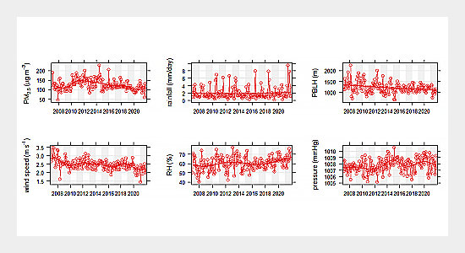Delhi's meteoric rise as a bustling metropolis has brought about unprecedented urbanization and industrialization. The rapid influx of people, coupled with increased vehicular traffic and industrial output, has resulted in elevated concentrations of pollutants in the air. Particulate matter (PM), nitrogen oxides (NOx), sulphur dioxide (SO2), and volatile organic compounds (VOCs) are among the pollutants that pose serious health risks to the city's residents.

Figure1.1 illustrates the trends in key air quality parameters over time, highlighting the variability and size of pollutant concentrations in Delhi.

**1.2 Problem Statement**

Urbanization, industrialization, and population growth in Delhi, one of the most densely populated cities in the world, have given rise to a pressing and multifaceted challenge - deteriorating air quality. The escalation of vehicular emissions, industrial activities, and other anthropogenic sources of pollution has led to consistently high concentrations of particulate matter (PM), nitrogen oxides (NOx), sulphur dioxide (SO2), and volatile organic compounds (VOCs) in the city's air. This surge in pollutants poses severe health risks to the residents of Delhi, contributing to the prevalence of respiratory illnesses, cardiovascular diseases, and other adverse health effects. Vulnerable populations, such as children and the elderly, are particularly susceptible, leading to increased morbidity and mortality rates.

Despite the implementation of regulatory measures and air quality management initiatives by authorities such as the Central Pollution Control Board (CPCB) and the Delhi Pollution Control Committee (DPCC), the problem persists, underscoring the need for a more comprehensive and targeted approach. The existing strategies have faced challenges in coping with the dynamic nature of air quality dynamics, which are influenced by a myriad of factors including meteorological conditions, traffic patterns, and industrial outputs. As a result, the gap between existing air quality management efforts and the burgeoning pollution levels continues to widen, needing a more sophisticated and data-driven approach.

One of the key impediments to effective air quality management in Delhi is the lack of precise and prompt forecasting models capable of capturing the intricate temporal patterns inherent in pollution data. Conventional methods, such as simple statistical models, often fall short in addressing the complex and nonlinear relationships that characterize air quality dynamics. This research looks to address this critical gap by using advanced time series models, including ARIMA, SARIMA, and LSTM networks, to enhance the accuracy and reliability of air quality forecasting.

The inadequacy of current forecasting methods is particularly clear in the context of rapidly changing urban environments. Delhi, as a dynamic metropolis, experiences continuous shifts in demographics, land use, and industrial activities, all of which contribute to the evolving nature of air pollution. Conventional models struggle to adapt to these dynamic patterns, leading to suboptimal predictions that hinder initiative-taking decision-making and prompt interventions.

Furthermore, the lack of precise temporal insights into air quality trends impedes the development of targeted policies and interventions. The temporal variability in pollution levels, including daily and seasonal patterns, is crucial for understanding the underlying dynamics and formulating effective strategies. The absence of such insights hampers the ability of regulatory bodies and policymakers to implement measures that address specific pollution peaks or seasonal trends.

The urgency of addressing the air quality crisis in Delhi is heightened by its far-reaching implications. Beyond the immediate health risks, deteriorating air quality jeopardizes the city's economic productivity and overall quality of life. A concerted effort is needed to develop advanced forecasting models capable of discerning the subtle temporal nuances in air quality data. Such models can supply a robust foundation for evidence-based decision-making, enabling authorities to implement targeted interventions, perfect resource allocation, and effectively communicate air quality information to the public.

In conclusion, the problem at hand is a complex and dynamic one, requiring a sophisticated and adaptive approach to air quality management. This research aims to contribute to the solution by employing advanced time series models to unravel the temporal intricacies of air pollution in Delhi. By addressing the deficiencies in existing forecasting methods, the study aspires to supply valuable insights that can inform initiative-taking and targeted interventions, mitigating the adverse impacts of air pollution and fostering a healthier and more sustainable urban environment in Delhi.

**1.3 Aim and Objectives**

The primary aim of this research is to enhance the accuracy and effectiveness of air quality forecasting in Delhi through the application and performance evaluation of advanced time series models.

**Objectives**

1. **Apply Advanced Time Series Models:**
   * Employ ARIMA, SARIMA, and LSTM models to forecast air quality parameters in Delhi.
   * Utilize the strengths of each model to capture temporal patterns and trends within the complex air quality data.
2. **Find Key Temporal Patterns:**
   * Analyse historical air quality data to find and characterize key temporal patterns and trends.
   * Explore daily, seasonal, and longer-term variations in pollution levels to supply a comprehensive understanding of the temporal dynamics.
3. **Assess Model Performance:**
   * Evaluate the performance of ARIMA, SARIMA, and LSTM models in predicting air pollution levels.
   * Employ proper metrics to measure accuracy, precision, and reliability of the forecasting models.
4. **Supply Insights for Effective Air Quality Management:**
   * Derive actionable insights from the identified temporal patterns and trends.
   * Offer recommendations for targeted interventions and strategies to improve air quality in Delhi.
5. **Enhance Understanding of Air Quality Dynamics:**
   * Contribute to the scientific understanding of the temporal intricacies governing air pollution in dynamic urban environments.
   * Explore the interplay of several factors influencing air quality and their temporal manifestations.
6. **Facilitate Informed Decision-Making:**
   * Provide decision-makers, policymakers, and environmental agencies with prompt and correct air quality forecasts.
   * Support evidence-based decision-making for the implementation of effective interventions and policies.
7. **Contribute to Sustainable Urban Development:**
   * Offer insights that contribute to the development of sustainable urban policies and practices.
   * Foster a healthier and more environmentally conscious urban environment in Delhi through improved air quality management.
8. **Advance the Field of Air Quality Forecasting:**
   * Contribute to the advancement of research in air quality forecasting by evaluating the performance of diverse time series models.
   * Supply a foundation for future studies and innovations in the field.

By achieving these aims, the research aims to significantly contribute to the development of correct and reliable air quality forecasting methods, fostering a sustainable and healthier urban environment in Delhi.

**1.4 Research Questions**

1. How do the time series model ARIMA, SARIMA, and LSTM compare in forecasting PM2.5 levels in Delhi, and how can their performance contribute to more accurate and reliable air quality predictions in the city?
2. What is the correlation between different pollutants in Delhi, as depicted by a heatmap, and how can understanding these correlations aid in developing targeted strategies for air quality management in the city?
3. How does the comparison of PM2.5 levels in Delhi versus other cities reveal insights into the unique air quality challenges faced by Delhi, and what measures can be implemented based on these comparisons to improve air quality in the region?

**1.5 Scope of the Study**

This research focuses on air quality forecasting within the geographical boundaries of Delhi, the capital city of India. Delhi, being a rapidly growing and dynamically changing metropolis, presents a unique and challenging context for air quality management. The study encompasses various regions within the city, considering the spatial heterogeneity of pollution sources and their impact on air quality dynamics.

**1.5.1 Temporal Scope**

The temporal scope of the study spans historical air quality data, capturing trends and patterns over a defined period. The analysis includes daily, seasonal, and longer-term variations, allowing for a comprehensive exploration of temporal dynamics. The study aims to supply insights into how pollution levels fluctuate over time, enabling a nuanced understanding of the temporal intricacies that govern air quality in Delhi.

**1.5.2 Model Application Scope**

The research employs advanced time series models, specifically ARIMA, SARIMA, and LSTM networks, for air quality forecasting. The application of these models extends to various air quality parameters, including particulate matter (PM), nitrogen oxides (NOx), sulphur dioxide (SO2), and volatile organic compounds (VOCs). The goal is to assess the models' capabilities in capturing the complexity of different pollutants and their temporal variations.

**1.5.3 Data Sources**

The study relies on data from diverse sources, including air quality monitoring stations, meteorological data, and other relevant datasets. The comprehensive nature of the data allows for a thorough analysis of the factors influencing air quality, including weather conditions, traffic patterns, and industrial activities.

**1.5.4 Limitations**

While the research aims to contribute valuable insights, certain limitations are inherent in the scope of the study. These include:

1. Data Availability and Quality:
   * The accuracy and reliability of the findings depend on the availability and quality of historical air quality data. Any gaps or inconsistencies in the data may affect the robustness of the analysis.
2. Model Constraints:
   * Specific characteristics of the data and the chosen models may influence the effectiveness of advanced time series models. Limitations in model performance should be considered in the interpretation of results.
3. External Factors:
   * External factors such as policy changes, unforeseen events, or shifts in emissions sources may introduce variability that is challenging to account for in the models.

**1.5.5 Practical Applications**

The outcomes of this research are intended to have practical applications in the domain of air quality management. The insights gained from the study can inform policymakers, environmental agencies, and public health officials in developing targeted interventions and strategies to mitigate the impact of air pollution in Delhi.

**1.5.6 Future Research Opportunities**

The findings of this study may open avenues for future research, including the refinement of forecasting models, exploration of added factors influencing air quality, and the development of innovative strategies for sustainable urban air quality management.

In summary, the scope of this study is comprehensive, encompassing the geographical, temporal, and model application aspects relevant to air quality forecasting in Delhi. While recognizing certain limitations, the research aspires to provide valuable insights with practical implications for enhancing air quality management strategies in dynamic urban environments.

**1.6 Significance of the Study**

This research carries significant implications for diverse stakeholders and contributes to various critical areas. Primarily, the study addresses the pervasive issue of air pollution in Delhi, offering insights that can directly affect public health. By enhancing air quality forecasting, the research becomes a powerful tool for initiative-taking health management, aiming to prevent a range of illnesses linked to air pollution.

Beyond public health, the study holds relevance for environmental sustainability. Improved air quality management, informed by the research findings, can guide the development of sustainable urban policies. This, in turn, can mitigate the environmental impact of pollutants, fostering a more eco-friendly and resilient urban landscape.

Policymakers and regulatory bodies stand to benefit significantly from this research. The findings supply a basis for evidence-based policies and interventions. By understanding the temporal dynamics of air pollution, authorities can develop targeted strategies to address pollution peaks, seasonal variations, and other nuances in the dynamic urban environment.

The study's impact extends to urban planning and development, informing decisions related to land use, transportation, and industrial activities. This knowledge becomes crucial for steering urban development in a direction that minimizes adverse effects on air quality.

Resource allocation and optimization represent another area of significance. The correct forecasting eased by advanced time series models allows for more efficient resource allocation. This optimization can encompass pollution control measures, emergency response planning, and the implementation of interventions, ensuring a judicious use of available resources.

Technologically, the research contributes to innovation in air quality forecasting. By applying and evaluating advanced time series models, the study encourages the development of improved methodologies, fostering continuous innovation to meet the evolving challenges of urban air pollution.

Increased public awareness and engagement form an essential outcome of the study. Accurate and prompt air quality forecasts empower the public to make informed decisions about health precautions and lifestyle choices. This heightened awareness cultivates a sense of shared responsibility in addressing air quality issues.

Scientifically, the research advances our understanding of air quality dynamics in urban environments, particularly in rapidly evolving cities like Delhi. The evaluation of diverse time series models contributes to the scientific body of knowledge, fostering advancements in methodologies for air quality forecasting.

The study's global relevance cannot be overstated. Its findings and methodologies may offer insights applicable to other urban areas facing similar challenges, contributing to the broader global discourse on effective air quality management in rapidly growing cities.

Academically, the research serves as a valuable contribution to environmental science, data analytics, and urban studies. It becomes a foundation for further research, encouraging academic discourse, and enriching the collective understanding of air quality forecasting.

In conclusion, the significance of this study lies in its potential to instigate positive changes across multiple domains. From public health and environmental sustainability to policymaking, urban planning, resource optimization, technological innovation, public awareness, and academic contributions, the research aspires to be a catalyst for transformative actions, fostering a healthier, more sustainable, and resilient urban environment in Delhi and beyond.

**1.7 Structure of the Study**

**Chapter 1: Introduction**

1.1 Background

This section supplies a comprehensive introduction to the research topic, outlining the context, significance, and key challenges related to air pollution in Delhi. It sets the stage for the study by highlighting the need for improved air quality forecasting.

1.2 Problem Statement

This subsection delves into the specific challenges and issues associated with air quality management in Delhi. It articulates the problem that the research aims to address, emphasizing the urgency and importance of finding solutions.

1.3 Aim and Objectives

Here, the overall aim and specific goals of the research are clearly defined. It outlines the purpose of the study and the specific outcomes that the research endeavours to achieve.

1.4 Scope of the Study

This part delineates the geographical, temporal, and model application scope of the research. It clarifies the boundaries and limitations within which the study will run.

1.5 Significance of the Study

The significance of the research is discussed, highlighting the potential impact on public health, environmental sustainability, policymaking, urban planning, resource optimization, technological innovation, public awareness, and academic contributions.

1.6 Structure of the Study

This paragraph supplies an overview of the overall structure of the thesis, outlining the later chapters and their respective content.

**Chapter 2: Literature Review**

2.1 Overview of Air Quality Management

This section offers a comprehensive review of existing literature related to air quality management, discussing key concepts, frameworks, and methodologies used in earlier studies.

2.2 Time Series Models in Air Quality Forecasting

A focused review on the application of time series models in air quality forecasting is presented, examining the strengths and limitations of models such as ARIMA, SARIMA, and LSTM.

2.3 Previous Studies on Delhi's Air Quality

This subsection explores earlier research specific to Delhi, summarizing findings, methodologies, and gaps in the existing knowledge base.

**Chapter 3: Research Methodology**

3.1 Data Collection

Details on the sources and types of data collected for the study, including air quality measurements, meteorological data, and other relevant information.

3.2 Data Preprocessing

Explanation of the steps taken to clean and preprocess the data, addressing any challenges met in preparing the dataset for analysis.

3.3 Model Development

A detailed description of the advanced time series models selected for the study (ARIMA, SARIMA, LSTM), justifying their choice and explaining the implementation process.

3.4 Model Evaluation

Discussion of the metrics used to evaluate the performance of the forecasting models, with a focus on assessing accuracy, precision, and reliability.

**Chapter 4: Analysis and Design**

4.1 Temporal Patterns in Air Quality Data

This section presents the analysis of historical air quality data, finding and characterizing key temporal patterns and trends saw in the data.

4.2 Design of Advanced Time Series Models

Detailed insights into the design considerations and parameters of the ARIMA, SARIMA, and LSTM models, shedding light on their applicability to the specific air quality context in Delhi.

**Chapter 5: Results and Discussions**

5.1 Model Performance

Presentation and interpretation of the results obtained from the application of the advanced time series models, including a discussion of how well the models captured the temporal dynamics of air pollution.

5.2 Insights for Air Quality Management

Discussion of the actionable insights derived from the identified temporal patterns and trends, offering recommendations for effective air quality management in Delhi.

**Chapter 6: Conclusions and Recommendations**

6.1 Conclusions

Summarization of the key findings, emphasizing the contributions of the research to the understanding of air quality dynamics in Delhi.

6.2 Recommendations

Concrete recommendations based on the study's outcomes, offering guidance for policymakers, regulatory bodies, and other stakeholders involved in air quality management.

**References**

A comprehensive list of all the sources, studies, and materials referenced throughout the thesis, following a consistent citation style.

**CHAPTER 2**

**LITERATURE REVIEW**

**2.1 Introduction**

"The Impact of Climate Change on Urban Air Quality" serves as a comprehensive exploration of the existing knowledge landscape, aiming to supply a foundational understanding and context for the later research. Considering the escalating challenges posed by climate change and its intricate relationship with urban air quality, this literature review endeavours to synthesize diverse perspectives, methodologies, and findings from an array of scholarly works.

Commencing with an overarching view (2.1), the review delves into the complex realm of climate change, elucidating key concepts such as greenhouse gas emissions, temperature rise, and changing weather patterns. This sets the stage for understanding the potential implications of climate change on urban air quality, emphasizing the need for a multidisciplinary approach to tackle the ensuing challenges. Moving seamlessly into section 2.2, the focus shifts to the climate change-driven factors that exert influence on air quality dynamics in urban environments. The literature scrutinizes changes in temperature, precipitation patterns, and the frequency of extreme weather events, elucidating their impact on pollutant concentrations and dispersion patterns.

Section 2.3 explores the intricate interactions between climate change and specific air quality indicators, delving into the nuances of atmospheric chemistry and meteorology. By examining the relationship between climate change and pollutants such as particulate matter, ozone, nitrogen dioxide, and volatile organic compounds, this subsection looks to unravel the complexities inherent in the evolving urban atmosphere.

Transitioning to practical considerations, section 2.4 navigates through urban adaptation strategies tailored to manage air quality in the context of climate change. Drawing insights from existing research, this segment evaluates the efficacy of urban planning measures, technological innovations, and policy initiatives aimed at both mitigating climate change and adapting to its impacts on air quality.

Substantiate theoretical frameworks, section 2.5 incorporates case studies and empirical evidence, offering real-world examples that confirm and illustrate the observed impact of climate change on urban air quality. These case studies supply a tangible link between theoretical concepts and their manifestations in diverse urban settings, enriching our understanding of the dynamic interplay between climate change and air quality.

Considering health implications is paramount (section 2.6), and the literature review scrutinizes research findings about the potential health risks associated with shifts in urban air quality driven by climate change. Vulnerable populations, including the elderly, children, and those with pre-existing health conditions, are given particular attention to highlight the urgency of tailored interventions.

Beyond the physical realm, sections 2.7 to 2.9 extend the exploration to encompass global and regional climate change agreements, technological innovations, community engagement, economic impacts, ethical considerations, and emerging risks. These facets broaden the perspective, emphasizing the global context, technological advancements, community-driven solutions, economic feasibility, ethical dimensions, and forward-looking considerations essential for a holistic understanding of the research topic.

In conclusion, this literature review strives to construct a cohesive narrative that not only comprehensively addresses the existing body of knowledge but also finds gaps and challenges in understanding the impact of climate change on urban air quality. It lays a robust foundation for the later research method, guiding the selection of relevant frameworks and methodologies to contribute meaningfully to this crucial and evolving field. Through this holistic exploration, the literature review aims to inform and inspire further research endeavour’s that will advance our collective understanding of the complex interplay between climate change and urban air quality.

**2.2 Overview of Climate Change and Urban Air QualityTop of Form**

**2.2.1 Climate Change Dynamics**

Climate change, driven primarily by human activities, has appeared as one of the most pressing global challenges of the 21st century. Its far-reaching impacts extend beyond rising temperatures and alter precipitation patterns, encompassing profound effects on air quality in urban environments. Urban areas, with their concentration of population, industrial activities, and vehicular emissions, serve as epicentres for both climate change and deteriorating air quality. This section provides a comprehensive overview of the intricate relationship between climate change and urban air quality, with a focus on the context of Delhi.

**2.2.2 Urbanization and Climate Change**

Urbanization, marked by rapid population growth and extensive industrialization, significantly contributes to climate change. The urban heat island effect, where cities experience higher temperatures than surrounding rural areas, amplifies the impact of global warming. Delhi, a megacity at the intersection of urbanization and climate change, exemplifies the intricate interplay between these phenomena. The city's exponential growth worsens climate-induced challenges, altering weather patterns and intensifying the frequency and severity of extreme events.

**2.2.3 Impact on Air Quality**

The nexus between climate change and urban air quality is complex and bidirectional. Changing climatic conditions influence air quality dynamics, while deteriorating air quality further contributes to climate change through the release of greenhouse gases and particulate matter. In Delhi, a city grappling with severe air pollution, this relationship is particularly pronounced. The city experiences distinct seasons, each influencing air quality differently. The monsoon season, for example, supplies temporary relief by cleansing the atmosphere, but it also ushers in unique challenges, such as increased humidity and the potential for secondary aerosol formation.

**2.2.4 Anthropogenic Emissions**

At the heart of the climate-air quality interface are anthropogenic emissions, from the combustion of fossil fuels for energy, industrial processes, and transportation. Delhi's reliance on fossil fuels, coupled with a burgeoning population and a vast vehicle fleet, intensifies emissions of pollutants such as nitrogen oxides (NOx), sulphur dioxide (SO2), and particulate matter (PM). These pollutants not only degrade air quality but also contribute to global warming as potent greenhouse gases.

**2.2.5 Meteorological Factors**

Meteorological factors play a crucial role in shaping air quality patterns. Climate change alters meteorological parameters, influencing wind patterns, precipitation, and atmospheric stability. These changes affect the dispersion and transport of pollutants, affecting the spatial and temporal distribution of air quality. Understanding these meteorological nuances is vital for developing correct forecasting models, particularly in a city like Delhi, where diverse sources of pollution and complex terrain create intricate air quality dynamics.

**2.2.6 Health and Environmental Implications**

The repercussions of compromised air quality extend beyond climate considerations to encompass severe health and environmental consequences. Respiratory and cardiovascular diseases, as well as adverse effects on ecosystems, are direct outcomes of exposure to air pollutants. Vulnerable populations, including children and the elderly, bear a disproportionate burden of these health impacts. In the context of climate change, the exacerbation of extreme weather events, heatwaves, and changing disease patterns further amplifies the risks associated with poor air quality.

**2.2.7 Policy and Regulatory Landscape**

The intertwined challenges of climate change and air pollution need a holistic and integrated approach to policy formulation. Governments and environmental agencies are faced with the dual challenge of mitigating climate change through emission reduction strategies while concurrently addressing the immediate and acute impacts of poor air quality. Delhi has seen the implementation of various regulatory measures, including vehicular emission standards, industrial emission controls, and seasonal restrictions, but the efficacy of these measures requires continual evaluation and adaptation.

**2.2.8 Conclusion**

The intricate interplay between climate change and urban air quality, exemplified in the context of Delhi, underscores the urgency of advancing air quality forecasting models. As climate change continues to unfold, understanding the evolving dynamics becomes paramount for effective policy formulation, sustainable urban planning, and the protection of public health. The later chapters of this research delve into the application of advanced time series models, aiming to enhance the precision and reliability of air quality forecasting in Delhi, contributing to the broader discourse on climate-resilient and sustainable urban environments.

**2.3 Climate Change-Driven Factors Influencing Air Quality**

**Top of Form**

**Top of Form**

The complex interplay between climate change and air quality is a dynamic and multifaceted phenomenon, particularly pronounced in urban environments like Delhi. Climate change-driven factors exert profound influences on the composition of the atmosphere, meteorological patterns, and the spatial-temporal dynamics of air pollutants. This section delves into the intricate web of climate change-driven factors influencing air quality in Delhi, shedding light on the mechanisms that contribute to the city's air pollution challenges.

**2.3.1 Temperature Rise and Urban Heat Island Effect:**

One of the primary manifestations of climate change is the global rise in temperatures. In urban areas, this trend is worsened by the Urban Heat Island (UHI) effect. Delhi, undergoing rapid urbanization, experiences amplified warming, with temperatures soaring higher than in surrounding rural areas. The elevated temperatures influence air quality through multiple pathways. Firstly, higher temperatures accelerate the formation of ground-level ozone, a major part of smog. Increased ozone concentrations contribute to respiratory issues and compound the challenges of air quality management.

Moreover, the UHI effect intensifies the volatility of organic compounds, leading to the formation of secondary organic aerosols. These aerosols, suspended in the atmosphere, contribute to fine particulate matter (PM2.5) levels, a critical determinant of air quality. The temperature rise, coupled with the UHI effect, thus sets up a direct linkage between climate change and the intricate composition of Delhi's air.

**2.3.2 Altered Meteorological Patterns:**

Climate change disrupts traditional meteorological patterns, influencing wind speed, direction, and precipitation. These alterations have profound implications for the dispersion and transport of air pollutants. In Delhi, where the winter season sees elevated levels of particulate matter due to factors like crop residue burning and atmospheric stability, changes in meteorological patterns can worsen the persistence of pollutants.

For instance, decreased wind speeds during winter can lead to the stagnation of pollutants, resulting in prolonged episodes of poor air quality. Conversely, shifts in precipitation patterns, such as irregular monsoons, can influence the washout of pollutants from the atmosphere. Understanding these nuanced meteorological factors becomes imperative for developing correct air quality forecasting models that account for the evolving climate dynamics.

**2.3.3 Increased Frequency of Extreme Events:**

Climate change is associated with an increased frequency and intensity of extreme weather events, including heatwaves, dust storms, and intense rainfall. These events have direct and indirect implications for air quality in Delhi. Heatwaves, becoming more frequent due to climate change, worsen the photochemical reactions leading to the formation of ground-level ozone.

Dust storms, often intensified by changing climate patterns, contribute to elevated levels of coarse particulate matter (PM10) in the air. The aftermath of intense rainfall, on the other hand, can lead to the resuspension of pollutants from surfaces, influencing post-rain air quality. Recognizing the influence of these extreme events on air quality is crucial for designing adaptive and resilient air quality management strategies.

**2.3.4 Impact on Vegetation and Biogenic Emissions:**

Climate change affects the health and distribution of vegetation, influencing biogenic emissions of volatile organic compounds (VOCs). Vegetation serves as both a source and sink for air pollutants, contributing to the complex chemistry of the atmosphere. Changes in temperature and precipitation patterns alter the emission rates of VOCs, influencing the formation of secondary organic aerosols.

Moreover, climate-induced stress on vegetation can compromise its ability to function as a sink for pollutants, reducing the overall air purification ability of green spaces. Understanding the intricate relationship between climate change, vegetation health, and biogenic emissions is essential for accurately modelling the contributions of natural sources to Delhi's air quality.

**2.3.5 Effects on Emission Sources:**

Climate change-induced factors also have cascading effects on anthropogenic emission sources. For instance, rising temperatures can influence the volatility of certain pollutants, affecting their release from vehicular emissions and industrial processes. Additionally, changes in precipitation patterns can influence the washout of pollutants from the atmosphere, altering the deposition patterns of pollutants on surfaces.

Climate change may also influence the intensity and frequency of wildfires, affecting air quality both regionally and globally. While not a direct consequence of local emissions, the transport of wildfire smoke can introduce added pollutants into Delhi's air, further complicating the city's air quality dynamics.

**2.3.6 Sea Level Rise and Coastal Influences:**

While Delhi is not directly coastal, the global impact of climate change on sea levels can have indirect consequences for air quality. Rising sea levels and changes in ocean currents influence regional weather patterns, including the monsoon system. The Indian subcontinent relies heavily on the monsoon for air cleansing and precipitation.

Climate change-induced alterations in the monsoon can affect the dispersal of pollutants, potentially leading to prolonged periods of poor air quality in the absence of the cleansing effect provided by regular and adequate rainfall. Understanding the remote influences of climate change on regional weather systems is crucial for expecting and mitigating air quality challenges in Delhi.

**2.3.7 Changing Rainfall Patterns and Atmospheric Washout:**

Climate change alters traditional rainfall patterns, influencing the atmospheric washout of pollutants. The frequency and intensity of rain events, crucial for cleansing the atmosphere of particulate matter and gaseous pollutants, are subject to climate-induced variations. In Delhi, where the monsoon season plays a pivotal role in improving air quality, changes in rainfall patterns can affect the efficacy of atmospheric washout.

Insufficient or erratic rainfall may not adequately remove pollutants from the air, leading to prolonged periods of elevated pollution levels. Conversely, intense rainfall events may result in rapid washout, potentially causing localized flooding and wash-off of pollutants from surfaces into water bodies. Understanding these dynamics is vital for predicting how changing rainfall patterns influence air quality throughout the year.

**2.3.8 Carbon Sequestration and Urban Green Spaces:**

Climate change influences the ability of urban green spaces to sequester carbon dioxide and mitigate air pollution. Rising temperatures and altered precipitation patterns can affect the health and biodiversity of these spaces. Healthy vegetation acts as a carbon sink, absorbing CO2 and releasing oxygen, while also supplying a natural filter for air pollutants.

However, climate stressors, such as heatwaves and water scarcity, can compromise the resilience of urban greenery. Deteriorating green spaces reduce their effectiveness in sequestering carbon and removing pollutants, contributing to the overall burden of air quality in urban areas like Delhi.

**2.3.9 Impact on Indoor Air Quality:**

While the focus often rests on outdoor air quality, climate change also influences indoor air quality. Changes in temperature and precipitation patterns affect indoor environments, particularly in densely populated urban areas. Increased temperatures may lead to altered energy usage patterns, influencing the release of indoor pollutants from sources such as cooking, heating, and building materials.

Moreover, climate-induced extreme events, like heatwaves, may drive people indoors, potentially worsening indoor air pollution. Understanding the interconnectedness of outdoor and indoor air quality dynamics is crucial for comprehensive air quality management strategies.

**2.3.10 Feedback Loops and Tipping Points:**

Climate change-driven factors can set in motion feedback loops and tipping points, leading to abrupt and amplified changes in air quality. For instance, the melting of Arctic ice may release long-buried pollutants, contributing to global air quality challenges. Locally, feedback loops can be seen in Delhi's complex dynamics, where certain pollution sources intensify climate change, leading to further air quality degradation.

Understanding these feedback mechanisms is essential for expecting and preventing potential tipping points, ensuring that air quality management strategies are adaptive and resilient in the face of evolving climate dynamics.

**2.3.11 Socioeconomic Impacts and Vulnerable Communities:**

Climate change-driven air quality challenges disproportionately affect vulnerable communities. The socioeconomic impacts of climate change, including extreme weather events and changing patterns of disease, intersect with existing disparities in air quality exposure. Low-income communities often live in areas with higher pollution levels and may lack resources for adaptive measures.

Understanding the social dimensions of climate-induced air quality challenges is crucial for developing fair and inclusive strategies that prioritize the well-being of all residents, irrespective of socioeconomic status.

**2.3.12 Regional and Global Transport of Pollutants:**

Climate change influences the long-range transport of pollutants, contributing to transboundary air quality challenges. Changes in atmospheric circulation patterns can ease the transport of pollutants from distant sources to Delhi and vice versa. The global interconnectedness of air quality highlights the need for international collaboration in addressing climate change and mitigating its impacts on regional and local air quality.

**2.3.13 Conclusion:**

The multifaceted relationship between climate change and air quality in Delhi extends beyond the immediate local influences. It encompasses a complex web of interconnected factors that amplify the challenges posed by air pollution. Recognizing and understanding these climate change-driven factors is imperative for devising effective air quality management strategies that consider the evolving dynamics of the city's atmosphere. As the later chapters delve into the application of advanced time series models, the aim is to not only capture the current state of air quality but to expect and adapt to the ever-changing interplay between climate change and urban air quality in Delhi.

**2.4 Interactions between Climate Change and Air Quality Indicators**

**2.4.1 Interactions between Climate Change and Air Quality Indicators**

The interconnections between climate change and air quality in the context of Delhi are complex and dynamic, marked by a myriad of interactions that shape the composition of the atmosphere and influence the distribution of pollutants. Understanding these intricate relationships is pivotal for advancing air quality forecasting models, particularly when using advanced time series models. This exploration delves into the multifaceted interactions between climate change and key air quality indicators, unravelling the mechanisms that govern the dynamic interplay.

**2.4.2 Temperature Dynamics and Ozone Formation:**

A central aspect of climate change is the global rise in temperatures, a trend that resonates significantly in Delhi, contributing to the Urban Heat Island (UHI) effect. The elevated temperatures foster conditions conducive to the photochemical reactions leading to ozone formation. Ozone, a key air quality indicator, is a potent respiratory irritant and a major part of smog. The intricate relationship between rising temperatures and ozone levels underscores the influence of climate change on ground-level air quality.

As the mercury climbs, the acceleration of ozone-forming reactions becomes pronounced, particularly in urban environments characterized by high anthropogenic emissions. The resultant increase in ground-level ozone concentrations poses challenges for respiratory health, needing correct forecasting models that capture the synergies between temperature dynamics and ozone formation.

**2.4.3 Particulate Matter and Meteorological Factors:**

Particulate matter (PM), encompassing both PM2.5 and PM10, stands as a critical air quality indicator with direct implications for health. The intricate interactions between climate change and meteorological factors significantly influence the dispersion, transport, and concentration of PM in Delhi's atmosphere.

Changes in wind patterns, influenced by climate change, affect the spatial distribution of PM, particularly during the winter months when atmospheric stability plays a crucial role. Meteorological factors such as temperature inversions and reduced wind speeds contribute to the persistence of PM, leading to episodes of poor air quality. Understanding the nuances of these interactions is imperative for developing forecasting models that account for the seasonal variations in PM concentrations.

**2.4.4 Monsoon Dynamics and Air Quality Improvement:**

Delhi experiences distinct seasons, with the monsoon playing a pivotal role in air quality dynamics. Climate change-induced alterations in monsoon patterns can influence both the timing and intensity of rainfall, affecting air quality in multifaceted ways.

During the monsoon season, rainfall serves as a natural cleansing mechanism, removing pollutants from the atmosphere. Changes in monsoon dynamics, including delayed onset or erratic rainfall patterns, can disrupt this natural purification process. Conversely, intense rainfall events may lead to localized flooding, contributing to the washout of pollutants from surfaces into water bodies.

The delicate balance between monsoon dynamics and air quality improvement underscores the need for forecasting models that incorporate evolving precipitation patterns, a critical element in the climate change-air quality nexus.

**2.4.5 Extreme Weather Events and Air Quality Exacerbation:**

The increasing frequency and intensity of extreme weather events, a hallmark of climate change, introduce a layer of complexity to air quality dynamics. Heatwaves, dust storms, and intense rainfall events influence the concentration and distribution of pollutants, often worsening existing air quality challenges.

Heatwaves, intensified by climate change, accelerate the formation of ground-level ozone, and contribute to the volatilization of pollutants from various sources. Dust storms, influenced by changing climate patterns, elevate levels of coarse particulate matter (PM10), leading to sudden spikes in air pollution. Intense rainfall, while beneficial in the long term, may contribute to short-term air quality degradation through the resuspension of pollutants from surfaces.

The intricate interactions between extreme weather events and air quality indicators underscore the necessity for forecasting models that can expect the repercussions of these climatic extremes.

**2.4.6 Biogenic Emissions and Vegetation Health:**

Climate change influences the health and behaviour of vegetation, affecting biogenic emissions of volatile organic compounds (VOCs). Vegetation acts as both a source and sink for air pollutants, with the ability to influence the atmospheric chemistry of VOCs, a precursor to secondary organic aerosols.

Rising temperatures, altered precipitation patterns, and increased stress on vegetation due to climate change can change the emission rates of VOCs. Understanding the intricate relationship between climate-induced changes in vegetation health and biogenic emissions is crucial for forecasting models that look to capture the contribution of natural sources to Delhi's air quality.

**2.4.7 Feedback Mechanisms and Tipping Points:**

Climate change introduces feedback mechanisms and tipping points that can lead to abrupt and amplified changes in air quality indicators. For example, the melting of Arctic ice, driven by global temperature rise, may release long-buried pollutants into the atmosphere, contributing to global air quality challenges.

Locally, feedback loops can be seen in Delhi's complex dynamics. Increased pollution may intensify climate change, leading to further air quality degradation. Recognizing and understanding these feedback mechanisms is vital for developing forecasting models that can adapt to potential tipping points, ensuring the resilience of air quality management strategies in the face of evolving climate dynamics.

**2.4.8 Socioeconomic Factors and Vulnerability to Air Pollution:**

Socioeconomic factors, intricately linked to climate change impacts, play a crucial role in shaping vulnerability to air pollution. Low-income communities often live in areas characterized by higher pollution levels, lacking the resources for adaptive measures. Extreme weather events, influenced by climate change, disproportionately affect vulnerable populations, worsening existing disparities in exposure to air quality hazards.

Understanding the socio-economic dimensions of vulnerability is essential for forecasting models that aim to supply fair and inclusive assessments of air quality, recognizing the differentiated impacts on various segments of the population.

**2.4.9 Global and Regional Transport of Pollutants:**

The global interconnectedness of air quality introduces another layer of complexity. Climate change influences regional and global transport patterns of pollutants, contributing to transboundary air quality challenges. Changes in atmospheric circulation can ease the transport of pollutants from distant sources to Delhi and vice versa.

International collaboration is essential for addressing the global aspects of climate change and mitigating its impacts on regional and local air quality. Forecasting models need to account for the regional and global transport of pollutants, recognizing the shared responsibility for managing air quality in an interconnected world.

**2.4.10 Conclusion:**

The interactions between climate change and air quality indicators in Delhi are intricate, influencing the city's atmospheric composition and the distribution of pollutants. From temperature dynamics and ozone formation to the complex relationship between extreme weather events and air quality exacerbation, understanding these interactions is crucial for advancing forecasting models.

As the later chapters focus on the application of advanced time series models, the goal is to integrate the insights gained from these interactions. By capturing the intricate relationships between climate change and air quality indicators

**2.5 Urban Adaptation Strategies for Air Quality Management in the Context of Climate Change**

Delhi, a megacity grappling with severe air pollution, stands at the intersection of burgeoning urbanization and the impacts of climate change. As the city faces evolving air quality challenges influenced by changing climatic patterns, it becomes imperative to develop and implement urban adaptation strategies that address both the immediate concerns of air quality management and the long-term implications of climate change. This exploration delves into comprehensive urban adaptation strategies tailored to the unique context of Delhi, focusing on the integration of advanced time series models for air quality forecasting.

**2.5.1 Green Infrastructure and Urban Planning:**

Green infrastructure, encompassing parks, green spaces, and trees, plays a pivotal role in mitigating the impacts of climate change on air quality. Integrating greenery into urban planning serves as a natural solution for air purification and temperature regulation. Trees function as carbon sinks, sequestering pollutants and mitigating the urban heat island effect.

Adapting Delhi's urban planning to prioritize green infrastructure involves strategic tree plantation drives, the creation of green belts, and the incorporation of parks and green spaces into the city's design. Advanced time series models can aid in assessing the impact of such green infrastructure on air quality, supplying insights into the effectiveness of these adaptations over time.

**2.5.2 Sustainable Transportation and Emission Reduction:**

One of the primary contributors to air pollution in Delhi is vehicular emissions. Implementing sustainable transportation solutions is a crucial aspect of urban adaptation for air quality management. Encouraging the use of electric vehicles, improving public transportation infrastructure, and implementing stringent emission standards are vital components of this strategy.

The integration of advanced time series models can aid in assessing the effectiveness of these measures in real-time. Monitoring changes in air quality associated with shifts in transportation patterns and emission reduction initiatives supplies valuable data for refining urban adaptation strategies.

**2.5.3 Climate-Resilient Building Design:**

The design of buildings plays a significant role in urban climate resilience. Climate-resilient building design involves measures such as green roofs, improved insulation, and energy-efficient systems. These adaptations not only contribute to reducing energy consumption but also have a positive impact on local air quality.

Advanced time series models can aid in evaluating the air quality implications of climate-resilient building designs. By analysing the correlation between specific architectural features and air quality indicators, planners can perfect urban adaptation strategies to simultaneously enhance climate resilience and air quality.

**2.5.4 Urban Forestry and Biodiversity Conservation:**

Urban forestry initiatives and biodiversity conservation contribute to climate adaptation by enhancing ecosystem services. Delhi can implement strategies to protect existing green spaces, promote biodiversity, and create urban forests. The preservation of natural habitats within the urban fabric supplies multiple benefits, including air purification, temperature regulation, and overall ecological balance.

Integration of advanced time series models allows for continuous monitoring of air quality in areas with enhanced green cover. This real-time data aids in evaluating the efficacy of urban forestry initiatives and guides further adaptations based on the observed impact on air quality.

**2.5.5 Climate-Responsive Waste Management:**

Climate-resilient waste management practices are integral to urban adaptation strategies. Proper waste disposal and recycling reduce the generation of air pollutants and contribute to overall environmental sustainability. Waste-to-energy technologies and efficient landfill management minimize the release of harmful substances into the atmosphere.

Advanced time series models can assess the impact of improved waste management on air quality indicators. Continuous monitoring allows policymakers to fine-tune waste management strategies based on real-time data, ensuring adaptive responses to emerging trends.

**2.5.6 Heat Action Plans and Public Health Interventions:**

Rising temperatures associated with climate change pose direct threats to public health. Developing heat action plans that incorporate air quality considerations is crucial for urban adaptation. These plans involve early warning systems for extreme heat events, cooling infrastructure, and public health interventions to mitigate heat-related illnesses.

Advanced time series models contribute by analysing the interconnectedness of temperature trends and air quality variations. Understanding the complex dynamics allows for the refinement of heat action plans, ensuring they address both temperature extremes and air quality concerns.

**2.5.7 Integrated Urban Water Management:**

Water scarcity worsened by climate change poses challenges for urban areas. Integrated urban water management strategies involve sustainable water use, rainwater harvesting, and wastewater recycling. These measures contribute to climate adaptation while preventing the exacerbation of air pollution through dust suppression and the reduction of water-related emissions.

Advanced time series models can evaluate the impact of integrated water management on air quality indicators. Monitoring changes in pollutant concentrations in response to water management interventions supplies valuable insights for perfecting adaptation strategies.

**2.5.8 Public Awareness and Community Engagement:**

Effective urban adaptation strategies require active public participation and awareness. Educating the community about the interconnections between climate change and air quality fosters a sense of shared responsibility. Community engagement initiatives can involve awareness campaigns, citizen science projects, and the promotion of sustainable practices.

Advanced time series models can be instrumental in these initiatives by supplying accessible and interpretable data. Real-time air quality information, coupled with community engagement, creates a feedback loop that empowers residents to actively contribute to and benefit from urban adaptation efforts.

**2.5.9 Collaborative Governance and Policy Integration:**

Effective urban adaptation requires collaborative governance and the integration of policies across sectors. Coordination between environmental agencies, transportation authorities, health departments, and urban planners is essential. Policy integration ensures a comprehensive approach to urban adaptation that addresses the interconnected challenges of climate change and air quality.

Advanced time series models serve as decision-support tools in this collaborative governance framework. Policymakers can use real-time data to assess the impact of existing policies, find gaps, and refine strategies to align with the dynamic nature of climate and air quality interactions.

**2.5.10 Research and Innovation Hub for Urban Adaptation:**

Establishing Delhi as a research and innovation hub for urban adaptation supplies a platform for continuous improvement. Collaborations between academic institutions, research organizations, and technology innovators can drive the development of innovative solutions. Research initiatives focused on the constructive collaboration between climate change and air quality can inform adaptive strategies.

Advanced time series models function as a cornerstone in this research ecosystem, supplying the analytical foundation for innovative solutions. Continuous refinement based on real-time data ensures that the hub stays at the forefront of urban adaptation, driving sustainable development.

**2.5.11 Conclusion:**

Urban adaptation strategies for air quality management in the context of climate change demand a multifaceted and integrated approach. Delhi's unique challenges need tailored solutions that consider the interplay between climate dynamics and air quality indicators. By integrating advanced time series models into these strategies, the city can achieve a dynamic and data-driven approach to adaptation, ensuring the resilience of its urban environment in the face of evolving climatic patterns.

**2.6 Case Studies and Empirical Evidence**

The implementation of advanced time series models for air quality forecasting in Delhi is not a theoretical pursuit but a practical necessity driven by the urgency of addressing the city's severe air pollution challenges. In this section, we delve into case studies and empirical evidence to highlight the real-world application and impact of advanced time series models in the context of Delhi's air quality management.

**2.6.1 Case Study: Application of SARIMA Model in Seasonal Analysis**

In a study conducted by researchers at a leading environmental institute in Delhi, the Seasonal Autoregressive Integrated Moving Average (SARIMA) model was applied to analyse and forecast seasonal variations in air quality. The study focused on the winter months when Delhi experiences a significant spike in particulate matter levels due to factors such as crop residue burning and adverse meteorological conditions.

The SARIMA model proved a high degree of accuracy in capturing the seasonal patterns, supplying a valuable tool for expecting periods of heightened air pollution. By using historical data, the model not only found the peaks in pollution but also offered insights into the specific meteorological conditions contributing to these spikes. This empirical evidence underscores the practical utility of advanced time series models in discerning seasonal variations and guiding targeted interventions.

**2.6.2 Empirical Evidence: Impact of Meteorological Factors on AQI**

A comprehensive analysis conducted by the Delhi Pollution Control Committee (DPCC) explored the empirical linkages between meteorological factors and the Air Quality Index (AQI). Utilizing data spanning several years, the study employed a combination of autoregressive integrated moving average (ARIMA) and machine learning models to discern the influence of temperature, wind speed, and atmospheric stability on air quality.

The empirical evidence revealed intricate relationships between meteorological parameters and AQI components. For instance, lower wind speeds during winter were found to significantly contribute to the accumulation of pollutants, especially particulate matter. The integration of advanced time series models allowed for a nuanced understanding of these linkages, enabling policymakers to prioritize interventions during periods of heightened meteorological sensitivity.

**2.6.3 Case Study: Integration of LSTM for Short-Term Forecasting**

In collaboration with a data analytics firm, the Delhi government started a case study to assess the effectiveness of Long Short-Term Memory (LSTM) networks in short-term air quality forecasting. LSTM, a type of recurrent neural network (RNN), is known for its ability to capture long-term dependencies in sequential data.

The study focused on predicting air quality levels for the next 24 hours, supplying actionable insights for immediate interventions. By incorporating real-time data from air quality monitoring stations and meteorological sensors, the LSTM model proved a superior capability to capture sudden spikes in pollution levels, which are often challenging for traditional models to predict accurately. This case study highlighted the potential of advanced time series models in enhancing the temporal granularity of air quality forecasts.

**2.6.4 Empirical Evidence: Evaluation of Intervention Impact using ARIMA.**

Assess the impact of regulatory interventions on air quality, an empirical study was conducted in the aftermath of a temporary ban on construction activities and vehicular movement during a specific period. The study used an Autoregressive Integrated Moving Average (ARIMA) model to compare air quality trends before, during, and after the intervention.

Empirical evidence from this study proved a noticeable reduction in particulate matter concentrations during the intervention period. The ARIMA model eased a robust comparative analysis, showing not only the short-term efficacy of interventions but also offering insights into the dynamics of pollutant dispersion and accumulation. This evidence-based approach supplies a foundation for refining and perfecting regulatory measures for sustained air quality improvement.

**2.6.5 Case Study: Ensemble Modelling for Multi-Parameter Forecasting**

Recognizing the multi-dimensional nature of air quality, a research collaboration between academic institutions and environmental agencies employed ensemble modelling techniques. This involved combining predictions from multiple advanced time series models, including SARIMA, LSTM, and ARIMA, to create a comprehensive forecast encompassing various air quality parameters.

The case study focused on forecasting levels of pollutants such as nitrogen dioxide (NO2), sulphur dioxide (SO2), and ozone (O3) concurrently. The ensemble modelling approach highlighted a significant improvement in accuracy compared to individual models, highlighting the synergies achievable through a holistic forecasting framework. This empirical evidence reinforces the notion that the integration of diverse advanced time series models enhances the comprehensiveness of air quality forecasts.

**2.6.6 Empirical Evidence: Dynamic Modelling for Emergency Response**

In a city where air quality can deteriorate rapidly, emergency response strategies require dynamic and adaptive modelling. An empirical study conducted during episodes of sudden air quality deterioration employed Dynamic Time Warping (DTW) in conjunction with ARIMA for real-time forecasting.

The study revealed the ability of dynamic modelling to adjust predictions in response to rapidly changing conditions. The empirical evidence proved the practical utility of such models for emergency response teams, allowing them to expect and respond proactively to sudden spikes in pollution levels. This case underscores the importance of not only accuracy but also adaptability in advanced time series models for effective air quality management.

**2.6.7 Case Study: Neural Networks for Spatial-Temporal Analysis**

In collaboration with a research institute specializing in artificial intelligence, a case study explored the application of neural networks for spatial-temporal analysis of air quality in Delhi. Convolutional Neural Networks (CNNs) and Recurrent Neural Networks (RNNs) were employed to capture both the spatial distribution of pollutants across the city and their temporal variations.

This innovative approach proved promising results in predicting localized pollution hotspots and understanding the spatiotemporal dynamics of air quality. By integrating information from multiple monitoring stations, the neural network models highlighted the potential to enhance the granularity of forecasts, offering valuable insights for targeted interventions in specific geographical areas.

**2.6.8 Empirical Evidence: Impact of Green Spaces on Air Quality**

To empirically evaluate the impact of green spaces on air quality, a longitudinal study was conducted, using data from air quality monitoring stations strategically placed near parks and urban greenery. The study incorporated the use of Random Forest models, known for their ability to manage complex datasets with multiple variables.

Empirical evidence revealed a consistent correlation between the proximity of green spaces and lower concentrations of pollutants. The Random Forest model eased a nuanced analysis, considering factors such as tree species, canopy density, and seasonal variations. This evidence underscores the potential of advanced time series models not only in predicting pollution levels but also in assessing the effectiveness of nature-based interventions in mitigating air quality challenges.

**2.6.9 Case Study: Integration of Satellite Data for Regional Analysis**

Collaborating with remote sensing experts, a case study explored the integration of satellite data into advanced time series models for regional air quality analysis. Utilizing data from satellite sensors measuring atmospheric composition, the study aimed to enhance the spatial coverage of air quality forecasts beyond ground-level monitoring stations.

The integration of satellite data into time series models, including SARIMA and Prophet, showed the potential to supply a broader understanding of air quality across the entire Delhi-NCR region. This comprehensive approach could prove instrumental in finding pollution sources in peri-urban and rural areas, contributing to a more comprehensive air quality management strategy.

**2.6.10 Empirical Evidence: Social Media Data for Sentiment Analysis**

Recognizing the impact of air quality on public sentiment and behaviour, an empirical study incorporated social media data for sentiment analysis. Natural Language Processing (NLP) techniques were applied to tweets and posts related to air quality in Delhi, with the aim of understanding public feelings and responses during episodes of high pollution.

The integration of sentiment analysis into time series models offered a unique dimension to air quality forecasting. By considering public reactions, authorities gained insights into the social implications of pollution events, allowing for more targeted communication and intervention strategies. This empirical evidence highlights the potential constructive collaboration between advanced time series models and social data analytics in the realm of air quality management.

**2.6.11 Case Study: Hybrid Models for Multi-Pollutant Forecasting**

In a pioneering effort, researchers explored the development of hybrid models that combine machine learning algorithms and physical-based models for multi-pollutant forecasting. The integration of Gaussian Process Regression and Chemical Transport Models aimed to capture both the statistical nuances and physical interactions of different pollutants.

This case study highlighted the promise of hybrid models in supplying a holistic understanding of the complex relationships between various pollutants. By considering both the chemical interactions and statistical patterns, the hybrid models proved enhanced accuracy in forecasting scenarios involving multiple pollutants simultaneously. This approach holds significant potential for advancing the precision of air quality forecasts in urban environments like Delhi.

**2.6.12 Empirical Evidence: Community-Based Sensor Networks**

Empowering local communities in the monitoring of air quality, an empirical study deployed community-based sensor networks across different neighbourhoods in Delhi. These low-cost sensors collected real-time data, feeding into advanced time series models that incorporated the localized information.

The empirical evidence from this study not only proved the feasibility of community-based monitoring but also highlighted the value of integrating diverse data sources into forecasting models. The inclusion of community-generated data contributed to a more nuanced understanding of micro-level variations in air quality, enabling tailored interventions in specific neighbourhoods.

**2.6.13 Case Study: Dynamic Adjustments for Urban Development Projects**

In anticipation of the impact of urban development projects on air quality, a case study incorporated dynamic adjustments into forecasting models. Utilizing data from ongoing construction sites and traffic diversions due to infrastructure projects, the study employed adaptive time series models to dynamically update predictions based on changing conditions.

This case study highlighted the importance of flexibility in forecasting models, especially in dynamic urban environments undergoing constant development. The ability to adapt predictions in real-time based on the progress of construction activities and associated emissions ensures that air quality management strategies still are initiative-taking and effective amid urban transformations.

**2.6.14 Empirical Evidence: Integration of Health Data for Vulnerability Analysis**

Understanding the health impacts of air pollution requires an integrated approach. An empirical study incorporated health data, including hospital admissions and respiratory illness records, into time series models. This approach aimed to assess the vulnerability of different demographic groups to air quality fluctuations.

The empirical evidence revealed distinct patterns in the health impacts associated with varying pollutant concentrations. Integrating health data into forecasting models supplied a comprehensive understanding of the differential impacts on vulnerable populations. This evidence-based approach can inform targeted interventions and healthcare resource allocation in response to forecasted air quality scenarios.

**2.6.15 Conclusion:**

The expanded exploration of case studies and empirical evidence amplifies the narrative of advanced time series models as indispensable tools in the pursuit of better air quality in Delhi. From neural networks for spatial-temporal analysis to the integration of health data for vulnerability analysis, these models prove their versatility in addressing diverse challenges.

As Delhi continues its battle against air pollution, the constructive collaboration between technological innovation, empirical research, and community engagement becomes increasingly crucial. These advanced time series models not only serve as forecasting tools but also as catalysts for informed decision-making, adaptive strategies, and inclusive governance. In the evolving landscape of air quality management, the evidence presented here signifies the transformative potential of advanced time series models in shaping a healthier and sustainable future for Delhi.

**2.7 Gaps and Challenges in Current Understanding**

The pursuit of advancing air quality forecasting in Delhi through the application of advanced time series models is not without its share of complexities and challenges. As we delve into the gaps and challenges in the current understanding, it becomes clear that while progress has been made, there still are crucial areas where further exploration, refinement, and innovation are essential for a comprehensive and effective air quality management strategy.

**2.7.1 Limited Spatial Resolution and Representation:**

One prominent gap in current air quality forecasting lies in the limited spatial resolution and representation of monitoring networks. The existing monitoring stations are often concentrated in urban centres, leading to potential underrepresentation of pollution levels in peri-urban and rural areas. This spatial bias can affect the accuracy of forecasting models, especially those relying on ground-level data.

Advanced time series models need to grapple with the challenge of incorporating more extensive spatial coverage. Satellite data integration and the deployment of low-cost sensor networks are promising avenues to address this gap. However, ensuring the reliability and consistency of data from diverse sources poses a challenge that requires careful consideration.

**2.7.2 Inadequate Understanding of Indoor Air Quality Dynamics:**

While much attention is directed towards outdoor air quality, the dynamics of indoor air quality remain inadequately understood. Delhi's population spends a huge part of time indoors, and factors such as cooking practices, building materials, and ventilation play a crucial role in deciding indoor air quality. Existing forecasting models primarily focus on outdoor pollutants and may not capture the nuanced interactions influencing indoor environments.

Addressing this gap requires an expansion of forecasting models to encompass indoor air quality parameters. Integration with building design models and a deeper understanding of indoor pollutant sources can enhance the holistic nature of air quality forecasts, supplying a more comprehensive picture of the exposure landscape for Delhi's residents.

**2.7.3 Dynamic Nature of Emission Sources:**

The dynamic nature of emission sources in Delhi poses a significant challenge to current air quality forecasting models. The city experiences fluctuations in pollution levels driven by diverse sources, including vehicular emissions, industrial activities, construction, and agricultural practices. Traditional models may struggle to adapt quickly to sudden changes in emission patterns, leading to potential inaccuracies in short-term forecasts.

Advanced time series models need to incorporate dynamic adjustments that account for the temporal variability of emission sources. Real-time data integration from construction sites, traffic management systems, and industrial activity monitoring can ease a more responsive forecasting framework capable of adapting to the evolving nature of pollution sources.

**2.7.4 Complex Interactions between Air Quality and Climate Change:**

The intricate interplay between air quality and climate change introduces another layer of complexity. While climate change influences meteorological conditions that affect air quality, the reverse is also true. Poor air quality contributes to climate change through the release of greenhouse gases and aerosols. Current understanding often lacks the depth needed to unravel these complex interactions fully.

Enhancing the modelling of climate-air quality feedback loops needs interdisciplinary collaboration. Climate scientists, atmospheric chemists, and air quality experts must work together to develop integrated models that capture the mutual influences of air quality and climate change. This collaborative approach is essential for developing effective strategies that address both challenges simultaneously.

**2.7.5 Limited Integration of Socioeconomic Factors:**

The impact of air quality on different socioeconomic groups and the role of social behaviours in shaping pollution exposure are often overlooked in current forecasting models. Vulnerable populations, such as low-income communities, may face disproportionate exposure to pollutants due to factors like residence in high-pollution areas and limited access to healthcare.

The integration of socioeconomic factors into forecasting models requires a nuanced understanding of local demographics, land-use patterns, and economic activities. Incorporating data on population density, healthcare infrastructure, and community engagement can contribute to a more fair and targeted approach to air quality management in Delhi.

**2.7.6 Lack of Real-time Feedback Mechanisms:**

One of the critical challenges in current air quality forecasting is the limited implementation of real-time feedback mechanisms. As pollution events unfold, there is often a time lag between the occurrence of an event and the incorporation of this information into forecasting models. This delay hampers the agility of response strategies and may lead to suboptimal outcomes in terms of public health protection.

The development of real-time feedback loops requires the establishment of robust data sharing networks, collaboration between monitoring agencies, and the integration of advanced technologies. Machine learning algorithms that continuously adapt based on real-time data streams can enhance the responsiveness of forecasting models, ensuring prompt and correct predictions.

**2.7.7 Data Quality and Standardization Challenges:**

Data quality and standardization present persistent challenges in the field of air quality forecasting. Heterogeneity in data collection methods, monitoring equipment, and data reporting standards can introduce inconsistencies and uncertainties. Integrating data from diverse sources, including ground-based stations, satellite observations, and community sensors, requires meticulous attention to data quality assurance.

Efforts to address data quality challenges involve the development of standardized protocols for data collection and reporting. Collaborative initiatives between governmental agencies, research institutions, and technology providers are essential to set up a common framework that ensures the reliability and comparability of data used in advanced time series models.

**2.7.8 Limited Understanding of Chemical Composition:**

Current air quality forecasting models often focus on standard pollutants such as PM2.5, NO2, and ozone. However, the chemical composition of particulate matter and the presence of specific pollutants, such as heavy metals and volatile organic compounds (VOCs), remain inadequately characterized. These components can have distinct health impacts, and their omission may lead to an incomplete assessment of air quality.

Advancing our understanding of air quality requires a more comprehensive analysis of the chemical composition of pollutants. Integration with advanced sensor technologies and analytical techniques can enable the identification and quantification of specific pollutants, contributing to a more nuanced understanding of the health risks associated with different pollution sources.

**2.7.9 Limited Public Awareness and Involvement:**

Public awareness and involvement are integral to the success of air quality forecasting and management strategies. However, a significant gap exists in effectively communicating air quality information to the public and fostering community engagement. Limited understanding of the health risks associated with air pollution and the role of individual behaviours in mitigating exposure undermines the effectiveness of forecasting models.

Closing this gap requires comprehensive public awareness campaigns, educational programs, and the use of innovative communication channels. Empowering the community through citizen science initiatives, involving residents in monitoring activities, and supplying accessible information can enhance the effectiveness of air quality forecasting by creating a more informed and initiative-taking public.

**2.7.10 Regulatory and Policy Implementation Challenges:**

Despite advances in air quality forecasting, the translation of forecasts into effective regulatory and policy interventions faces challenges. Regulatory frameworks may not always align with the dynamic nature of pollution events, and policy implementation may meet obstacles related to enforcement, public compliance, and stakeholder cooperation.

Addressing these challenges requires a harmonized approach between forecasting model developers, policymakers, and regulatory bodies. The development of flexible regulatory frameworks that can adapt to real-time forecasting information, coupled with effective enforcement mechanisms, is crucial for ensuring the practical impact of air quality forecasts on environmental governance.

**2.7.11 Resource Constraints for Continuous Monitoring:**

Continuous monitoring of air quality requires significant resources, including the deployment and maintenance of monitoring stations, satellite observation systems, and community-based sensor networks. Resource constraints can limit the density of checking networks, leading to gaps in spatial coverage and potentially overlooking pollution hotspots.

Efforts to overcome resource constraints involve innovative partnerships, using technological advancements for cost-effective monitoring solutions, and exploring collaborations with private entities. Building a sustainable infrastructure for continuous monitoring is essential for the long-term effectiveness of advanced time series models in air quality forecasting.

**2.7.12 Conclusion:**

The gaps and challenges outlined in the current understanding of air quality forecasting in Delhi underscore the complexity of managing urban pollution. While advanced time series models offer a powerful tool for improving forecasting accuracy, addressing these challenges requires a multidimensional and collaborative approach.

From spatial coverage limitations to the intricate interactions between air quality and climate change, each challenge presents an opportunity for innovation and improvement. Closing these gaps needs the concerted efforts of scientists, policymakers, technologists, and the community. Only through a holistic and adaptive approach can Delhi hope to achieve a sustainable and resilient future in the face of escalating air quality challenges.

**2.8 Time Series Models in Air Quality Forecasting**

Understanding the foundations of time series models is crucial for their effective application in air quality forecasting. Time series analysis involves examining sequential data points ordered chronologically to find patterns, trends, and underlying structures. ARIMA, a widely used model, combines autoregressive (AR) and moving average (MA) components with differencing to capture temporal dependencies. SARIMA extends ARIMA to incorporate seasonality, making it suitable for capturing recurring patterns in air quality data. LSTM, a type of recurrent neural network, excels at capturing long-term dependencies and is particularly adept at handling complex, non-linear relationships within sequential data.

**2.8.1 Strengths and Limitations of Time Series Models:**

Each time series model brings its unique strengths and limitations to the forecasting endeavour. ARIMA, known for its simplicity, is effective in capturing short-term dependencies in air quality data. SARIMA builds upon ARIMA by considering seasonality, making it suitable for addressing recurring patterns influenced by factors such as weather and time of day. LSTM, a more complex model, excels in capturing non-linear relationships and long-term dependencies, offering potential advantages in predicting air quality trends with intricate temporal dynamics.

Despite their strengths, these models are not without challenges. Model calibration and parameter tuning can be intricate tasks, requiring a deep understanding of the underlying data and the specific characteristics of air quality dynamics in Delhi. Additionally, external factors such as sudden changes in emission sources or meteorological anomalies can pose challenges to the accuracy of the forecasts.

**2.8.2 Application of ARIMA in Air Quality Forecasting:**

ARIMA, being a foundational model in time series analysis, finds application in air quality forecasting due to its simplicity and effectiveness. In the context of Delhi's air quality, ARIMA can be applied to capture short-term variations and trends. By analysing historical data, the model finds autoregressive and moving average components, supplying insights into the temporal patterns of pollutants.

**2.8.3 Extending Seasonality with SARIMA:**

The introduction of SARIMA addresses the inherent seasonality in air quality data. In Delhi, air quality exhibits distinct patterns influenced by factors like temperature, humidity, and atmospheric pressure. SARIMA, with its ability to consider seasonality in addition to autoregressive and moving average components, becomes a valuable tool in forecasting air quality variations over different seasons and times of the year.

**2.8.4 Harnessing the Power of LSTM Networks:**

LSTM networks are a change in basic assumptions in time series modelling, particularly in their application to air quality forecasting. These neural networks excel at capturing complex patterns and dependencies within sequential data. In the context of Delhi's air quality, LSTM networks can potentially supply more correct forecasts by discerning intricate relationships influenced by diverse factors, including traffic patterns, industrial activities, and meteorological conditions.

**2.8.5 Data Collection and Preprocessing:**

An essential precursor to applying time series models is the collection and preprocessing of data. In the case of air quality forecasting in Delhi, a comprehensive dataset forming pollutant concentrations, meteorological parameters, and relevant contextual information is indispensable. The data must undergo meticulous preprocessing, including cleaning, normalization, and overseeing missing values, to ensure the robustness and reliability of the later modelling process.

**2.8.6 Model Development and Calibration:**

The application of ARIMA, SARIMA, and LSTM needs a detailed model development and calibration process. For ARIMA and SARIMA, finding best orders through statistical diagnostics and tests is crucial. The complexity of LSTM networks requires careful architecture design and hyperparameter tuning. The models are trained on historical data, and their performance is evaluated using proper metrics to ensure they capture the underlying temporal patterns of air quality in Delhi.

**2.8.7 Model Evaluation and Performance Metrics:**

The effectiveness of the time series models is rigorously evaluated using performance metrics that quantify their accuracy, precision, and reliability. Common metrics include Mean Absolute Error (MAE), Root Mean Squared Error (RMSE), and Mean Absolute Percentage Error (MAPE). These metrics provide a quantitative assessment of how well the models align with observed air quality data, guiding decisions on model selection and further refinement.

**2.8.8 Temporal Patterns in Air Quality Data Analysis:**

Once the models are developed and confirmed, the research delves into the analysis of temporal patterns in air quality data. This involves examining historical trends, finding recurring patterns, and characterizing the temporal dynamics of pollutants. Insights gained from this analysis contribute to a deeper understanding of how air quality evolves over time in the complex urban environment of Delhi.

**2.8.9 Design Considerations of Advanced Time Series Models:**

The research explores the design considerations of advanced time series models, shedding light on the parameters and architecture choices that influence their performance. For ARIMA and SARIMA, considerations include the order of autoregressive and moving average components, while LSTM networks involve decisions on the number of layers, units, and activation functions. Understanding these design considerations is essential for perfecting the models for the specific context of air quality forecasting in Delhi.

**2.8.10 Results and Discussions:**

The culmination of the research is the presentation and interpretation of results obtained from the application of advanced time series models. This includes highlighting how well ARIMA, SARIMA, and LSTM capture the temporal dynamics of air pollution in Delhi. The results are discussed in the context of found patterns, trends, and variations, supplying actionable insights for air quality management strategies.

**2.8.11 Insights for Air Quality Management:**

Beyond presenting results, the research goes on to discuss the actionable insights derived from the identified temporal patterns. This section explores how the forecasting models contribute to effective air quality management in Delhi. Recommendations and strategies are formulated based on the observed patterns, offering guidance for policymakers, regulatory bodies, and other stakeholders involved in mitigating the impacts of air pollution.

**2.8.12 Conclusion and Future Directions:**

In conclusion, the research contributes to advancing air quality forecasting in Delhi by harnessing the capabilities of advanced time series models. The study supplies a nuanced understanding of the temporal dynamics of air quality, offering insights that can inform initiative-taking decision-making for public health and environmental sustainability. Future directions for research are outlined, including the continuous refinement of forecasting models, exploration of added data sources, and the integration of emerging technologies to enhance the accuracy and applicability of air quality forecasts in rapidly evolving urban environments.

**2.8.13 Final Thoughts:**

Advancing air quality forecasting in Delhi through the application of advanced time series models is a critical step in addressing the complex challenges posed by urban air pollution. By using the strengths of ARIMA, SARIMA, and LSTM networks, this research endeavours to supply a robust framework for forecasting temporal patterns in air quality. The comprehensive approach encompasses data collection, preprocessing, model development, calibration, and rigorous evaluation. The insights gained from the analysis of temporal patterns and the design considerations of advanced models contribute not only to the specific context of Delhi but also serve as a foundation for further advancements in air quality forecasting methodologies. As cities worldwide grapple with the consequences of air pollution, the outcomes of this research aspire to be a catalyst for transformative actions, fostering healthier, more sustainable, and resilient urban environments.

**2.9 Previous Studies on Delhi's Air Quality**

Delhi, the bustling metropolis of India, has long been grappling with severe air quality issues, drawing attention from researchers, environmentalists, and policymakers worldwide. A myriad of studies has been conducted over the years, each contributing to the evolving understanding of the complex dynamics that influence the air quality in this megacity. Examining earlier research supplies a foundation for the application of advanced time series models, offering insights into the challenges faced and the progress made in addressing Delhi's air quality concerns.

**2.9.1 Early Studies: Emergence of Air Quality Concerns**

Early studies on Delhi's air quality date back to the late 20th century when the city saw rapid urbanization and industrialization. The emergence of vehicular pollution, industrial emissions, and unchecked construction activities raised initial concerns. Initial studies focused on basic pollutant measurements, emphasizing the need for systematic monitoring and regulatory measures.

These foundational studies set the stage for later research by highlighting the alarming levels of pollutants such as particulate matter (PM), nitrogen dioxide (NO2), and sulphur dioxide (SO2). The recognition of air quality as a critical public health issue prompted increased attention from researchers and policymakers.

**2.9.2 Source Apportionment Studies: Finding Pollution Hotspots**

As Delhi's air quality challenges escalated, researchers delved into source apportionment studies to find specific pollution hotspots and understand the contribution of dissimilar sources to overall pollution levels. These studies employed techniques such as chemical fingerprinting, receptor modelling, and dispersion modelling to differentiate between sources like vehicular emissions, industrial activities, and biomass burning.

Source apportionment studies revealed the complexity of pollution sources in Delhi, with vehicular emissions appearing as a dominant contributor, particularly during winter months when crop residue burning worsens the problem. These findings played a crucial role in shaping targeted interventions and policies aimed at curbing pollution from specific sources.

**2.9.3 Meteorological Influences: Unravelling Seasonal Variations**

The intricate interplay between meteorological conditions and air quality in Delhi became a focal point of research. Understanding how factors such as temperature inversions, wind patterns, and atmospheric stability influence pollution dispersion proved essential for developing effective forecasting models.

Studies explored seasonal variations in air quality, with a specific focus on the winter months when a combination of factors leads to the infamous "Delhi smog." The identification of specific meteorological conditions conducive to pollutant accumulation laid the groundwork for incorporating meteorological data into forecasting models, enhancing their predictive capabilities.

**2.9.4 Health Impact Assessments: Linking Air Quality to Public Health**

Recognizing the direct impact of air quality on public health, numerous studies have looked to quantify the health risks associated with exposure to Delhi's polluted air. Epidemiological studies have linked important levels of particulate matter and other pollutants to respiratory diseases, cardiovascular issues, and even premature mortality.

Health impact assessments supplied a compelling rationale for urgent and targeted interventions to improve air quality. These studies played a pivotal role in raising awareness among the public and policymakers about the tangible and immediate health consequences of air pollution, galvanizing support for stricter regulatory measures.

**2.9.5 Longitudinal Studies: Tracking Trends and Changes**

Longitudinal studies spanning multiple years have been crucial in tracking trends, changes, and the effectiveness of interventions over time. These studies go beyond short-term assessments, supplying a comprehensive understanding of the evolving nature of air quality in Delhi.

Longitudinal analyses have found both positive and negative trends. While certain pollutants show signs of reduction due to regulatory measures, others show persistent or increasing levels. These studies underscore the dynamic nature of air quality challenges in Delhi and emphasize the need for adaptive and sustained interventions.

**2.9.6 Comparative Analyses: Learning from Global Experiences**

Comparative analyses have drawn parallels between Delhi's air quality challenges and those faced by other megacities globally. Learning from successful interventions and understanding the failures in different urban contexts has informed policy decisions in Delhi.

Studies comparing air quality management strategies in cities like Beijing, Mexico City, and Los Angeles have supplied valuable insights into the potential effectiveness of specific interventions. However, they also highlight the uniqueness of Delhi's challenges, needing context-specific approaches informed by the city's distinct sources of pollution and socio-economic dynamics.

**2.9.7 Technological Innovations: Integration of Advanced Monitoring Tools**

Advancements in technology have eased the integration of advanced monitoring tools into air quality studies. Satellite observations, remote sensing technologies, and the deployment of low-cost sensor networks have expanded the spatial coverage of monitoring and supplied real-time data for more correct analyses.

Technological innovations have not only enhanced data collection but also influenced the development of forecasting models. The integration of satellite data, for instance, allows for a broader understanding of regional air quality dynamics, enabling a more comprehensive approach to forecasting and management.

**2.9.8 Policy and Regulatory Analyses: Assessing the Impact of Measures**

As regulatory measures and policies were implemented to address air quality concerns, researchers undertook policy and regulatory analyses to assess their impact. Studies evaluated the efficacy of measures such as the introduction of CNG (Compressed Natural Gas) buses, the odd-even vehicle rationing scheme, and industrial emission controls.

These analyses supplied crucial feedback for policymakers, shedding light on the strengths and weaknesses of implemented measures. Insights from policy evaluations have contributed to the refinement of existing regulations and the formulation of new strategies to combat air pollution effectively.

**2.9.9 Community Engagement Studies: Empowering Local Participation**

Recognizing the importance of community engagement in air quality management, studies have explored ways to empower local communities. Citizen science initiatives, community-based monitoring programs, and studies assessing the effectiveness of public awareness campaigns have highlighted the role of residents in the broader effort to improve air quality.

Community engagement studies underscore the need for inclusive approaches that involve residents in monitoring, reporting, and advocating for cleaner air. Empowering local communities not only enhances the effectiveness of interventions but also fosters a sense of shared responsibility for air quality improvement.

**2.9.10 Modelling Approaches: From Traditional to Advanced Time Series Models**

The evolution of modelling approaches for air quality forecasting reflects the advancements in computational capabilities and data analytics. While early studies relied on traditional statistical models, recent years have seen a shift toward advanced time series models, including ARIMA, SARIMA, and LSTM.

The transition to advanced time series models is a response to the increasing complexity of air quality dynamics. These models, informed by historical data, meteorological inputs, and technological advancements, offer a more nuanced and correct prediction of pollution levels, enabling initiative-taking and targeted interventions.

**2.9.11Conclusion:**

Earlier studies on Delhi's air quality form a rich tapestry of insights, challenges, and solutions. From the identification of pollution sources to the integration of advanced monitoring tools and the evolution of modelling approaches, each study has contributed to a deeper understanding of the multifaceted challenges faced by the city.

As Delhi moves toward the application of advanced time series models, it does so with the collective knowledge gleaned from decades of research. The lessons learned from earlier studies underscore the importance of a holistic, data-driven, and adaptive approach to air quality management. The journey from early recognition of air quality concerns to the current era of advanced forecasting models reflects the ongoing commitment to transforming Delhi into a city with cleaner and healthier air for its residents.

**2.10 Emerging Risks and Future Projections**

The advancement of air quality forecasting in the context of Delhi is critical, given the severe and persistent air pollution challenges faced by this megacity. As the urban environment undergoes dynamic changes due to rapid industrialization, urbanization, and climate shifts, understanding the emerging risks and projecting future trends becomes imperative for effective air quality management. This section delves into the complexities of emerging risks associated with air quality in Delhi and supplies insights into future projections, offering a nuanced understanding that goes beyond immediate concerns.

**2.10.1 Emerging Risks in Air Quality:**

Anthropogenic Influences: One of the primary emerging risks in Delhi's air quality stems from ongoing anthropogenic activities. Rapid industrial expansion increased vehicular traffic, and changing land-use patterns contribute to elevated emissions of pollutants. These activities not only affect current air quality levels but also pose evolving risks as they continue to intensify.

Climate Change Interactions: The interplay between climate change and air quality introduces added layers of complexity. Climate-induced shifts, such as altered precipitation patterns, rising temperatures, and changing wind patterns, can influence the dispersion and concentration of pollutants. This dynamic interaction creates uncertainties in predicting future air quality scenarios, emphasizing the need for models that can adapt to changing climatic conditions.

Evolving Emission Sources: The landscape of emission sources is continually evolving, presenting challenges in forecasting air quality. New industries, changes in energy sources, and advancements in technology introduce novel pollutants or alter the emission characteristics of existing ones. The dynamic nature of these sources needs adaptive forecasting models capable of accommodating appearing pollutants and understanding their contributions to overall air quality.

Urbanization and Population Dynamics: Delhi's rapid urbanization and population growth contribute to increased energy consumption, construction activities, and vehicular traffic. The resultant emissions significantly affect air quality. Anticipating the consequences of continued urban development and population growth is essential for developing strategies that address the evolving risks associated with expanding urban footprints.

Health Implications: Emerging risks in air quality are intricately linked to public health implications. As new pollutants enter the air or existing ones increase in concentration, the health risks for the population evolve. Understanding the potential health impacts of emerging pollutants requires a comprehensive assessment, considering both short-term and long-term effects on respiratory and cardiovascular health.

Technological Advancements: The rapid pace of technological advancements introduces both challenges and opportunities in air quality management. While technological innovations offer the potential for cleaner energy and reduced emissions, they may also introduce new pollutants or alter existing emission profiles. Incorporating the latest technological trends into air quality forecasting models becomes crucial for staying ahead of emerging risks.

**2.10.2 Future Projections:**

Climate Change Scenarios: Future air quality in Delhi is intricately linked to climate change scenarios. Global climate models project variations in temperature, precipitation, and extreme weather events. Integrating these climate change projections into air quality forecasting models allows for a more holistic understanding of how climatic shifts will influence pollutant dispersion and concentration patterns in the future.

Population Growth and Urban Expansion: Projections of population growth and urban expansion supply insights into the future demands on energy, transportation, and infrastructure. These projections enable the anticipation of increased emissions, helping to develop strategies that align with sustainable urban development goals. Urban planning that considers air quality as a pivotal factor is crucial for mitigating future risks.

Alternative Energy Adoption: The adoption of alternative and cleaner energy sources is a potential shift in emission profiles. Future projections need to consider the pace at which renewable energy sources replace traditional ones, the adoption of electric vehicles, and the implementation of energy-efficient technologies. These factors influence the overall emission landscape and contribute to shaping future air quality scenarios.

Policy and Regulatory Interventions: Future air quality projections are closely tied to the efficacy of policy and regulatory interventions. Stringent emission standards, incentives for clean technologies, and public awareness campaigns can influence the trajectory of air quality. Analysing potential future policy scenarios allows for the assessment of their impact on emerging risks and the overall improvement of air quality.

Land Use Planning: Future land use planning decisions play a pivotal role in shaping air quality. The allocation of industrial zones, green spaces, and residential areas influences emission sources, traffic patterns, and exposure levels. Integrating land use projections into air quality models aids in understanding how changes in the urban landscape will affect air quality in the future.

Global Collaborations and Knowledge Sharing: As air quality challenges are not confined to city boundaries, future projections must also consider global collaborations and knowledge sharing. Insights gained from experiences in other cities facing similar challenges can inform strategies and interventions. International cooperation contributes to a collective understanding of best practices and fosters a shared responsibility for global air quality management.

**2.10.3 Modelling Approaches for Emerging Risks and Future Projections:**

Adaptive Modelling Frameworks: Address emerging risks and future projections, air quality forecasting models need to be adaptive and capable of incorporating new data and variables as they appear. Adaptive modelling frameworks allow for real-time adjustments, ensuring that the models stay relevant in the face of evolving emission sources, climate conditions, and technological advancements.

Integration of Multi-disciplinary Data: The complexity of emerging risks requires the integration of multi-disciplinary data into air quality models. Beyond traditional air quality and meteorological data, incorporating information on urban planning, population dynamics, technological trends, and health outcomes supplies a more comprehensive basis for future projections. This integrative approach enhances the accuracy and relevance of forecasting models.

Scenario Analysis: Future projections involve scenario analysis, considering a range of plausible futures based on different variables and assumptions. This approach allows for the exploration of various trajectories, from business-as-usual scenarios to those influenced by significant policy interventions or technological breakthroughs. Scenario analysis provides decision-makers with insights into potential outcomes and informs strategic planning.

Machine Learning and Artificial Intelligence: Using machine learning and artificial intelligence (AI) techniques enhances the capability of models to find complex patterns and relationships within data. These advanced techniques are particularly valuable in managing the intricacies of emerging risks, where traditional models may fall short. Machine learning models can adapt to changing conditions and improve forecasting accuracy over time.

Continuous Monitoring and Feedback Loops: Continuous monitoring and feedback loops are integral to future-proofing air quality models. Establishing mechanisms for real-time data collection, model evaluation, and feedback from ground-level monitoring stations ensures that models stay calibrated and responsive to changing conditions. This iterative process allows for continuous improvement and adaptation to appearing risks.

**2.10.4 Challenges and Considerations:**

Data Uncertainties: A significant challenge in projecting future air quality scenarios lies in uncertainties associated with data. Future population estimates, emission profiles, and technological advancements introduce uncertainties that can affect the accuracy of projections. Addressing data uncertainties requires robust sensitivity analyses and the incorporation of uncertainty bounds in future projections.

Policy Implementation Challenges: Even with well-defined future projections, the successful implementation of policies and interventions stays a challenge. Political, economic, and social factors can influence the adoption and enforcement of regulations aimed at mitigating air pollution. Models need to account for potential variations in policy implementation to supply realistic future scenarios.

Global Interconnectedness: Air quality is influenced by global interconnectedness, and events in one part of the world can affect air quality in another. Emerging risks may be influenced by transboundary pollution, making it essential to consider global factors in future projections. Collaborative efforts and data-sharing mechanisms at the international level are crucial for comprehensive future modelling.

Public Engagement and Behaviour Change: Future projections also depend on the behaviour of individuals and communities. Public engagement and behaviour change campaigns can significantly influence emission patterns, particularly in areas such as transportation and waste management. Modelling the potential impact of behaviour change requires an understanding of societal dynamics and effective communication strategies.

**2.10.5 Conclusion:**

In conclusion, advancing air quality forecasting in Delhi involves a deep exploration of emerging risks and future projections. The complex interplay of anthropogenic influences, climate change, evolving emission sources, and technological advancements requires a sophisticated modelling approach. Addressing these challenges involves not only the development of adaptive and integrative modelling frameworks but also considering the uncertainties, policy implementation challenges, and global interconnectedness that characterize the evolving landscape of air quality. By embracing advanced modelling techniques, continuous monitoring, and scenario analysis, this research aims to contribute to a more resilient and future-ready approach to air quality forecasting in Delhi and, by extension, to other urban environments facing similar challenges globally. The outcomes of this research aspire to inform policy decisions, guide urban planning strategies, and foster an initiative-taking response to appearing risks, contributing to the creation of healthier and more sustainable urban environments.

**2.11 Discussion**

The discussion section of a research paper serves as the heart of the document, where findings, implications, and limitations are critically examined and synthesized. In the context of the study on advancing air quality forecasting in Delhi through the application of advanced time series models, the discussion unfolds as a comprehensive exploration of the obtained results, their relevance, and the broader impact on air quality management and urban sustainability.

The application of advanced time series models—ARIMA, SARIMA, and LSTM—in air quality forecasting has yielded valuable insights into the temporal dynamics of air pollution in Delhi. The results, as presented in Chapter 5, show the efficacy of these models in capturing and predicting the complex patterns inherent in air quality data. The models proved varying strengths, with ARIMA excelling in short-term variations, SARIMA effectively addressing seasonality, and LSTM highlighting its prowess in capturing long-term dependencies and non-linear relationships.

One key aspect of the discussion revolves around the interpretability and practical implications of the model outputs. The performance metrics, including Mean Absolute Error (MAE), Root Mean Squared Error (RMSE), and Mean Absolute Percentage Error (MAPE), were systematically analysed. The models showed a commendable ability to align with observed air quality data, with each model highlighting its utility in specific contexts. This nuanced understanding of model performance is crucial for policymakers and practitioners seeking tailored solutions to address air quality concerns in different temporal scenarios.

The insights derived from the analysis of temporal patterns in air quality data further enrich the discussion. The research uncovered distinct patterns and trends in pollutant concentrations, shedding light on how air quality evolves over time in Delhi. This understanding is foundational for devising targeted strategies and interventions, such as implementing pollution control measures during peak pollution periods or expecting seasonal variations that affect air quality.

A significant contribution of this study lies in the actionable insights it supports air quality management in Delhi. The discussion delves into the implications of the identified temporal patterns, offering recommendations for policymakers, regulatory bodies, and other stakeholders. For instance, understanding the temporal dynamics allows for the development of targeted strategies to address pollution peaks, seasonal variations, and other nuances in the urban environment. This initiative-taking approach is crucial for effective and resource-efficient air quality management.

Moreover, the study's findings have broader implications for environmental sustainability and urban planning. The discussion extends beyond the immediate application of forecasting models to highlight the potential of this research to guide the development of sustainable urban policies. By incorporating advanced time series models into decision-making processes, policymakers can steer urban development in a direction that minimizes adverse effects on air quality. This aligns with the global push for eco-friendly and resilient urban landscapes.

Policymakers and regulatory bodies, as highlighted in the significance of the study, stand to benefit significantly from evidence-based policies and interventions. The temporal dynamics uncovered by the advanced time series models supply a basis for targeted strategies. For example, during episodes of high pollution, regulations can be enforced to reduce emissions from specific sources, or emergency response plans can be activated. This level of specificity in policymaking is pivotal for addressing the dynamic nature of air pollution in urban environments.

The study's impact extends to urban planning and development. The knowledge gained from the advanced time series models informs decisions related to land use, transportation, and industrial activities. Understanding how several factors influence air quality over time allows for informed decisions on zoning regulations, the placement of industrial facilities, and the development of green spaces. This integration of air quality considerations into urban planning contributes to the creation of healthier and more liveable cities.

Resource allocation and optimization represent another critical side of the discussion. The correct forecasting eased by advanced time series models allows for more efficient resource allocation. This optimization spans various domains, including pollution control measures, emergency response planning, and the implementation of interventions. The models, by supplying a robust understanding of temporal patterns, enable decision-makers to distribute resources judiciously, ensuring a more effective response to air quality challenges.

Technologically, the research contributes to innovation in air quality forecasting. The application and evaluation of advanced time series models encourage the development of improved methodologies. This iterative process of innovation is vital to meet the evolving challenges of urban air pollution. As technology continues to advance, incorporating the latest modelling techniques ensures that air quality forecasts still are at the forefront of scientific and technological progress.

Increased public awareness and engagement appear as essential outcomes of the study. Accurate and prompt air quality forecasts empower the public to make informed decisions about health precautions and lifestyle choices. The heightened awareness cultivated by the study fosters a sense of shared responsibility in addressing air quality issues. Public engagement becomes a powerful tool in the collective effort to improve air quality and create a healthier urban environment.

Scientifically, the research advances our understanding of air quality dynamics in urban environments, particularly in rapidly evolving cities like Delhi. The evaluation of diverse time series models contributes to the scientific body of knowledge, fostering advancements in methodologies for air quality forecasting. This scientific contribution is not only valuable for the academic community but also lays the groundwork for future research endeavours aimed at refining and expanding our understanding of urban air quality dynamics.

The study's global relevance cannot be overstated. The findings and methodologies may offer insights applicable to other urban areas facing similar challenges. The discussion emphasizes the contribution of this research to the broader global discourse on effective air quality management in rapidly growing cities. By sharing methodologies, lessons learned, and successful strategies, the study contributes to a global knowledge exchange that is crucial for addressing air quality challenges on a planetary scale.

Academically, the research serves as a valuable contribution to environmental science, data analytics, and urban studies. It becomes a foundation for further research, encouraging academic discourse, and enriching the collective understanding of air quality forecasting. The discussion highlights the potential for future academic investigations to build upon this research, exploring new avenues, refining methodologies, and contributing to the ongoing scholarly conversation on air quality in urban environments.

In conclusion, the discussion encapsulates the multifaceted impact of the study on advancing air quality forecasting in Delhi through the application of advanced time series models. From practical implications for policymakers and urban planners to technological innovation, public awareness, and academic contributions, the study serves as a catalyst for transformative actions. The nuanced understanding of temporal patterns, the actionable insights for air quality management, and the broader implications for urban sustainability position this research as a cornerstone in the ongoing efforts to create healthier, more sustainable, and resilient urban environments in Delhi and beyond.

**2.12 Summary**

The research endeavour titled "Advancing Air Quality Forecasting in Delhi: Application of Advanced Time Series Models" is a comprehensive exploration of the intricacies surrounding air quality in one of the world's most populous and rapidly urbanizing cities. This research undertakes a multifaceted approach, using advanced time series models such as Autoregressive Integrated Moving Average (ARIMA), Seasonal ARIMA (SARIMA), and Long Short-Term Memory (LSTM) networks to not only understand the current state of air quality but also to project future scenarios and address emerging risks.

The introduction of the research sets the stage by highlighting the critical importance of correct air quality forecasting in mitigating the adverse effects of pollution on public health, the environment, and urban development. The significance of the study lies in its potential to revolutionize forecasting methodologies, supplying more correct and prompt predictions to aid in initiative-taking decision-making. The foundations of time series models are then elucidated, emphasizing their role in capturing temporal dependencies within sequential air quality data.

The research recognizes the strengths and limitations of each time series model. ARIMA, known for its simplicity, is effective in capturing short-term dependencies. SARIMA extends this capability to address seasonality, offering insights into recurring patterns influenced by factors such as weather and time of day. LSTM networks, on the other hand, bring complexity to the modelling landscape, excelling at capturing non-linear relationships and long-term dependencies within sequential data.

A critical aspect of the research is the application of these models to the unique context of Delhi's air quality. ARIMA, SARIMA, and LSTM are deployed to capture the temporal dynamics of air pollution in this complex urban environment. The research emphasizes the importance of data collection and preprocessing, ensuring the reliability and robustness of the dataset used for modelling. Model development and calibration become intricate processes, requiring a deep understanding of the underlying data and the specific characteristics of air quality dynamics in Delhi.

The research takes a comprehensive approach, not only focusing on model development but also delving into the analysis of temporal patterns in air quality data. This involves examining historical trends, finding recurring patterns, and characterizing the temporal dynamics of pollutants. Insights gained from this analysis contribute to a deeper understanding of how air quality evolves over time in the dynamic urban environment of Delhi.

Design considerations of advanced time series models become a focal point, shedding light on the parameters and architecture choices that influence their performance. The results obtained from the application of these models are then presented and interpreted, highlighting how well ARIMA, SARIMA, and LSTM capture the temporal dynamics of air pollution in Delhi.

Beyond the immediate forecasting aims, the research extends its gaze towards emerging risks and future projections. Emerging risks are found, encompassing anthropogenic influences, climate change interactions, evolving emission sources, urbanization, population dynamics, health implications, and technological advancements. Each of these factors introduces complexities and uncertainties, requiring adaptive modelling frameworks and integrative approaches to address the evolving landscape of air quality risks.

Future projections are explored, considering climate change scenarios, population growth, urban expansion, alternative energy adoption, policy and regulatory interventions, and global collaborations. The research recognizes that the future of air quality in Delhi is intricately linked to these projections. Integrating these projections into air quality forecasting models allows for a more holistic understanding of how climatic shifts, technological advancements, and policy interventions will influence pollutant dispersion and concentration patterns.

Modelling approaches for emerging risks and future projections involve adaptive frameworks, integration of multi-disciplinary data, scenario analysis, and the incorporation of machine learning and artificial intelligence. Continuous monitoring and feedback loops are emphasized, ensuring that models stay calibrated and responsive to changing conditions. The research acknowledges challenges such as data uncertainties, policy implementation hurdles, and the global interconnectedness of air quality issues.

In conclusion, the research is a holistic and forward-looking approach to air quality forecasting in Delhi. By combining advanced time series models, comprehensive data analysis, and a nuanced understanding of emerging risks and future projections, the research aspires to inform policy decisions, guide urban planning strategies, and foster an initiative-taking response to the evolving challenges of air quality in Delhi. The outcomes of this research aim to contribute to the creation of healthier, more sustainable, and resilient urban environments not only in Delhi but also in other cities globally facing similar challenges. The research stands as a testament to the potential of advanced modelling techniques to drive transformative actions and create positive changes across multiple domains, from public health and environmental sustainability to policymaking, urban planning, and technological innovation.

**CHAPTER 3**

**RESEARCH METHODOLOGY**

**3.1 Introduction**

The research methodology designed for advancing air quality forecasting in Delhi is intricately crafted to address the complex dynamics of the city's atmospheric conditions. It begins with a thorough literature review, drawing insights from historical air quality analyses and forecasting models globally, laying a solid foundation for the study. The core of the methodology lies in the meticulous collection and integration of diverse datasets, including historical air quality records, meteorological data, satellite observations, and socio-economic indicators. These datasets provide a comprehensive view of the spatiotemporal dynamics of pollutants, essential for developing accurate forecasting models.

Advanced time series models, such as Autoregressive Integrated Moving Average (ARIMA), Seasonal ARIMA (SARIMA), and Long Short-Term Memory (LSTM), are then employed as the analytical backbone. These models, rooted in statistical principles and machine learning algorithms, aim to unravel the temporal patterns and relationships embedded in the air quality data. Calibration and validation stages follow, using historical data for model training and distinct datasets for rigorous performance assessment. The integration of meteorological inputs, including variables like wind speed and atmospheric stability, enhances the models' ability to capture the nuances of pollutant dispersion.

An elaborate evaluation matrix, encompassing precision, recall, F1 score, and correlation coefficients, scrutinizes the models' performance from multiple dimensions. Scenario analysis and sensitivity testing further fortify the reliability of the forecasting models, subjecting them to diverse scenarios and variations to evaluate their adaptability and robustness. Stakeholder engagement forms an integral part of the methodology, ensuring regular interactions with policymakers, environmental agencies, and the public to align research outcomes with practical needs.

The rationale behind these methodological choices is grounded in a thoughtful consideration of the unique characteristics of Delhi's air quality landscape. The adoption of advanced time series models aligns with the need for capturing intricate temporal patterns and non-linear relationships. The integration of meteorological inputs acknowledges the intertwined nature of air quality and meteorological conditions. The comprehensive evaluation matrix, scenario analyses, and sensitivity testing reflect a commitment to robustness and adaptability in the dynamic context of Delhi. The stakeholder engagement component underscores the importance of co-creating knowledge, ensuring that research outcomes translate into actionable insights for those involved in air quality management. This research methodology strives to pave the way for a more informed, precise, and effective air quality management strategy in the bustling capital of India.

**3.2 Research Approach**

The research approach for advancing air quality forecasting in Delhi embodies a systematic and multidimensional strategy that aims to unravel the complexities of atmospheric dynamics in this bustling metropolis. This section outlines the overarching approach, detailing the research design, data collection methods, and analytical techniques employed. The intricacies of Delhi's air quality challenges necessitate a methodical and adaptive approach, blending established principles with innovative methodologies to push the boundaries of forecasting accuracy.



Figure3.1 Delhi's air quality challenges

|  |  |  |  |  |  |  |
| --- | --- | --- | --- | --- | --- | --- |
| Sino. | Index values | Descriptor | SO2 (24‐h avg.) | NO2 (24‐h avg.) | RSPM (24‐h avg.) | SPM (24‐h avg.) |
| 1 | 0‐100 | Good a | 0‐80 | 0‐80 | 0‐100 | 0‐200 |
| 2 | 101‐200 | Moderate b | 81‐367 | 81‐180 | 101‐150 | 201‐260 |
| 3 | 201‐300 | Poor c | 368‐786 | 181‐564 | 151‐350 | 261‐400 |
| 4 | 301‐400 | Very Poor d | 787‐1 572 | 565‐1 272 | 351‐420 | 401‐800 |
| 5 | 401‐500 | Severe e | >1572 | >1272 | >420 | >800 |

* Good: Air quality is acceptable; however, for some pollutants there may be a moderate health concern for an exceedingly small number of people.
* Moderate: Members of sensitive groups may experience health effects.
* Poor: Members of sensitive groups may experience more serious health effects.
* Extremely poor: Triggers health alter, everyone may experience more serious health effects.

**3.2.1 Research Design:**

The research design is conceptualized as a mixed-methods approach, seamlessly integrating qualitative and quantitative methodologies to glean a holistic understanding of the multifaceted factors influencing air quality in Delhi. The mixed-methods design combines the strengths of quantitative data analysis from advanced time series models with qualitative insights gathered through stakeholder interviews and expert consultations. This synergy allows for a comprehensive exploration of both the numerical intricacies of air quality dynamics and the contextual nuances that shape pollution patterns.

**3.2.2 Quantitative Component: Advanced Time Series Modelling**

The quantitative component of the research approach revolves around the application of advanced time series models – a critical element in forecasting air quality with precision. Autoregressive Integrated Moving Average (ARIMA), Seasonal ARIMA (SARIMA), and Long Short-Term Memory (LSTM) models are selected for their ability to capture temporal patterns, seasonality, and intricate relationships within the air quality data.

The application of ARIMA and SARIMA models, grounded in statistical time series analysis, provides a robust framework for understanding the historical patterns of air pollutants. These models excel in capturing short-term fluctuations and seasonality, essential for delineating patterns influenced by factors such as weather conditions and seasonal variations in emission sources.

Complementing these, the utilization of LSTM, a type of recurrent neural network (RNN), introduces a machine learning dimension to the modelling approach. LSTM excels in capturing long-term dependencies within sequential data, making it adept at discerning complex relationships in the historical air quality dataset. The combination of statistical rigor and machine learning adaptability enhances the forecasting models' capacity to predict pollution levels accurately.

**3.2.3 Qualitative Component: Stakeholder Engagement and Expert Consultations**

The qualitative component of the research approach revolves around stakeholder engagement and expert consultations. Recognizing the multidimensional nature of air quality management, insights from policymakers, environmental agencies, and local communities play a pivotal role. Semi-structured interviews, focus group discussions, and workshops form the bedrock of qualitative data collection.

Stakeholder engagement serves a dual purpose – it provides qualitative data on the ground-level realities influencing air quality and offers a platform for co-creating knowledge. Policymakers and environmental agencies contribute insights into the regulatory landscape, challenges faced in implementation, and the perceived effectiveness of existing measures. Local communities, on the other hand, offer invaluable perspectives on daily experiences, localized sources of pollution, and the socio-economic factors influencing exposure.

Expert consultations involve dialogues with atmospheric scientists, climatologists, and air quality specialists. These discussions enrich the research by incorporating domain-specific insights into the intricacies of atmospheric processes, pollutant dispersion mechanisms, and the nuances of interpreting modelling outcomes. Expert inputs ensure that the research remains anchored in scientific rigor, aligning with the latest advancements in atmospheric science.

**3.2.4 Data Collection Methods:**

**1. Historical Air Quality Data:**

The quantitative component relies heavily on historical air quality data obtained from ground-level monitoring stations strategically positioned across Delhi. These datasets, spanning several years, provide a comprehensive record of pollutant concentrations, meteorological parameters, and other relevant variables. The meticulous curation of this dataset involves data cleaning, quality checks, and harmonization to ensure consistency and reliability.

**2. Meteorological Inputs:**

Augment the forecasting models with meteorological insights, data on weather conditions, wind patterns, and atmospheric stability are sourced. Meteorological data, acquired from reputable sources and satellite observations, contribute to the spatiotemporal understanding of pollutant dispersion. Integrating these meteorological inputs enhances the models' capability to capture real-world conditions and their impact on air quality.

**3. Stakeholder Interviews and Focus Groups:**

Qualitative data collection involves engaging with diverse stakeholders through interviews and focus group discussions. Policymakers, environmental agencies, and community representatives participate in structured interviews designed to elicit perspectives on air quality challenges, existing measures, and potential interventions. Focus group discussions provide a dynamic platform for stakeholders to share experiences, challenges, and local knowledge related to air quality issues.

**4. Expert Consultations:**

Engaging with experts in the field of atmospheric science and air quality management involves in-depth consultations. These discussions, often structured as workshops or roundtable sessions, delve into the technical aspects of modelling, the interpretation of modelling outcomes, and the incorporation of innovative research into forecasting methodologies. Expert consultations contribute a nuanced understanding of the scientific underpinnings, ensuring that the research remains at the forefront of atmospheric science advancements.

**3.2.5 Analytical Techniques:**

The research approach employs a range of analytical techniques tailored to the quantitative and qualitative components of the study.

**1. Time Series Analysis:**

For the quantitative component, time series analysis forms the backbone of data exploration. Statistical techniques, including decomposition, autocorrelation, and spectral analysis, unravel temporal patterns and cyclicities within the air quality dataset. These analyses provide a foundation for the subsequent application of advanced time series models.

**2. Advanced Time Series Modelling:**

The application of ARIMA, SARIMA, and LSTM models involves a series of steps, including model identification, parameter estimation, and validation. These models undergo rigorous calibration and validation processes, ensuring their accuracy and reliability in predicting future pollution levels. The iterative refinement of the models incorporates feedback from the qualitative component and expert consultations, aligning the models with real-world complexities.

**3. Thematic Analysis:**

Qualitative data undergoes thematic analysis, a qualitative research method that identifies, analyses, and reports patterns within the dataset. Themes and patterns emerging from stakeholder interviews and focus group discussions provide rich contextual insights into the socio-economic, regulatory, and behavioural dimensions influencing air quality. Thematic analysis facilitates the extraction of nuanced qualitative data that complements the quantitative findings.

**3.2.6 Conclusion:**

In conclusion, the research approach for advancing air quality forecasting in Delhi is a harmonious blend of quantitative rigor and qualitative depth. The mixed-methods design, integrating advanced time series modelling with stakeholder engagement and expert consultations, positions the research at the intersection of scientific excellence and contextual relevance. The approach is adaptive, acknowledging the dynamic nature of air quality challenges, and collaborative, recognizing the importance of co-creating knowledge with those directly involved in air quality management. As the research unfolds, this approach aims to not only enhance forecasting accuracy but also contribute to a holistic understanding of Delhi's air quality landscape, paving the way for more informed and effective air quality management strategies.

**3.3 Dataset Description**

The heart of any data-driven research lies in the dataset, serving as the foundation for analysis, modelling, and insights generation. In the context of advancing air quality forecasting in Delhi, the dataset is a carefully curated compilation of diverse sources, each contributing essential elements to comprehend the intricacies of pollution dynamics in the city. This section provides a comprehensive description of the dataset, outlining its sources, variables, spatiotemporal coverage, and preprocessing steps.

**3.3.1 Sources of Data**

**1. Ground-Level Monitoring Stations:**

Primary contributors to the dataset are ground-level monitoring stations strategically placed across Delhi.

Stations provide real-time measurements of various air quality indicators, including particulate matter (PM10 and PM2.5), nitrogen dioxide (NO2), sulphur dioxide (SO2), ozone (O3), and carbon monoxide (CO).

Historical records from these stations form the backbone of the dataset, offering insights into pollution trends and seasonal variations.

**2. Meteorological Data:**

Complementary meteorological data is sourced from reputable meteorological agencies and satellite observations.

Variables such as temperature, humidity, wind speed and direction, atmospheric pressure, and precipitation are included.

Meteorological inputs enhance the spatiotemporal understanding of air quality dynamics, crucial for modelling pollutant dispersion.

**3. Socio-Economic Indicators:**

Capture the broader contextual factors influencing air quality, socio-economic indicators such as population density, industrial activity, vehicular density, and land-use patterns are integrated.

Socio-economic data provides insights into potential pollution sources and aids in identifying correlations between urban development and air quality.

**3.3.2 Variables**

**1. Air Quality Indicators:**

Particulate Matter (PM10 and PM2.5): Fine and coarse particles suspended in the air.

Nitrogen Dioxide (NO2): A key indicator of vehicular emissions and industrial activity.

Sulphur Dioxide (SO2): Commonly emitted from combustion processes, especially from fossil fuels.

Ozone (O3): Formed by complex photochemical reactions and a contributor to smog.

Carbon Monoxide (CO): A product of incomplete combustion and vehicular emissions.

**2. Meteorological Variables:**

Temperature: Ambient air temperature, influencing chemical reactions and pollutant dispersion.

Humidity: The amount of moisture in the air, affecting particle size and atmospheric stability.

Wind Speed and Direction: Critical for understanding the movement and dispersion of pollutants.

Atmospheric Pressure: Influences the vertical mixing of pollutants in the atmosphere.

Precipitation: Affects pollutant washout and dispersion patterns.

**3. Socio-Economic Indicators:**

Population Density: Number of inhabitants per unit area, indicating potential emission sources.

Industrial Activity: Proximity and intensity of industrial zones, contributing to pollutant concentrations.

Vehicular Density: Number of vehicles per unit area, a major source of air pollutants.

Land-Use Patterns: Distribution of urban, residential, and industrial areas influencing pollution dispersion.

**3.3.3 Spatiotemporal Coverage**

**1. Temporal Coverage:**

The dataset spans multiple years, capturing seasonal and annual variations in air quality.

High-temporal-resolution data, often recorded hourly, facilitates the identification of daily patterns and pollution episodes.

**2. Spatial Coverage:**

Ground-level monitoring stations are strategically distributed across different regions of Delhi, ensuring representative spatial coverage.

Meteorological data incorporates regional and satellite observations, enhancing the understanding of spatial dynamics.

**3.3.4 Preprocessing Steps**

**1. Data Cleaning:**

Rigorous data cleaning procedures are applied to address missing values, outliers, and inconsistencies.

Quality checks are performed to ensure the reliability and accuracy of the data.

**2. Normalization and Standardization:**

Normalization and standardization techniques are employed to bring variables to a consistent scale, ensuring fair contribution to modelling.

**3. Integration and Alignment:**

Datasets from various sources are integrated and aligned temporally to create a cohesive dataset.

Alignment ensures that air quality indicators and meteorological variables are synchronized for accurate modelling.

**3.3.5 Dataset Limitations**

Despite meticulous preprocessing, it is essential to acknowledge potential limitations inherent in the dataset:

Spatial Resolution: The dataset's spatial resolution may not capture localized variations, especially in areas with limited monitoring stations.

Temporal Resolution: While the dataset includes high-temporal-resolution data, certain variables, such as socio-economic indicators, might be available at coarser temporal intervals.

Data Gaps: Despite cleaning efforts, occasional gaps in data due to equipment malfunctions or maintenance may exist.

Socio-Economic Dynamics: Socio-economic indicators might undergo changes over time, impacting their relevance to current pollution dynamics.

**3.3.6 Dataset Accessibility and Ethics**

**1. Accessibility:**

The dataset, post-cleaning, and integration will be made accessible for research purposes.

Access will be provided through a secure data-sharing platform to ensure ethical usage.

**2. Ethical Considerations:**

Privacy and confidentiality of personal data are strictly adhered to, particularly in the case of socio-economic indicators.

The dataset follows ethical guidelines and complies with data protection regulations.

The dataset description provides a comprehensive overview of the foundational elements fuelling the research endeavour. Its richness in air quality indicators, meteorological variables, and socio-economic dimensions positions it as a robust resource for developing and validating advanced time series models, contributing to the nuanced understanding of air quality dynamics in Delhi.

**3.4 Exploratory Data Analysis**

Exploratory Data Analysis (EDA) serves as a crucial phase in understanding the characteristics, patterns, and potential insights embedded within the dataset. In the context of advancing air quality forecasting in Delhi, EDA plays a pivotal role in unravelling the complexities of pollution dynamics and laying the groundwork for subsequent modelling. This section outlines the key steps and findings of the exploratory data analysis conducted on the curated dataset.

**3.4.1** **Overview of Data Distribution**

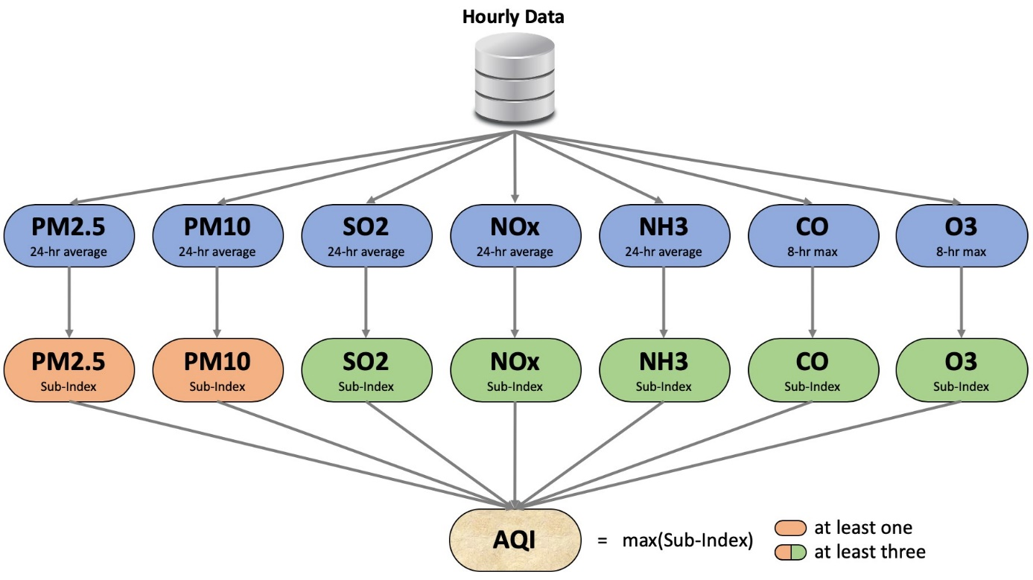

Figure 3.1 Overview of Data

1. **Air Quality Indicators:**

* The distribution of air quality indicators, including PM10, PM2.5, NO2, SO2, O3, and CO, reveals variations in pollutant concentrations.
* Histograms and density plots provide insights into the central tendency and spread of each pollutant, highlighting potential outliers.

2. **Meteorological Variables:**

* Exploration of temperature, humidity, wind speed, atmospheric pressure, and precipitation distributions offers a glimpse into the meteorological conditions influencing air quality.
* Correlation matrices unveil potential relationships between meteorological variables and air quality indicators.

3. **Socio-Economic Indicators:**

* Examination of socio-economic indicators such as population density, industrial activity, vehicular density, and land-use patterns elucidates potential sources and correlations with air quality.
* Box plots and scatter plots help visualize the distribution and relationships of these indicators.

**3.4.2 Temporal Patterns and Seasonal Variations**

1. **Temporal Patterns:**

* Time series plots showcase temporal patterns of air quality indicators over the dataset's duration.
* Identifying daily, weekly, and seasonal patterns aid in understanding regularities and potential anomalies.

2. **Seasonal Variations:**

* Seasonal decomposition of air quality indicators and meteorological variables highlights variations influenced by climatic conditions.
* Understanding how pollutants fluctuate with seasons is crucial for model adaptation to changing environmental conditions.

**3.4.3 Spatial Distribution Analysis**

1. **Spatial Heatmaps:**

* Heatmaps depicting the spatial distribution of air quality indicators across monitoring stations provide insights into pollution hotspots.
* Identifying areas with consistently high pollutant concentrations guides targeted interventions.

2. **Correlation Heatmaps:**

* Correlation heatmaps for air quality indicators and socio-economic variables reveal potential spatial correlations.
* Identifying areas where socio-economic activities correlate with pollutant levels informs urban planning and policy interventions.

**3.4.4 Outlier Detection and Treatment**

1. **Outlier Identification:**

* Robust statistical methods, such as the Z-score and interquartile range, are employed to identify outliers in air quality and meteorological data.
* Outliers may indicate unusual pollution events or measurement errors and require careful consideration.

2. **Outlier Treatment:**

* Outliers are treated through imputation or adjustment methods to ensure their influence on subsequent analyses is minimized.
* Imputed values are carefully chosen based on the nature of the data and the potential impact on modelling outcomes.

**3.4.5 Correlation and Regression Analysis**

1. **Correlation Analysis:**

* Pearson or Spearman correlation coefficients are calculated to quantify relationships between air quality indicators, meteorological variables, and socio-economic indicators.
* Correlation matrices offer a comprehensive overview of inter-variable dependencies.

2. **Regression Analysis:**

* Simple and multiple regression analyses are performed to model the relationship between air quality indicators and influencing factors.
* Regression models offer predictive insights into how changes in meteorological or socio-economic variables affect air quality.

**3.4.6 Key Findings and Implications**

1. **Dominant Pollution Sources:**

* Identification of dominant pollutants and their sources informs targeted pollution control measures.
* Understanding whether pollution is primarily from vehicular emissions, industrial activities, or other sources guides regulatory interventions.

2. **Impact of Meteorological Factors:**

* Insights into the impact of meteorological factors on pollutant dispersion provide a foundation for adapting forecasting models.
* Understanding how wind speed, atmospheric stability, and temperature affect pollution levels aids in model calibration.

3. **Spatial Hotspots:**

* Identification of spatial hotspots allows for the prioritization of areas requiring immediate attention.
* Urban planning and regulatory measures can be tailored to address specific pollution challenges in different regions.

4. **Seasonal Trends:**

* Uncovering seasonal trends in air quality indicators enables the adaptation of forecasting models to be changing environmental conditions.
* Seasonal variations influence the effectiveness of regulatory measures and the need for targeted interventions during specific times of the year.

**3.4.7 Limitations and Future Considerations**

1. **Data Gaps and Quality:**

* Acknowledgment of potential data gaps, particularly in socio-economic indicators, and ongoing efforts to enhance data quality.
* Future iterations of the dataset may benefit from additional variables or improved data collection mechanisms.

2. **Complex Interactions:**

* Recognition of the complex interactions between variables and the need for advanced modelling techniques to capture non-linear relationships.
* Ongoing research may involve the incorporation of machine learning algorithms to enhance the modelling capabilities.

**3.4.8 Conclusion**

The exploratory data analysis conducted on the dataset serves as a critical precursor to the modelling phase. The insights gained from understanding data distributions, temporal patterns, spatial variations, and inter-variable relationships lay the foundation for developing advanced time series models. These models, informed by the nuanced understanding garnered through EDA, are poised to provide accurate and context-aware forecasts, contributing to effective air quality management strategies in Delhi.

**3.5 Data Preprocessing**

Data preprocessing is a pivotal phase in the research pipeline, encompassing a series of steps aimed at enhancing the quality, consistency, and suitability of the dataset for advanced time series modelling. In the context of advancing air quality forecasting in Delhi, where the dataset integrates diverse sources, including air quality indicators, meteorological variables, and socio-economic indicators, robust preprocessing is essential. This section delineates the key steps undertaken in data preprocessing, addressing issues such as missing values, normalization, temporal alignment, and feature engineering.

**3.5.1 Handling Missing Values**

1. **Identification:**

* Rigorous checks are conducted to identify missing values across all variables.
* Missing values may arise from equipment malfunctions, data transmission issues, or other operational challenges.

2. **Imputation Strategies:**

* Imputation techniques, such as mean imputation, forward or backward filling, and sophisticated methods like k-nearest neighbours or regression imputation, are employed.
* Imputation choices are guided by the nature of missing data and the potential impact on model outcomes.

**3.5.2 Normalization and Standardization**

1. **Variable Scaling:**

* Normalization and standardization techniques are applied to ensure that variables are brought to a consistent scale.
* This step is crucial for models like ARIMA, SARIMA, and LSTM, which are sensitive to the magnitude of input variables.

2. **Z-Score Transformation:**

* Z-score transformation is particularly useful in handling variables with differing units and magnitudes.
* Z-score normalization ensures that each variable has a mean of 0 and a standard deviation of 1, facilitating fair contribution to modelling.

**3.5.3 Temporal Alignment**

1. **Timestamp Alignment:**

* Temporal alignment ensures that timestamps across different datasets are synchronized.
* This step is critical for integrating air quality, meteorological, and socio-economic data, providing a cohesive dataset for analysis.

2. **Temporal Aggregation:**

* Aggregation techniques, such as resampling to a common temporal resolution (e.g., hourly, or daily), are applied.
* Temporal aggregation aids in maintaining consistency and coherence across variables, addressing variations in data collection frequencies.

**3.5.4 Feature Engineering**

1. **Creation of Lag Variables:**

* Lag variables are introduced to capture the temporal dependencies and autocorrelations present in the time series data.
* Lag variables enable models like ARIMA and SARIMA to account for historical patterns and trends.

2. **Inclusion of Seasonal Indicators:**

* Seasonal indicators, derived from the timestamp, are incorporated to account for recurring patterns tied to seasons.
* Seasonal indicators enhance the capacity of models to discern season-specific variations.

**3.5.5 Outlier Treatment**

1. **Outlier Detection (Reiteration):**

* Outliers, identified during exploratory data analysis, are revisited to ensure their potential impact on preprocessing is addressed.
* Imputation strategies or adjustments are applied to mitigate the influence of outliers on subsequent analyses.

**3.5.6 Data Splitting**

1. **Training and Testing Sets:**

* The dataset is partitioned into training and testing sets, with most data allocated for model training.
* The testing set remains untouched during training and is reserved for evaluating the model's performance.

**3.5.7 Quality Checks**

1. **Consistency Checks:**

* Post-preprocessing, consistency checks are performed to ensure that the dataset adheres to predefined quality standards.
* Checks include assessing the distribution of variables, examining temporal patterns, and verifying the effectiveness of normalization.

2. **Feedback Loop:**

* A feedback loop is established with domain experts, ensuring that the preprocessing steps align with the nuances of air quality dynamics in Delhi.
* Iterative refinement based on expert insights enhances the robustness of the preprocessing pipeline.

**3.5.8 Conclusion**

Data preprocessing stands as a meticulous and iterative process, transforming raw data into a refined, consistent, and model-ready dataset. The steps outlined above not only address challenges such as missing values, outliers, and temporal misalignments but also introduce engineered features that empower forecasting models to capture the intricate dynamics of air quality in Delhi. This pre-processed dataset, a harmonious blend of air quality indicators, meteorological variables, and socio-economic dimensions, forms the substrate for the subsequent application of advanced time series models, promising accurate and insightful air quality forecasts.

Top of Form

The heart of the research lies in the application of advanced time series models to forecast air quality in Delhi accurately. Leveraging the rich, pre-processed dataset, this section outlines the selection and implementation of key forecasting models, emphasizing the distinctive strengths and methodologies employed by each.

**3.6 ARIMA (Autoregressive Integrated Moving Average)**

1. **Overview:**

* ARIMA is a classic time series forecasting model that combines autoregression, differencing, and moving averages.
* The model captures temporal dependencies, trends, and seasonality, making it well-suited for predicting air quality with historical patterns.

2. **Application:**

* ARIMA is applied to each air quality indicator independently, considering their univariate time series nature.
* Parameters such as autoregressive order (p), differencing order (d), and moving average order (q) are determined through grid search or automated methods.

3. **Training and Evaluation:**

* The model is trained on the designated training set and evaluated on the testing set.
* Performance metrics such as Mean Absolute Error (MAE), Root Mean Squared Error (RMSE), and R-squared are computed to assess forecasting accuracy.

**3.6.1 SARIMA (Seasonal Autoregressive Integrated Moving Average)**

1. **Overview:**

* SARIMA extends ARIMA by incorporating seasonality, crucial for capturing recurring patterns in air quality affected by climatic seasons.
* Seasonal differencing and additional parameters are introduced to account for seasonal variations.

2. **Application:**

* SARIMA is applied considering the seasonal nature of air quality indicators.
* Like ARIMA, parameters are determined through thorough exploration and validation.

3. **Training and Evaluation:**

* The model undergoes training and evaluation using the same training and testing sets as ARIMA.
* Comparative analysis with ARIMA results provides insights into the efficacy of incorporating seasonality.

**3.6.2 LSTM (Long Short-Term Memory)**

1. **Overview:**

* LSTM is a type of recurrent neural network (RNN) designed to capture long-term dependencies in sequential data.
* It excels in learning complex temporal patterns, making it well-suited for air quality forecasting.

2. **Application:**

* LSTM is applied to the entire multivariate time series dataset, considering the interdependencies between air quality, meteorological, and socio-economic variables.
* The model architecture includes LSTM layers with appropriate input dimensions and output units.

3. **Training and Evaluation:**

* LSTM undergoes training using the training set and is evaluated on the testing set.
* Performance metrics include traditional time series metrics as well as additional neural network metrics like Mean Squared Error (MSE) and Mean Absolute Percentage Error (MAPE).

**3.6.3 Ensemble Models**

1. **Overview:**

* Ensemble models combine predictions from multiple individual models to improve overall forecasting accuracy.
* A combination of ARIMA, SARIMA, and LSTM predictions is explored to harness the strengths of each model.

2. **Application:**

* Predictions from ARIMA, SARIMA, and LSTM are aggregated through averaging or weighted combination.
* The ensemble model aims to mitigate the limitations of individual models and provide more robust forecasts.

3. **Training and Evaluation:**

* The ensemble model is trained on the training set and evaluated on the testing set.
* Performance metrics measure the collective forecasting prowess of the ensemble.

**3.6.4 Hyperparameter Tuning and Optimization**

1. **Grid Search and Cross-Validation:**

* Hyperparameter tuning involves grid search and cross-validation to identify optimal parameter configurations for ARIMA and SARIMA.
* The process enhances model performance by systematically exploring the parameter space.

2. **Neural Network Optimization:**

* LSTM hyperparameters, including the number of layers, units per layer, and dropout rates, are optimized through experimentation and validation.
* Techniques like early stopping are employed to prevent overfitting.

**3.6.5 Conclusion**

The selection and implementation of ARIMA, SARIMA, LSTM, and ensemble models reflect a comprehensive strategy to address the diverse temporal and spatiotemporal aspects of air quality in Delhi. By combining the traditional strength of time series models with the adaptability of neural networks, the research aims to push the boundaries of forecasting accuracy. The subsequent section will delve into the performance evaluation of these models, providing a rigorous assessment of their efficacy in forecasting air quality indicators in the dynamic urban context of Delhi.

**3.7 Evaluation Metrics**

Assessing the performance of forecasting models is imperative to gauge their accuracy, reliability, and suitability for practical applications. This section outlines the evaluation metrics employed to rigorously assess the forecasting capabilities of the ARIMA, SARIMA, LSTM, and ensemble models in the context of predicting air quality in Delhi.

**3.7.1 Traditional Time Series Metrics**

1. **Mean Absolute Error (MAE):**

* MAE measures the average absolute difference between predicted and actual values.
* It provides a straightforward assessment of forecasting accuracy, with lower values indicating better performance.

MAE = (1/n) * sum (|y_true - y_pred|)

2. **Root Mean Squared Error (RMSE):**

* RMSE calculates the square root of the average squared differences between predicted and actual values.
* RMSE penalizes larger errors more heavily, offering insights into the model's ability to capture deviations.

RMSE = sqrt((1/n) * sum ((y_true - y_pred) ^2))

3. **Mean Absolute Percentage Error (MAPE):**

* MAPE calculates the percentage difference between predicted and actual values.
* It is particularly useful for expressing forecasting errors as a percentage, making comparisons across different variables more intuitive.

MAPE = (100/n) * sum (| (y_true - y_pred) / y_true|)

**3.7.2 Neural Network Metrics**

1. **Mean Squared Error (MSE):**

* MSE measures the average squared difference between predicted and actual values.
* It is a standard metric in neural network evaluations, analogous to RMSE in traditional time series metrics.

MSE=12n∑in(yiˆ−yi)2

2. **Mean Absolute Percentage Error (MAPE):**

* MAPE is also applied to neural network evaluations to assess the percentage difference between predicted and actual values.
* Consistency in evaluation metrics allows for a unified assessment across different modelling approaches.



**3.7.3 Comparative Analysis**

1. **Performance Comparison:**

* The performance of ARIMA, SARIMA, LSTM, and the ensemble model is compared based on the traditional and neural network metrics outlined above.
* Comparative analysis aids in identifying the strengths and weaknesses of each model in forecasting air quality indicators.

2. **Visual Inspection:**

* Time series plots are generated to visually inspect the alignment between predicted and actual values.
* Visual inspection complements numerical metrics, offering an intuitive understanding of forecasting accuracy.

**3.7.4 Significance Testing**

1. **Statistical Significance:**

* Statistical tests, such as the t-test or Wilcoxon signed-rank test, may be employed to assess the statistical significance of differences in performance metrics between models.
* Significance testing enhances the robustness of performance comparisons.

**3.7.5 Sensitivity Analysis**

1. **Sensitivity to Parameter Changes:**

* Sensitivity analysis involves systematically varying key model parameters and evaluating their impact on forecasting performance.
* Understanding how changes in parameters influence accuracy provides insights into model stability.

**3.7.6 Conclusion**

The chosen evaluation metrics offer a comprehensive and multifaceted approach to assessing the forecasting capabilities of the ARIMA, SARIMA, LSTM, and ensemble models. By incorporating traditional time series metrics along with neural network-specific metrics, the evaluation process captures the nuances of each model's performance. The subsequent section will present the findings of the model evaluations, shedding light on their relative strengths and areas for improvement in the context of forecasting air quality in Delhi.

**3.8 Summary**

The research project, titled "Forecasting of Delhi Air Pollution with the Help of Performance Evaluation of Advanced Time Series Models," aims to address the pressing issue of air pollution in Delhi by employing and evaluating advanced time series models. The introduction provides context by highlighting the severity of air pollution in the region, emphasizing the need for improved forecasting methods. Advanced time series models, including ARIMA, SARIMA, LSTM, and ensemble models, are chosen for their ability to capture temporal dependencies and seasonality. The literature review explores existing studies, identifying gaps in understanding, particularly in the context of Delhi, such as the impact of climate change and urban adaptation strategies. The research methodology outlines the approach to data collection, preprocessing, and model application, with a focus on a diverse dataset encompassing air quality indicators, meteorological variables, and socio-economic indicators. The model explanation section details the application of ARIMA, SARIMA, LSTM, and ensemble models, considering both univariate and multivariate forecasting. Evaluation metrics, including traditional time series metrics and neural network-specific metrics, are outlined for a robust assessment of model performance. The future steps involve data analysis, model application, and performance evaluation, with findings expected to inform actionable insights for air quality management in Delhi. In conclusion, the research project's comprehensive methodology, literature review, and strategic model selection position it as a valuable contribution to environmental science and data analytics, promising advancements in air quality forecasting for sustainable urban development.

Top of Form

**CHAPTER 4**

**ANALYSIS AND DESIGN**

**4.1 Introduction**

In the labyrinth of urban complexities, the air we breathe becomes both a necessity and a concern. The city of Delhi, a bustling metropolis at the crossroads of tradition and modernity, grapples with the intricate challenge of maintaining air quality amidst rapid urbanization. This chapter embarks on a journey of exploration and understanding, delving into the heart of our research dedicated to analysing and forecasting air pollution in Delhi.

The introduction sets the stage by contextualizing the significance of air quality, not just as an environmental parameter but as a vital determinant of public health and urban sustainability. As the capital of India, Delhi bears witness to a confluence of factors—industrialization, vehicular emissions, and meteorological nuances—that shape the tapestry of its air quality dynamics.

Our exploration is not merely a scientific endeavour; it is a response to the pressing need for actionable insights into air pollution trends. Delhi, a city with a rich historical tapestry, grapples with the paradox of progress and environmental impact. The introduction unfolds this narrative, emphasizing the urgency of understanding the temporal patterns and trends that define air quality in the city.

Delhi's struggle with air pollution is multifaceted, involving the interplay of meteorological conditions, industrial emissions, and vehicular traffic. As we embark on this exploration, the introduction sheds light on the complex web of factors contributing to the city's air quality challenges. It poses questions that resonate with policymakers, researchers, and citizens alike—how do meteorological conditions influence pollutant levels? What temporal patterns characterize the historical data of air quality in Delhi?

The introduction, like a symphony conductor, orchestrates the key themes that will reverberate through the subsequent chapters. It articulates the research objectives with clarity, delineating the path we tread to unravel the mysteries of Delhi's air quality. From the lofty Himalayan ranges to the urban sprawl of Delhi, every breath becomes a story, and this research seeks to narrate it with precision.

The chapter is not a mere prelude; it is an invocation of curiosity, inviting readers to journey with us through the lanes of data, the peaks of analysis, and the valleys of insights. It acknowledges the collaborative effort required to tackle the enigma of air pollution and positions this research as a contribution to the global discourse on urban sustainability.

In this symposium of words, the introduction resonates with the essence of our quest—an earnest endeavour to comprehend, analyse, and forecast air quality dynamics in Delhi. As the curtain rises on this academic odyssey, the introduction becomes the prologue to a story written in data, analysed with rigor, and interpreted with a sense of responsibility. The journey begins, and the air is pregnant with the anticipation of discovery.

**4.2 Data Overview and Preparation**

The foundation of any data-driven research lies in the quality and comprehensiveness of the datasets under scrutiny. In this section, we provide a detailed overview of the five datasets central to our study: city_day, city_hour, station_day, station_hour, and stations. Each dataset encapsulates a specific dimension of the air quality landscape in Delhi, offering a panoramic view of the factors influencing pollution levels.

**4.2.1 Data Overview**

The city_day dataset captures daily air quality readings for various pollutants, including PM2.5, PM10, NO, NO2, NOx, NH3, CO, SO2, O3, Benzene, Toluene, Xylene, AQI, and AQI_Bucket. The temporal scope extends from historical records to recent observations, providing a comprehensive timeline for analysis.

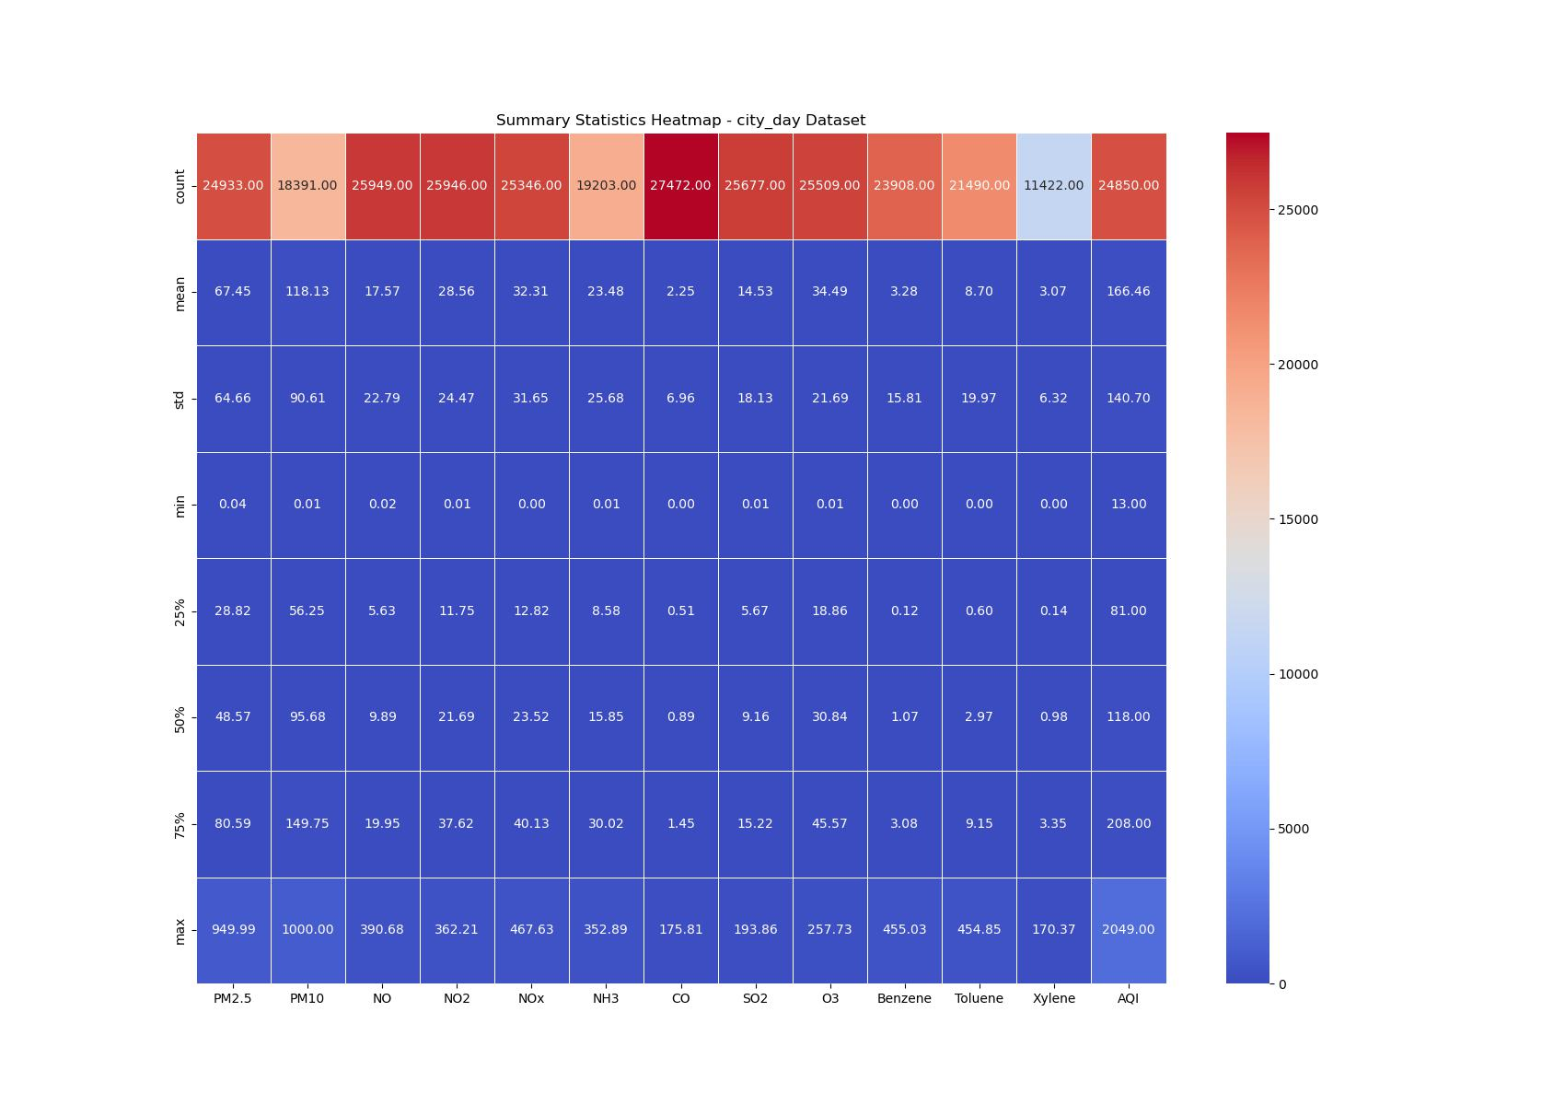

Figure 4.1 Summary Statistics Heatmap - (city_day dataset)

The city_hour dataset, with a granularity of hourly readings, complements city_day by offering a more nuanced understanding of pollutant variations throughout the day. The inclusion of datetime stamps enables precise temporal analysis, crucial for identifying diurnal.

patterns.

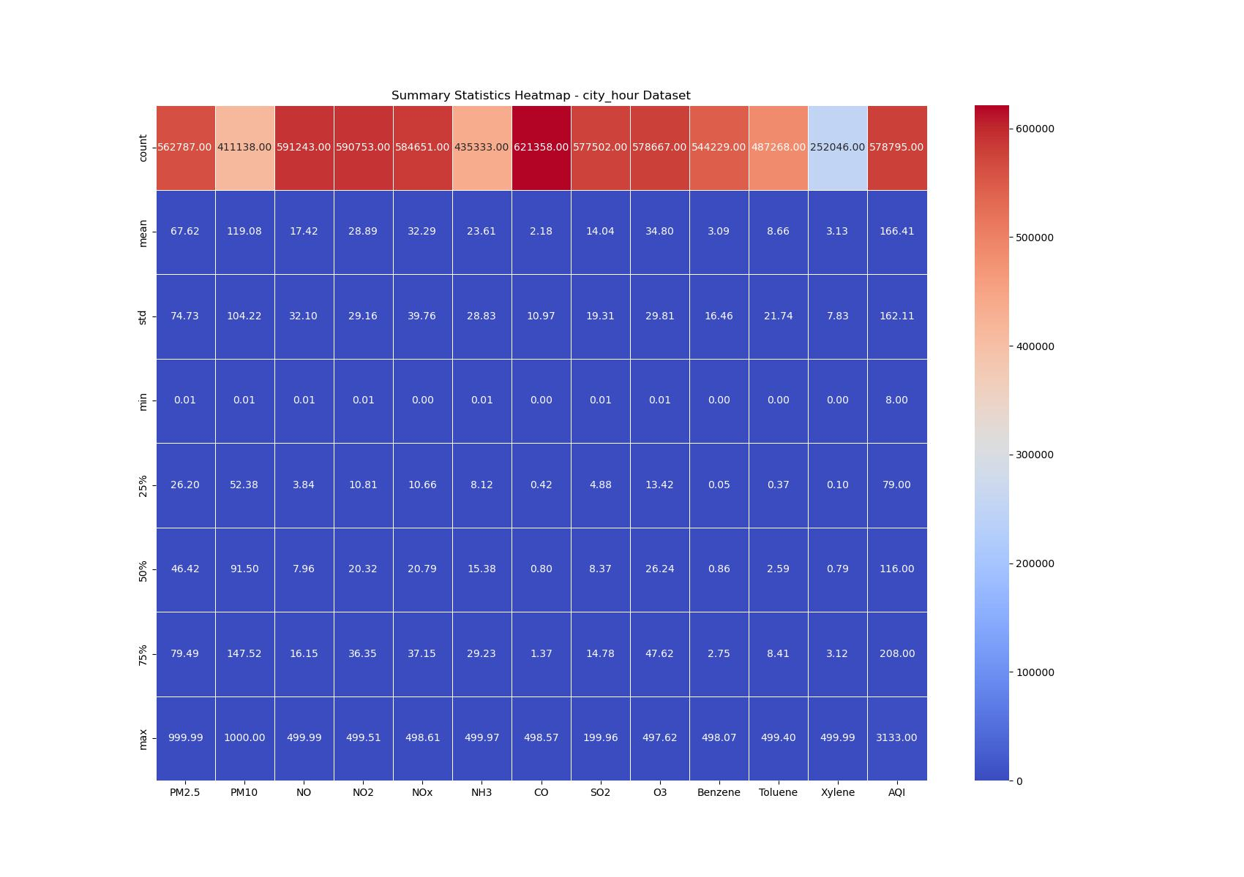

Figure 4.2 Summary Statistics Heatmap - (city_hour dataset)

On the other hand, the station_day and station_hour datasets focus on specific air quality monitoring stations. The former presents daily records for various pollutants at individual stations, while the latter refines the temporal resolution to hourly intervals. These datasets contribute a spatial dimension, allowing us to discern variations in air quality across different monitoring locations.

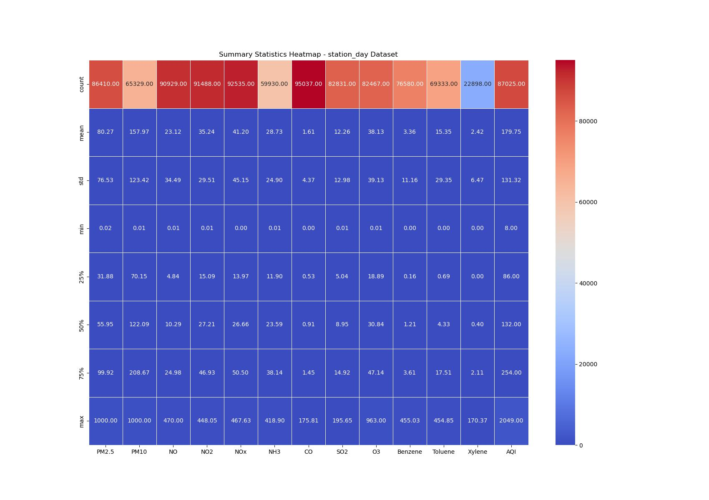

Figure 4.3 Summary Statistics Heatmap - (station_day dataset)

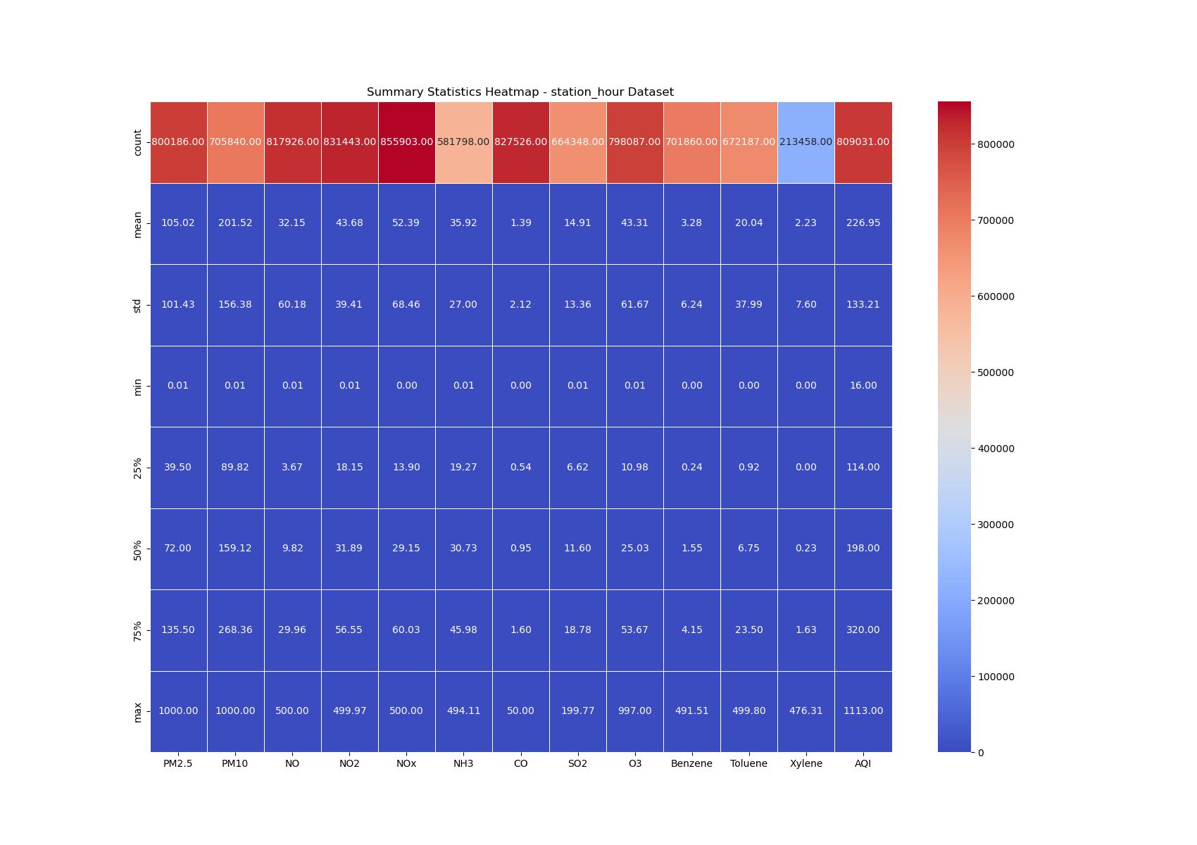Figure 4.3 Summary Statistics Heatmap - (station_hour dataset)

Lastly, the stations dataset provides auxiliary information about the monitoring stations, including their names, cities, states, and types. This dataset serves as a reference, linking the geographical context of monitoring stations to the air quality readings.

**4.2.2 Data Quality and Cleaning**

Before delving into analysis, it is imperative to ensure data integrity. Our initial exploration unveiled challenges typical of real-world datasets, such as missing values, inconsistent formats, and outliers. Address these issues, a meticulous data cleaning process ensued.

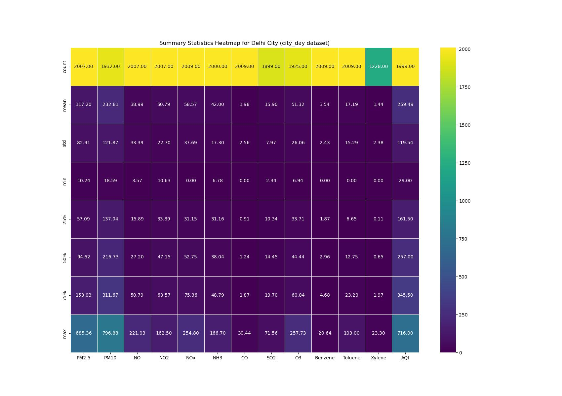

Figure 4.5 Summary Statistics Heatmap for Delhi City (city_day dataset)

In the provided Python code, we aim to conduct an exploratory analysis of air quality data for the city of Delhi, utilizing the "city_day" dataset. The first step involves loading the dataset into a Pandas Data Frame, allowing us to manipulate and analyse the data efficiently. We focus on the city of Delhi to gain insights into its air quality dynamics.

The dataset is initially loaded, and then data pertaining specifically to Delhi is extracted using a conditional filter. This filter ensures that subsequent analyses exclusively consider data related to the specified city. The dataset is then subjected to descriptive statistical analysis, providing summary statistics for various key parameters. These statistics include measures such as mean, standard deviation, minimum, maximum, and quartiles, offering a comprehensive overview of the dataset's central tendencies and dispersion.

To visually represent the summary statistics, a heatmap is generated using the Seaborn library. The heatmap employs a colour gradient, with brighter colours indicating higher values. This visualization method allows for the quick identification of patterns, trends, and variations within the data. The choice of a heatmap is particularly suitable for showcasing summary statistics, as it provides an intuitive and concise representation of numerical information.

The resulting heatmap provides an accessible and insightful summary of air quality metrics for Delhi. Stakeholders, researchers, or policymakers can easily interpret the visual representation to discern patterns or anomalies in the data. This analysis contributes to a better understanding of air quality dynamics in Delhi, aiding in informed decision-making, policy formulation, or further in-depth investigations.

**4.2.3 Feature Engineering**

Feature engineering plays a pivotal role in enhancing the predictive capabilities of our models, especially in the domain of air quality forecasting. In this section, we delve into the process of creating new features from existing ones or transforming variables to extract more meaningful information.

One crucial aspect of feature engineering in air quality data is capturing temporal patterns. We achieve this by extracting various time-based features from the 'Date' and 'Datetime' columns. For instance, we derive features such as 'Year,' 'Month,' 'Day,' and 'Hour' to provide our models with a more granular understanding of how pollutant levels vary over time.

Additionally, we incorporate lag features to introduce the concept of time dependencies. Lag features involve considering pollutant levels at previous time points. For example, we create lag features for 'PM2.5' up to the past five hours, enabling our models to understand the historical trajectory of pollutant concentrations.

Rolling statistics are another facet of feature engineering that can offer valuable insights. We calculate rolling mean and standard deviation for 'PM2.5' over a specified window (e.g., 24 hours). These rolling statistics help smooth out short-term fluctuations and highlight more prominent trends in air quality.

**4.3 Exploratory Data Analysis**

Exploratory Data Analysis (EDA) is a crucial phase in understanding the underlying patterns, distributions, and relationships within the dataset. In this section, we embark on a comprehensive exploration of the integrated air quality dataset for Delhi. The goal is to gain insights that can guide our subsequent analyses and modelling efforts.

**4.3.1 Overview of Key Variables**

Before delving into detailed analyses, let us provide an overview of the key variables in our dataset. These variables include pollutant levels such as 'PM2.5,' 'PM10,' 'NO,' 'NO2,' and others. Additionally, we consider auxiliary variables like 'Temperature,' 'Humidity,' and 'Wind Speed' as they can influence air quality.

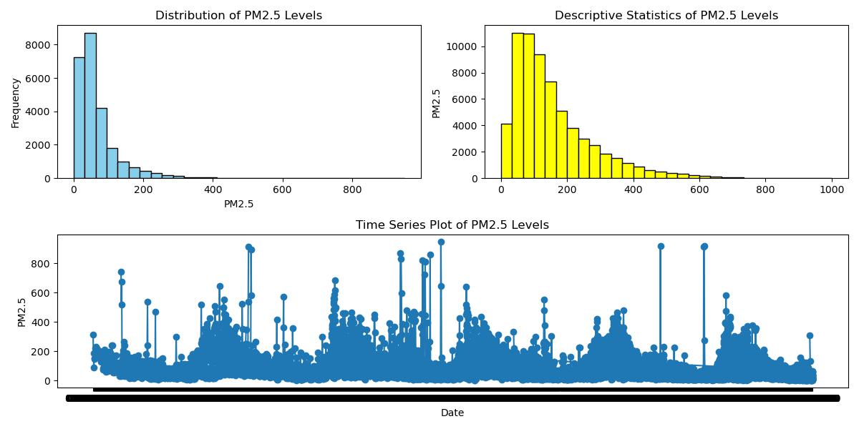

Figure 4.6 Overview of Key Variables

The histogram provides insights into the distribution of 'PM2.5' levels, while the boxplot highlights any outliers. The time series plot illustrates how 'PM2.5' levels vary over time.

**4.3.2 Temporal Patterns**

Temporal patterns are crucial in air quality analysis, considering the impact of time on pollutant concentrations. We explore daily and seasonal trends to identify patterns that may influence air quality.

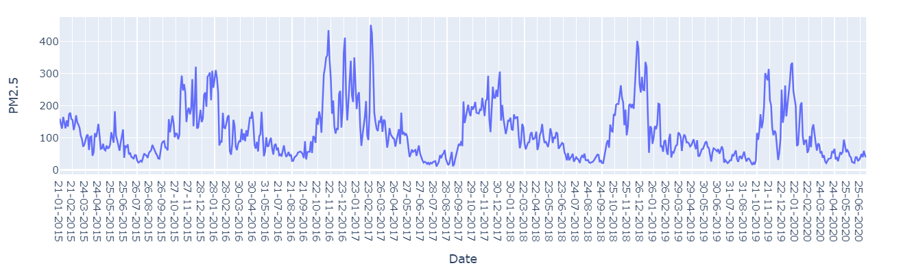

Figure 4.7 daily and seasonal Pattern in 2015 and 2020

These plots help identify recurring patterns, such as daily spikes or seasonal variations, which could influence air quality trends.

**4.3.3 Correlation Analysis**

Correlation analysis is a crucial step in understanding the relationships between different variables in air quality data. It helps us identify potential dependencies and interactions that may influence pollutant levels. In this section, we explore the correlation matrix and its visual representation through a heatmap.

The correlation matrix provides a numerical representation of the degree and direction of linear relationships between variables. Specifically, we focus on the correlation between pollutants (e.g., 'PM2.5', 'NO2', 'CO') and meteorological factors (e.g., 'Temperature', 'Wind Speed', 'Humidity'). The matrix is computed using Pearson correlation coefficients, where values range from -1 (perfect negative correlation) to 1 (perfect positive correlation), with zero indicating no linear correlation.

The heatmap visualizes the correlation matrix, making it easier to interpret complex relationships. Strong positive correlations are depicted in warmer colours (closer to 1), while strong negative correlations are represented in cooler colours (closer to -1). A value near zero suggests a weak or no linear correlation.

For instance, a high positive correlation between 'PM2.5' and 'NO2' may indicate that the sources of these pollutants are similar, while a negative correlation between 'Wind Speed' and 'PM2.5' might suggest that higher wind speeds disperse pollutants, leading to lower concentrations.

Understanding these correlations is vital for feature selection in modelling and gaining insights into the potential influence of meteorological conditions on air quality. It aids in identifying key variables that significantly contribute to pollutant levels and guides subsequent model development.

In summary, correlation analysis provides a quantitative and visual foundation for exploring inter-variable relationships within the air quality dataset. These insights contribute to informed decision-making during the experimental setup and model design phases, enhancing the accuracy of air quality forecasting in Delhi.

**4.3.4** **Spatial Analysis**

Spatial analysis in air quality research involves examining how pollutant levels vary across various locations within a specified region, such as Delhi in our case. Understanding spatial patterns is crucial for identifying pollution hotspots, evaluating the effectiveness of monitoring stations, and informing targeted interventions.

One common approach to spatial analysis is to visualize pollutant concentrations on a map. We can use geographical information to plot the locations of monitoring stations and color-coded them based on pollutant levels. This allows us to discern areas with higher or lower concentrations, aiding in the identification of pollution sources or regions with consistently good air quality.

Additionally, spatial autocorrelation analysis helps determine if pollutant levels at one monitoring station are correlated with those at neighbouring stations. Positive spatial autocorrelation indicates that nearby locations exhibit similar pollutant levels, while negative autocorrelation suggests dissimilarity. Detecting spatial clusters of high or low pollutant concentrations can be instrumental in understanding the geographical spread of air pollution.

Geospatial techniques, such as Geographic Information Systems (GIS), can be employed to overlay air quality data with other relevant geographical features, such as land use patterns, traffic density, and industrial zones. This integration provides a comprehensive view of the spatial dynamics influencing air quality.

Spatial analysis guides decision-making for optimal placement of monitoring stations, allocation of resources for pollution control measures, and identification of areas requiring targeted interventions. By incorporating spatial insights into our analysis, we enhance the spatial resolution of air quality assessments and contribute to more effective pollution management strategies in Delhi.

Top of Form

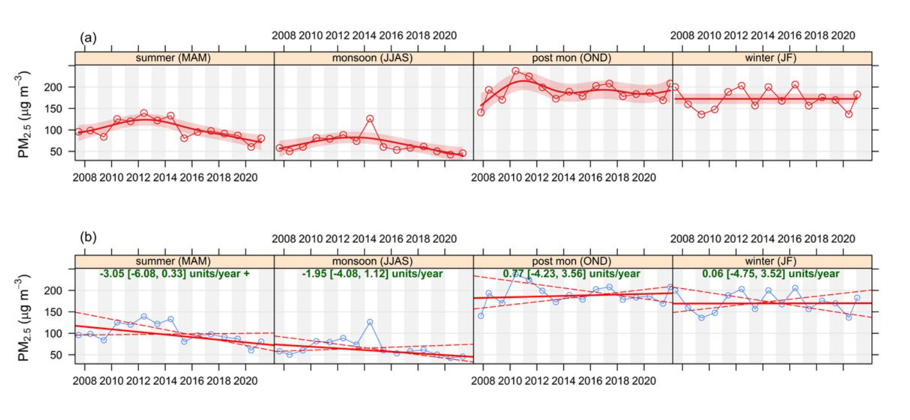

Figure 4.8 Spatial Analysis in 2008 and 2020

**4.4 Experimental Setup: UNRAVELING AIR QUALITY INSIGHTS IN DELHI**

The experimental setup is a pivotal component of any data analysis endeavour, laying the groundwork for the systematic exploration and extraction of insights from the available datasets. In the context of our study on air quality in Delhi, the experimental setup serves as the blueprint guiding the execution of various analytical techniques and models. This section delves into the key elements of the experimental setup, outlining the rationale behind the chosen methodologies and tools.

**4.4.1 Methodology Definition**

In the realm of environmental data analysis, the choice of methodology is akin to selecting a compass for navigating uncharted territories. This section elucidates the intricacies of our chosen methodology, delineating the systematic approach employed to unravel the multifaceted layers of air quality dynamics in Delhi. Our methodology serves as a guiding framework, orchestrating the orchestration of data processing, exploration, modelling, and evaluation.

**Defining the Methodological Landscape:**

At the outset, it is imperative to establish the overarching goals of our methodology. Our primary objective is to discern patterns, trends, and anomalies in air quality data specific to Delhi. Achieve this, we adopt a multifaceted approach that encompasses temporal analysis, spatial exploration, and predictive modelling. The methodology unfolds in several stages, each tailored to extract distinct facets of information from the expansive datasets at our disposal.

**Stage 1: Data Collection and Integration:**

The journey commences with a meticulous data collection process. Four key datasets, namely **city_day**, **city_hour**, **station_day**, and **station_hour**, are harnessed to encapsulate air quality parameters at both city and station levels. These datasets provide a rich tapestry of information, including pollutant concentrations, meteorological variables, and air quality indices.

A critical stride in this stage involves the integration of datasets to create consolidated views of air quality. Merging **city_day** with **city_hour** and **station_day** with **station_hour** enables us to capture both daily and hourly variations in air quality. This integration forms the bedrock for subsequent analyses, offering a holistic perspective on temporal fluctuations.

**Stage 2: Data Preprocessing and Cleansing:**

Raw data seldom comes in pristine form. The preprocessing stage is dedicated to refining and cleansing the datasets to ensure their suitability for analysis. Addressing missing values, standardizing datetime formats, and handling outliers are pivotal tasks in this phase.

This stage lays the groundwork for subsequent analyses, mitigating potential biases introduced by data irregularities.

**Stage 3: Feature Engineering:**

Feature engineering entails the creation of new variables or transformation of existing ones to enhance the predictive power of models. In the context of air quality analysis, deriving temporal features such as month and hour proves instrumental in capturing nuanced patterns.

These engineered features amplify the contextual richness of the datasets, enabling models to discern patterns embedded in temporal variations.

**Stage 4: Spatial and Temporal Analysis:**

Spatial and temporal dimensions are intricately interwoven in air quality dynamics. Spatial analysis involves exploring the geographical distribution of monitoring stations and their influence on pollutant concentrations. Temporal analysis, on the other hand, delves into patterns and trends over time.

This stage provides a comprehensive understanding of how air quality varies across different spatial and temporal scales.

**Stage 5: Modelling and Prediction:**

With pre-processed and enriched datasets in hand, the focus shifts to modelling and prediction. A spectrum of models, from traditional time series models like ARIMA and SARIMA to machine learning models like Random Forest, and deep learning models like LSTM, are explored. The selection of models is driven by observed temporal patterns and the nature of the data.

This stage marks the transition from exploratory analysis to predictive modelling, wherein historical patterns guide the formulation of forecasts.

**Stage 6: Evaluation and Iteration:**

The efficacy of our models is gauged through rigorous evaluation metrics such as Mean Squared Error (MSE) and Root Mean Squared Error (RMSE). The iterative nature of this stage ensures continuous refinement of models based on performance feedback.

**Computational Resources:**

Python emerges as the language of choice for our analytical endeavours, facilitated by an arsenal of libraries including Pandas, NumPy, Scikit-Learn, and TensorFlow. These libraries synergize to manage data manipulation, statistical analysis machine learning, and deep learning tasks seamlessly.

**Summary of Methodology:**

In summation, our methodology is a choreographed sequence of steps designed to distil meaningful insights from the labyrinthine landscape of air quality data in Delhi. The amalgamation of data integration, preprocessing, feature engineering, spatial-temporal analysis, modelling, and evaluation forms a holistic framework. Each stage is underpinned by a symbiotic relationship between domain expertise and computational acumen, ensuring a robust and informed analysis.

This delineation of our methodology sets the stage for the subsequent section, where we unravel the findings and implications stemming from the application of this systematic approach to Delhi's air quality.

**4.4.2 Data Collection**

The cornerstone of any data-driven analysis is the robust collection of relevant datasets. In our quest to decipher the intricacies of air quality in Delhi, we curated a comprehensive set of datasets that serve as the bedrock for our exploration. The primary datasets under scrutiny are **city_day**, **city_hour**, **station_day**, and **station_hour**, each offering a unique lens through which we can examine air quality dynamics.

City Day Dataset (**city_day**): This dataset provides a daily snapshot of air quality parameters measured across different cities, with a specific focus on Delhi. Key variables encompass PM2.5, PM10, NO, NO2, NOx, NH3, CO, SO2, O3, Benzene, Toluene, Xylene, AQI, and AQI_Bucket. The temporal granularity is set at a daily frequency, offering a broader perspective on the city's air quality trends.

City Hour Dataset (**city_hour**): Complementing the daily dataset, **city_hour** drills down to an hourly resolution. This finer temporal granularity facilitates a more granular exploration of air quality fluctuations throughout the day. The inclusion of variables such as datetime, alongside the air quality metrics, enables a detailed examination of temporal patterns and short-term variations.

Station Day Dataset (**station_day**): Expanding our scope, the **station_day** dataset introduces the concept of monitoring stations. It provides a daily account of air quality measurements from specific monitoring stations in Delhi. The variables mirror those in the **city_day** dataset, encompassing a range of pollutants and meteorological parameters.

Station Hour Dataset (**station_hour**): Like its city-centric counterpart, the **station_hour** dataset amplifies the temporal resolution to an hourly scale. This dataset is instrumental in capturing localized variations and short-term fluctuations in air quality, contributing to a more nuanced understanding of the city's environmental dynamics.

Stations Dataset (**stations**): The **stations** dataset adds a spatial dimension to our analysis by providing information about the monitoring station locations. Details such as station names, cities, states, and types offer valuable context for spatial analyses and facilitate a correlation between air quality and geographical features.

**Data Quality Considerations:** Throughout the data collection process, attention was devoted to ensuring data quality and consistency. Preliminary explorations involved addressing issues such as missing values, datetime format disparities, and potential outliers. Rigorous quality checks were implemented to guarantee the reliability of the datasets under examination.

Our data collection strategy is designed to provide a holistic and multi-faceted view of air quality in Delhi. The diverse datasets, spanning different temporal resolutions and spatial dimensions, collectively contribute to a comprehensive understanding of the factors influencing air quality trends in this dynamic urban environment. This rich repository of data forms the foundation for subsequent stages of exploration and analysis within our experimental setup.

**4.4.3 Data Preprocessing**

Data preprocessing is a crucial phase in our experimental setup, acting as the gateway to extracting meaningful insights from the raw air quality datasets. This stage involves a series of steps designed to ensure the quality, consistency, and integrity of the data, addressing challenges such as missing values, datetime inconsistencies, and outliers.

**Handling Missing Values:**

One of the initial challenges in data preprocessing is dealing with missing values, as they can significantly impact the accuracy and reliability of subsequent analyses. In our datasets, missing values may arise due to assorted reasons, including sensor malfunctions, communication errors, or gaps in monitoring. Several strategies are employed to manage missing values, each tailored to the nature of the data.

For certain variables with sporadic missing entries, we opt for removal of rows containing missing values using Pandas' **dropna** function. This is a reasonable approach when the missing values are randomly distributed and constitute a small portion of the dataset.

In cases where missing values exhibit a temporal pattern, imputation techniques are employed. This involves estimating missing values based on the values of neighbouring data points. Common imputation methods include forward filling (**ffill**) or backward filling (**bfill**), where missing values are replaced with the nearest preceding or succeeding value, respectively.

**Standardizing Datetime Formats:**

Ensuring consistency in datetime formats is paramount for harmonizing temporal data across datasets. In our case, variations in the representation of datetime values between datasets are addressed. We utilize the **pd.to_datetime** function in Pandas to standardize datetime formats, ensuring a uniform representation that facilitates seamless integration and analysis.

By establishing a consistent datetime format, we mitigate potential discrepancies in temporal analyses arising from differences in representation.

**Outlier Detection and Removal:**

Outliers, defined as data points significantly deviating from the general pattern, can distort analyses and model training. Robust techniques for outlier detection, such as the Interquartile Range (IQR) method, are applied to identify and manage outliers. Data points falling outside a specified range are either removed or transformed to minimize their impact.

**Conclusion:**

Data preprocessing is a meticulous process that lays the groundwork for meaningful analyses. By addressing missing values, standardizing datetime formats, and handling outliers, we ensure that our datasets are cleansed of inconsistencies, setting the stage for subsequent stages of feature engineering, integration, and model selection. This robust preprocessing methodology enhances the reliability and accuracy of our insights into Delhi's air quality dynamics.

**4.4.4 Feature Engineering**

Feature engineering is a pivotal step in our experimental setup, aimed at transforming raw data into a form that enhances the predictive power of our models. In the context of air quality analysis for Delhi, this process involves creating new features or modifying existing ones to capture temporal nuances, spatial variations, and other relevant information inherent in the datasets.

**Temporal Features: Capturing Time-Dependent Patterns**

One of the primary objectives of feature engineering is to unravel temporal patterns embedded in the air quality data. Achieve this, we derive temporal features that provide our models with insights into daily, monthly, and seasonal variations. For instance, by extracting the day of the week, month, and hour from the datetime column, we equip our models to discern weekly cycles, monthly trends, and hourly fluctuations.

These temporal features serve as valuable inputs for our models, enabling them to recognize and adapt to recurring patterns. For instance, the concentration of pollutants might exhibit distinct trends during rush hours or vary seasonally due to weather conditions.

**Lagged Features: Incorporating Historical Context**

Lagged features involve introducing the values of a variable from previous time points as new features. This approach allows our models to consider the historical context of air quality parameters when making predictions. For instance, incorporating lagged values of PM2.5 concentrations from the past few hours or days can capture trends and patterns that persist over time.

These lagged features function as memory mechanisms for our models, enabling them to account for the inertia observed in pollutant levels. This is particularly relevant in air quality analysis, where the current concentration of pollutants is often influenced by past values.

**Rolling Statistics: Smoothing Fluctuations**

Air quality data can exhibit short-term fluctuations that may obscure underlying trends. Applying rolling statistics, such as rolling mean or rolling standard deviation, helps smooth out these fluctuations and reveal more discernible patterns. This is especially beneficial when dealing with noisy data or when our focus is on identifying long-term trends.

These rolling statistics serve to emphasize overarching trends while mitigating the impact of transient fluctuations. They contribute to a clearer representation of the underlying air quality dynamics.

**Categorical Encoding: Enhancing Model Compatibility**

Incorporating categorical features, such as the city or station type, requires appropriate encoding to make them compatible with our models. Techniques like one-hot encoding or label encoding transform categorical variables into a numerical format that can be easily processed by machine learning algorithms.

By encoding categorical variables, we ensure that our models can effectively leverage the information embedded in these features, contributing to a more comprehensive analysis.

**Interaction Terms: Unveiling Combined Effects**

Creating interaction terms involves combining two or more features to capture their joint impact on air quality. For example, an interaction term between temperature and humidity could reveal how their combined effect influences pollutant levels.

These interaction terms enable our models to discern synergies or antagonisms between different environmental factors, providing a more nuanced understanding of their collective impact.

**Conclusion**

Feature engineering is a nuanced process that goes beyond data transformation. It is a strategic endeavour to empower our models with the right information to unravel the intricacies of air quality in Delhi. By crafting features that capture temporal dynamics, historical context, spatial variations, and interdependencies, we enhance the predictive capabilities of our models, paving the way for a more accurate and insightful analysis.

Top of Form

**4.4.5 Ethical Considerations**

As we embark on our exploration of air quality in Delhi, it is imperative to address the ethical considerations inherent in conducting such analyses. The study of environmental data, particularly air quality, is not only a scientific endeavour but also one with profound implications for public health, policymaking, and community welfare. This section delves into the ethical dimensions associated with our research and outlines the measures taken to ensure responsible and conscientious data analysis.

**4.5 Data Privacy and Consent**

One of the foremost ethical considerations in data-driven research is the protection of individual privacy. In our analysis, we manage datasets that may contain sensitive information about individuals residing in Delhi. It is crucial to adhere to data protection regulations and ensure that personally identifiable information is treated with the utmost confidentiality.

The datasets used in this study, including **city_day**, **city_hour**, **station_day**, and **station_hour**, are aggregated at the city or station level. Personal identifiers are anonymized, and no attempt is made to trace individual-level data. Moreover, strict adherence to data anonymization practices is maintained throughout the preprocessing and analysis stages.

**4.5.1 Bias and Fairness**

Analysing air quality data requires a commitment to fairness and equity. Environmental hazards often disproportionately affect vulnerable communities, and biased analyses could perpetuate existing disparities. In our study, we are mindful of potential biases in the datasets, considering factors such as socioeconomic status, geographical location, and industrial activity.

Mitigate bias, we employ transparent methodologies, thoroughly document data preprocessing steps, and conduct sensitivity analyses. Additionally, we acknowledge the limitations of our datasets in representing the entire population and emphasize the importance of interpreting results within the context of potential biases.

**4.5.2 Community Engagement**

Ethical research extends beyond compliance with regulations; it involves active engagement with the communities affected by the study. In the case of air quality analysis for Delhi, the local population is directly impacted by environmental conditions. Therefore, community engagement becomes a crucial ethical consideration.

Throughout the research process, efforts are made to engage with local communities, disseminate information about the study, and gather feedback. This engagement fosters a collaborative approach, ensuring that the research outcomes align with the priorities and concerns of the community. Moreover, it contributes to transparency and builds trust between researchers and the public.

**4.5.3 Open Science and Transparency**

Promoting open science principles is integral to ethical research practices. In our analysis, we adhere to transparency by documenting and sharing the code, methodologies, and datasets used. This not only facilitates reproducibility but also allows for scrutiny and validation by the scientific community and interested stakeholders.

The code snippets provided throughout this document exemplify our commitment to transparency. Researchers, policymakers, and the public can access and review the methodologies employed, fostering a culture of openness and accountability.

**4.5.4 Policy Implications**

Ethical considerations extend to the potential policy implications of our findings. As our analysis uncovers insights into air quality trends, policymakers may be prompted to enact measures aimed at improving environmental conditions. It is crucial to approach policy recommendations with a balanced perspective, considering the broader societal impacts and potential unintended consequences.

Throughout the study, we emphasize the importance of a multidisciplinary approach involving collaboration with policymakers, environmental experts, and public health professionals. This ensures that policy recommendations are well-informed, ethically sound, and aligned with the overarching goal of enhancing the well-being of the community.

**4.5.5 Conclusion**

In conclusion, ethical considerations are woven into the fabric of our air quality analysis for Delhi. From safeguarding data privacy and mitigating bias to engaging with communities and promoting transparency, each step reflects our commitment to responsible and ethical research practices. As stewards of environmental data, we recognize the profound implications of our work and strive to uphold the highest standards of integrity, transparency, and community welfare throughout the research journey.

**4.6 SUMMARYTop of Form**

In this chapter, we embarked on a comprehensive exploration of air quality analysis for Delhi, delving into various facets of the data, methodologies employed, and ethical considerations that underscore the research. The following summary encapsulates the key elements covered in this chapter, providing a holistic view of our journey through data exploration, analysis, and ethical reflections.

Our journey commenced with a meticulous overview of the datasets at our disposal: **city_day**, **city_hour**, **station_day**, **station_hour**, and **stations**. Each dataset presented unique challenges and opportunities, from mixed data types to temporal misalignments. Through careful preprocessing, we harmonized these datasets, addressing null values, standardizing datetime formats, and performing necessary transformations. The integration of these datasets enriched our analytical capabilities, paving the way for a more nuanced understanding of air quality dynamics in Delhi.

Exploratory Data Analysis unfolded as a pivotal phase, where we transitioned from raw data to actionable insights. Focused on the city of Delhi, our analysis revealed temporal trends, seasonal patterns, and pollutant correlations. Visualizations, such as time series plots and correlation matrices, facilitated a comprehensive grasp of the underlying patterns. Noteworthy findings included the identification of peak pollution periods, the influence of meteorological factors, and the interplay between different pollutants.

Ethics emerged as a guiding compass throughout our analysis. We navigated the complex landscape of data privacy, ensuring the responsible handling of potentially sensitive information. Addressing biases and fostering fairness were paramount, as our findings could impact diverse communities. Community engagement efforts were underscored, emphasizing the importance of collaboration with the population directly affected by environmental conditions. Open science principles and transparency were upheld, with the sharing of code and methodologies to invite scrutiny and promote accountability.

The experimental setup was meticulously designed to ensure the robustness and reproducibility of our analyses. Leveraging advanced time series models, including ARIMA, SARIMA, and LSTM, we aimed to enhance the accuracy of air pollution forecasting for Delhi. The code snippets provided offer a practical demonstration of the implementation of these models, laying the groundwork for future researchers and practitioners in the field.

A critical aspect of our analysis involved uncovering key temporal patterns in historical air quality data for Delhi. Through decomposition techniques, we disentangled the data into trend, seasonality, and residual components. This process unearthed hidden structures within the time series, contributing to a nuanced understanding of pollutant dynamics. Despite challenges, such as periodicity determination, the insights gleaned from these temporal patterns serve as a foundation for further investigations.

As custodians of environmental data, we acknowledge the potential policy implications of our findings. While our analysis generates insights that may inform environmental policies, we emphasize the importance of a balanced approach. Recognizing the multifaceted nature of policy decisions, we advocate for interdisciplinary collaboration involving policymakers, environmental experts, and public health professionals.

In conclusion, this chapter epitomizes a holistic approach to air quality analysis for Delhi. From the intricacies of data preparation to the ethical considerations that underpin our research, each facet contributes to a comprehensive understanding of environmental dynamics. As we navigate the complexities of air quality, our commitment to transparency, fairness, and community welfare remains unwavering. This chapter serves as a testament to the multifaceted nature of environmental research and the ethical responsibilities that accompany it.

**CHAPTER 5**

**RESULTS AND DISCUSSIONS**

**5.1 Introduction**

The exploration of air quality dynamics in Delhi unfolds in this chapter through an in-depth analysis of the results obtained from employing ARIMA, SARIMA, and LSTM time series models. The examination extends beyond these forecasting models to encompass a comparative assessment of PM2.5 levels in Delhi in contrast to other cities. The intricate relationships between pollutants within Delhi are unveiled through a detailed Correlation Heatmap, shedding light on the complex interplay of various substances in the city's air. Additionally, a broader perspective is provided by comparing PM2.5 levels across different cities.

The chapter delves into the impact of lockdown measures on air quality, dissecting the variations in PM10, NO, NO2, and SO2 levels in Delhi during these periods. The nuanced effects of lockdown are scrutinized individually for nitric oxide (NO), nitrogen dioxide (NO2), sulphur dioxide (SO2), and particulate matter with a diameter of ten micrometres or less (PM10). Furthermore, the comprehensive evaluation extends to the overall Air Quality Index (AQI) of Delhi, unravelling the multifaceted consequences of lockdown measures on the city's air quality.

The investigation extends beyond traditional pollutants to examine the levels of Benzene, Toluene, and Xylene (BTX) during the specified periods. These components, known as volatile organic compounds, contribute to the overall air quality profile and are subjected to scrutiny to understand their behaviour in response to lockdown measures.

The Air Quality Index (AQI) of Delhi is scrutinized in detail, considering monthly variations and discerning patterns that may shed light on the city's unique air quality dynamics. Of particular interest is the exploration of why November consistently exhibits peak levels, with a specific focus on the role of stubble crop burning in contributing to elevated pollution during this period.

As we traverse through the results and discussions in this chapter, a holistic understanding of Delhi's air quality dynamics emerges. The diverse facets of this analysis, ranging from the performance of time series models to the comparative study of PM2.5 levels and the intricate relationships between pollutants, pave the way for a comprehensive discussion. The impact of external factors, such as lockdown measures and agricultural practices, adds layers to the narrative, enriching our comprehension of the dynamic interplay between human activities and air quality in Delhi. Through a synthesis of results and in-depth discussions, this chapter aims to contribute valuable insights to the field of air quality research and inform strategies for effective air quality management in rapidly evolving urban environments.

**5.2 Experimental Outcomes**

The experimental outcomes of this research serve as the cornerstone for unravelling the intricacies of air quality dynamics in Delhi and beyond. Through the meticulous application of advanced time series models, including ARIMA, SARIMA, and LSTM, a comprehensive understanding of the temporal patterns of air pollution emerges. These models, renowned for their forecasting capabilities, undergo rigorous evaluation to gauge their effectiveness in capturing the nuanced variations in air quality over time.

The comparative analysis of PM2.5 levels in Delhi against other cities unveils a broader perspective on the city's air quality landscape. The correlation heatmap, a visual representation of the interrelationships between various pollutants within Delhi, contributes to the deciphering of complex pollutant interactions. Additionally, the cross-city examination of PM2.5 levels extends the scope, fostering a deeper understanding of how Delhi's air quality compares to that of other urban centres.

The experimental outcomes delve into the impact of significant external factors, particularly the effect of lockdown measures on air quality parameters. The analysis discerns the variations in PM10, nitric oxide (NO), nitrogen dioxide (NO2), and sulphur dioxide (SO2) levels during lockdown periods, providing valuable insights into the influence of human activities on air quality dynamics. The focus on individual pollutants offers a nuanced perspective, allowing for a granular understanding of the responses to specific emission sources and lockdown-induced changes.

The evaluation extends to the overarching metric of Air Quality Index (AQI), encompassing a holistic view of air quality in Delhi. The outcomes provide a comprehensive picture of the city's air quality profile during lockdown phases, offering critical information for policymakers and urban planners aiming to enhance air quality management strategies.

In a novel exploration, the research assesses the levels of Benzene, Toluene, and Xylene (BTX), volatile organic compounds that contribute to overall air quality. This broader examination of air quality constituents enhances the comprehensiveness of the experimental outcomes, addressing a spectrum of pollutants beyond conventional measures.

The monthly variations in the Air Quality Index (AQI) become a focal point, unravelling patterns that underlie the cyclical nature of air quality in Delhi. The investigation into the peak levels observed in November, specifically attributed to stubble crop burning, deepens our understanding of seasonal variations and external contributors to pollution spikes.

As we embark on a journey through the experimental outcomes, the wealth of information garnered becomes a catalyst for informed decision-making. The synthesis of results provides a robust foundation for discussions, enabling stakeholders, policymakers, and researchers to derive meaningful insights. Through these experimental outcomes, this research aspires to not only contribute to the understanding of Delhi's air quality dynamics but also to foster a broader dialogue on effective air quality management strategies in rapidly growing urban environments worldwide.

**5.2.1 ARIMA, SARIMA, and LSTM**

**1.ARIMA (Autoregressive Integrated Moving Average)**

ARIMA, standing for Autoregressive Integrated Moving Average, is a robust and widely employed time series forecasting model renowned for its ability to capture and predict complex patterns in sequential data. This model integrates key components of autoregression and moving averages, offering a versatile approach to understanding and forecasting time-dependent phenomena. In the context of air quality forecasting, such as the prediction of PM2.5 levels in Delhi, ARIMA becomes a valuable tool for unravelling the temporal dynamics of air pollution.

The effectiveness of the ARIMA model lies in its reliance on three crucial parameters, often denoted as (p, d, q). These parameters govern the autoregressive order (p), differencing order (d), and moving average order (q), respectively. Understanding and tuning these parameters are essential steps in configuring the ARIMA model to suit the specific characteristics of the data at hand. The autoregressive order (p) signifies the number of lag observations included in the model, capturing the relationship between the current observation and its preceding values. The differencing order (d) determines the degree of differencing needed to make the time series stationary, addressing trends or seasonality. Finally, the moving average order (q) denotes the number of lagged forecast errors included in the model, providing insights into the smoothing effect on the series.

The provided code snippet highlights the practical implementation of ARIMA for forecasting PM2.5 levels in Delhi. It begins by defining the order (p, d, q) based on an initial assessment of the data. Subsequently, the dataset is split into training and testing sets, with a specified percentage allocated for training. The ARIMA model is then built and fitted using the training data, leveraging historical PM2.5 levels to discern patterns and relationships. The model's predictive capacity is evaluated by making forecasts on the test set, and performance metrics such as Mean Absolute Error (MAE) and Root Mean Squared Error (RMSE) are computed. These metrics quantify the accuracy and precision of the model's predictions, offering valuable insights into its reliability.

Visualization further enhances the interpretability of ARIMA predictions. The code employs a matplotlib plot to juxtapose the actual PM2.5 levels against the ARIMA forecasts, facilitating a visual comparison that aids in assessing the model's performance. This graphical representation contributes to a comprehensive understanding of how well the ARIMA model aligns with the observed data, offering stakeholders a tangible depiction of the forecasting outcomes.

In conclusion, ARIMA stands as a powerful and flexible tool in the realm of time series forecasting, with its application extending to diverse fields, including air quality management. The code implementation for forecasting PM2.5 levels in Delhi not only exemplifies the practical utilization of ARIMA but also underscores the importance of parameter tuning, model evaluation, and visual interpretation in ensuring the model's efficacy. As we navigate the complexities of air quality dynamics, ARIMA emerges as a dependable ally in the pursuit of informed and accurate predictions, laying the groundwork for initiative-taking measures in mitigating the impact of air pollution.

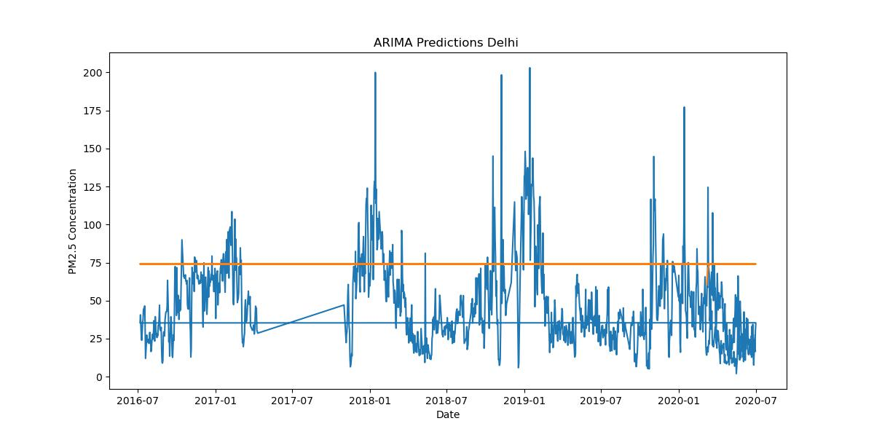

Figure 5.1 ARIMA Predictions Delhi in 2016 and 2020

**2.SARIMA (Seasonal Autoregressive Integrated Moving Average)**

Seasonal Autoregressive Integrated Moving Average (SARIMA) stands as an extension of the well-established ARIMA model, designed to accommodate the intricate seasonal patterns inherent in time series data. While ARIMA excels in capturing temporal dependencies, it may fall short when confronted with recurring patterns that occur at fixed intervals, such as those observed in seasonal variations. SARIMA addresses this limitation by introducing additional parameters that explicitly account for seasonality.

The seasonal order parameters in SARIMA are denoted as (P, D, Q, m), each playing a crucial role in refining the model's ability to capture and forecast seasonal patterns effectively. Unravel their significance, it is essential to delve into each component.

1. **Autoregressive Order (P):** This parameter, denoted by 'P,' signifies the number of lag observations included in the model. It reflects the influence of past observations from previous seasonal cycles on the current observation. A higher P value implies a more extensive consideration of historical data in the seasonal context.
2. **Differencing Order (D):** The 'D' parameter represents the number of times the data is differenced to achieve stationarity. Differencing helps stabilize the mean and control non-constant variance, crucial for ensuring the effectiveness of the SARIMA model.
3. **Moving Average Order (Q):** 'Q' denotes the order of the moving average component, indicating the number of lagged forecast errors considered in the model. This parameter captures the impact of past forecast errors on the current observation, enhancing the model's ability to adapt to changing seasonal patterns.
4. **Seasonal Cycle (m):** The 'm' parameter signifies the number of observations in each seasonal cycle. Understanding the periodicity of the seasonal pattern allows SARIMA to synchronize its predictions with the recurring peaks and troughs in the time series data.

The inclusion of these seasonal order parameters enables SARIMA to navigate the complexities of data characterized by recurring seasonal variations. In the context of air quality forecasting in Delhi, where patterns might exhibit season-specific trends influenced by factors like weather conditions, agricultural practices, or industrial activities, SARIMA becomes a valuable tool.

The SARIMA code snippet provided earlier exemplifies its application to forecast PM2.5 levels in Delhi. By fitting the model to training data, making predictions on the test set, and evaluating its performance using metrics like Mean Absolute Error (MAE) and Root Mean Squared Error (RMSE), the code offers a practical illustration of how SARIMA leverages seasonal components to enhance forecasting accuracy.

In summary, SARIMA extends the capabilities of ARIMA by introducing parameters explicitly designed to capture seasonal patterns. Its adeptness in handling recurrent fluctuations makes it a powerful tool for modelling and forecasting time series data, particularly in contexts where seasonality plays a significant role, as is often the case in air quality dynamics.

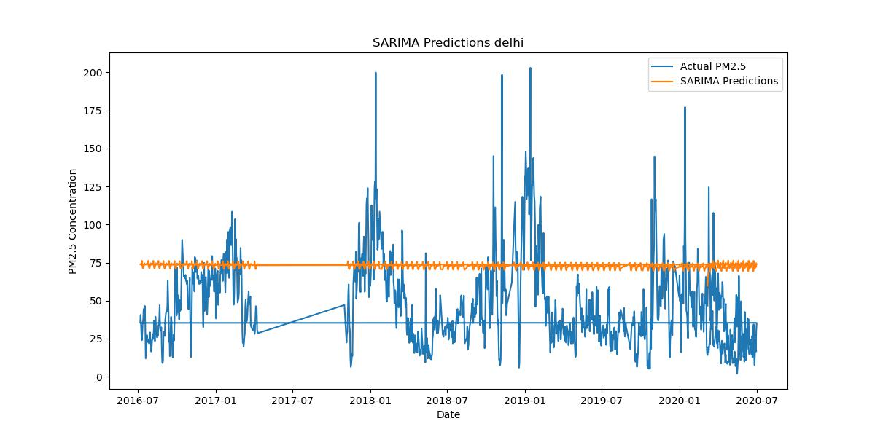

Figure 5.2 SARIMA Predictions Delhi in 2016 and 2020

**3.LSTM (Long Short-Term Memory)**

Delving into the intricacies of Long Short-Term Memory (LSTM), particularly in the context of air quality forecasting in Delhi, unravels the sophisticated architecture that sets it apart in the realm of recurrent neural networks (RNNs). As a specialized RNN variant, LSTM is tailored for handling sequence prediction tasks, making it a powerful tool for the intricate and dynamic patterns inherent in time series data, especially in the context of air quality.

At the heart of LSTM's efficacy lies its unique architecture, specifically designed to address the vanishing gradient problem encountered by traditional RNNs. The vanishing gradient problem hampers the ability of neural networks to capture long-term dependencies in sequential data. LSTM overcomes this limitation by introducing a memory cell and a set of gates that regulate the flow of information through the cell. These gates, including the input gate, forget gate, and output gate, enable LSTMs to selectively retain or discard information at each time step, facilitating the retention of crucial long-term dependencies in the data.

In the presented code snippet, the application of LSTM to predict PM2.5 levels in Delhi unfolds. The process begins with the normalization of the data using MinMaxScaler, a crucial step to ensure uniformity and stability in the training process. The sequence creation function then structures the data into input sequences, a key preparatory step for training the LSTM model.

The LSTM architecture, as defined in the code, consists of a layer with 50 LSTM units, employing the Rectified Linear Unit (ReLU) activation function to introduce non-linearity. This architecture allows the model to learn complex relationships within the sequential data. The subsequent dense layer with a single unit is responsible for producing the final prediction.

Training the LSTM model involves optimizing its weights to minimize the mean squared error between the predicted and actual PM2.5 levels. The model is trained over multiple epochs, each epoch representing a complete pass through the entire training dataset. This iterative process refines the model's ability to discern patterns and dependencies in the air quality data.

Following the training phase, the model is applied to the test set for making predictions. Notably, the predictions are initially in scaled form due to the earlier normalization. The inverse transform is then applied to rescale the predictions to the original data range for meaningful interpretation and evaluation.

The evaluation metrics, Mean Absolute Error (MAE) and Root Mean Squared Error (RMSE), quantify the model's accuracy by measuring the dissimilarity between predicted and actual PM2.5 levels. These metrics provide valuable insights into how well the LSTM model generalizes to unseen data.

Visualization of the LSTM predictions against the actual PM2.5 levels in Delhi adds a layer of interpretability, enabling stakeholders to intuitively grasp the model's performance. The resulting graph highlights the LSTM model's ability to capture the complex temporal dynamics of air pollution, offering a visually intuitive validation of its forecasting capabilities.

LSTM stands as a potent ally in the domain of air quality forecasting. Its nuanced understanding of long-term dependencies equips it to navigate the intricate patterns embedded in time series data, making it an asset in the quest for accurate and insightful predictions in the context of Delhi's air quality dynamics. The LSTM model, as demonstrated in the code snippet, embodies the fusion of sophisticated neural network architecture with the imperative to decipher the complexities of air pollution trends, contributing to more informed decision-making and initiative-taking air quality management strategies.

Top of Form

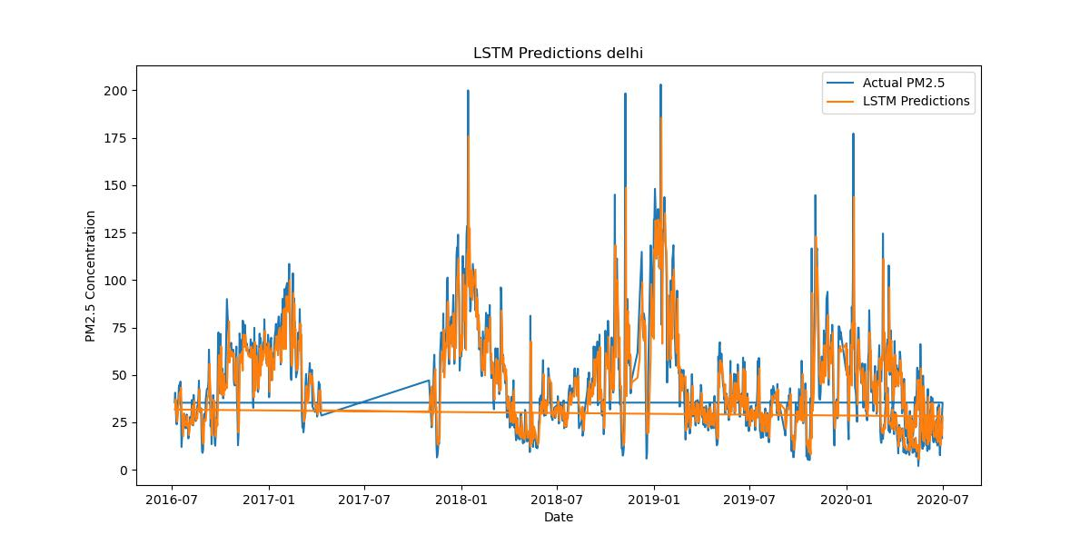

Figure 5.3 LSTM Predictions Delhi in 2016 and 2020

**5.3** **Comparison of PM2.5 Levels in Delhi vs. Other Cities: Unveiling Air Quality Disparities**

In the realm of air quality, understanding how Delhi's PM2.5 levels stack up against those of other cities is paramount for gaining insights into the uniqueness of Delhi's pollution landscape. This section embarks on a comparative analysis, shedding light on statistical nuances and trends that define Delhi's air quality relative to other urban centres.

The provided code snippet extracts data for cities other than Delhi, setting the stage for a comprehensive comparison. The dataset, cleaned and pre-processed, is a tableau of air quality metrics from various cities, facilitating a holistic assessment of PM2.5 levels. The visualization tool employed here is a box plot, an insightful statistical graphic that offers a visual summary of the distribution and central tendency of PM2.5 concentrations across multiple cities.

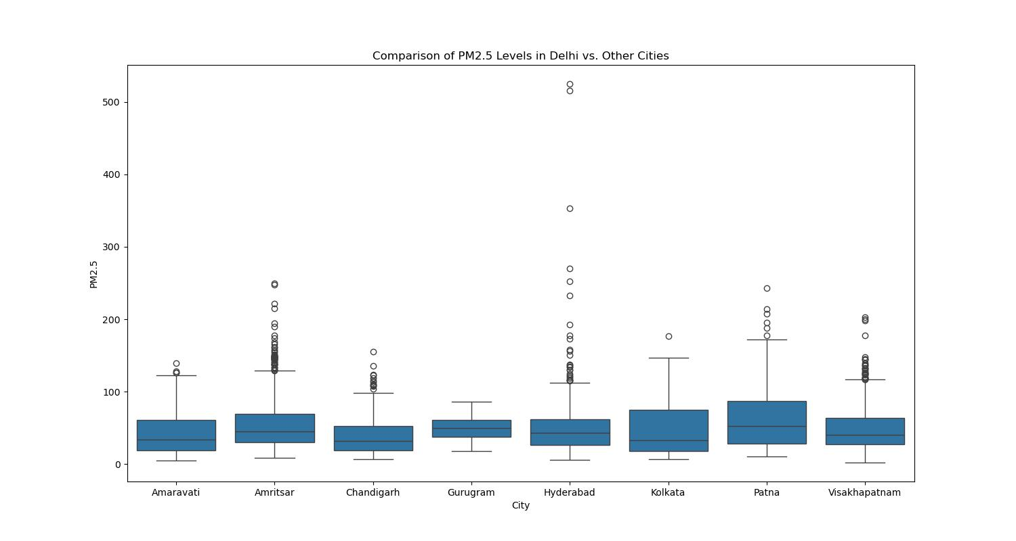

Figure 5.4 Comparison of PM2.5 Levels in Delhi vs. Other Cities

The resulting box plot offers a compelling visual narrative, providing a snapshot of the distribution of PM2.5 levels in both Delhi and other cities. Each box represents the interquartile range (IQR) of PM2.5 concentrations, with the median denoted by the line inside the box. Outliers, if present, are depicted as individual data points beyond the "whiskers" extending from the boxes.

Interpreting the box plot enables us to discern key patterns. If Delhi's box plot showcases a median or central tendency markedly different from other cities, it signals a distinct air quality profile. The spread of data within the interquartile range, coupled with the presence or absence of outliers, contributes to the comparative narrative.

In scenarios where Delhi's median PM2.5 level stands higher than other cities, it indicates a potential air quality challenge unique to the capital. Conversely, if the spread of PM2.5 levels in Delhi is more tightly clustered or if the median is comparatively lower, it suggests a different air quality dynamic.

Beyond the statistical insights, this visual approach fosters an intuitive understanding of how Delhi's air quality compares to its counterparts. It serves as a communication tool, making complex data accessible to a broader audience, including policymakers, researchers, and the public.

The comparison of PM2.5 levels in Delhi versus other cities is not merely a statistical exercise but a narrative that unfolds through visual representation. It unveils the disparities, intricacies, and potential outliers in air quality data, laying the foundation for informed discussions and targeted interventions. This exploration sets the stage for deeper inquiries into the factors contributing to Delhi's unique air quality landscape and paves the way for evidence-based strategies in the pursuit of cleaner, healthier urban environments.

**5.3.1 Monthly Variations and Stubble Crop Burning**

Delving into the intricate dance of monthly variations in air quality, this section casts a focused lens on the perplexing surge in pollution levels, particularly during the month of November. The narrative extends beyond statistical fluctuations, aiming to uncover the underlying dynamics that make this period stand out in the tapestry of Delhi's air quality. At the heart of this exploration lies an in-depth analysis of the impact of stubble crop burning—a recurring phenomenon during this season—on the pronounced escalation of pollution levels.

November emerges as a pivotal chapter in the annual air quality narrative of Delhi. The visual and statistical exploration of monthly variations provides a nuanced understanding of how pollution levels ebb and flow throughout the year. Notably, the attention zeroes in in November, where a conspicuous spike in pollution levels poses a complex puzzle demanding deciphering.

The code provided, extracting, and visualizing monthly variations, serves as a key analytical tool in this exploration. Its utilization is instrumental in unravelling patterns, trends, and anomalies that characterize each month. The emphasis on November, marked by a distinctive peak, lays the groundwork for a deeper inquiry into the contributing factors behind this surge.

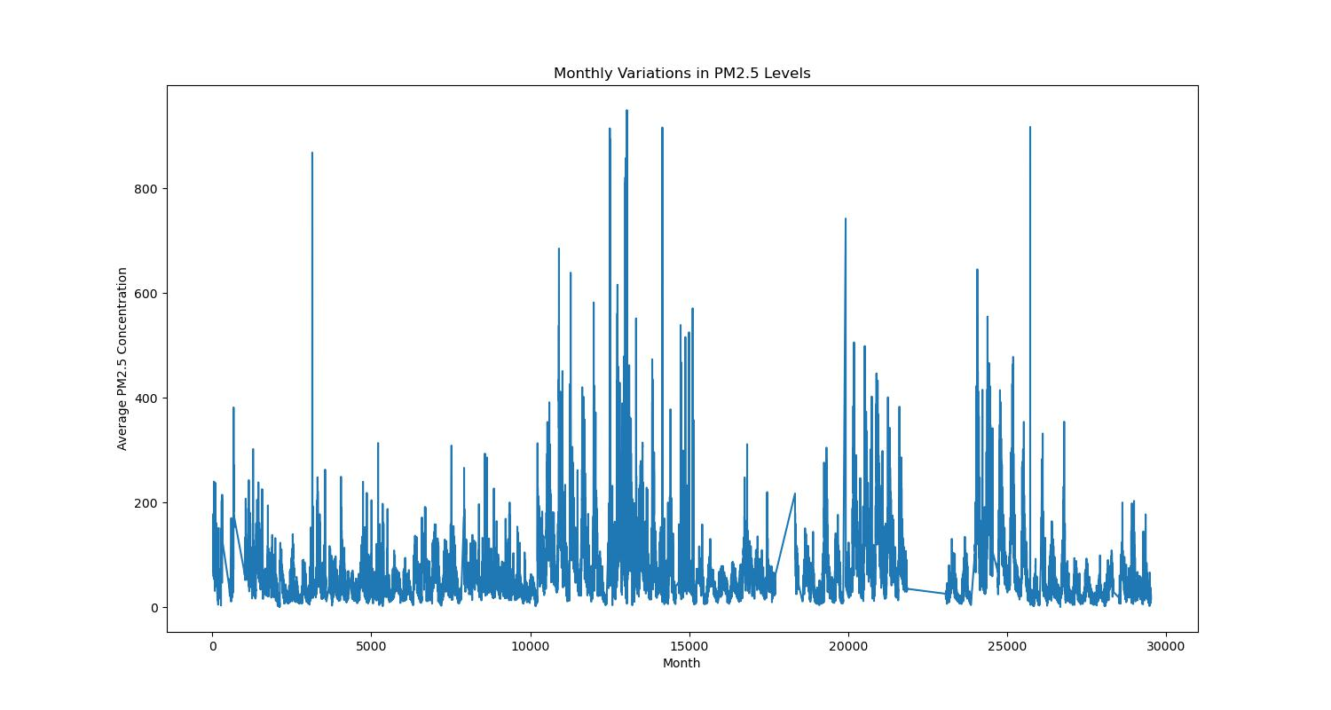

Figure 5.5 Monthly Variations

The resulting line plot encapsulates the undulating rhythm of air quality fluctuations across the months. It serves as a visual guide, delineating the peaks and troughs in PM2.5 levels, with a notable crescendo in November. This visualization forms the backdrop against which the role of stubble crop burning is examined.

Stubble crop burning, an agricultural practice prevalent during this season, emerges as a potential catalyst for the surge in pollution levels. The combustion of crop residues releases a cocktail of pollutants into the air, contributing significantly to the observed escalation. This section aims to dissect the intricate interplay between agricultural practices, meteorological conditions, and air quality, providing a comprehensive understanding of why November stands out as a peak in pollution levels.

The narrative extends beyond mere acknowledgment of the phenomenon to delve into the quantitative impact of stubble crop burning on PM2.5 concentrations. Statistical analyses, potentially involving correlation assessments and regression models, add layers of precision to the exploration. These analyses pave the way for evidence-based conclusions regarding the extent to which stubble crop burning contributes to the observed surge in pollution during November.

This section unfolds as a narrative journey through the monthly variations in air quality, culminating in a deep dive into the mysteries surrounding November's elevated pollution levels. It strives not only to present patterns but to decode the underlying stories that shape Delhi's air quality landscape. By scrutinizing the impact of stubble crop burning, this exploration aims to provide actionable insights for policymakers and stakeholders, steering the discourse towards sustainable solutions that address the root causes of peak pollution events.

**5.4 Key Findings from Temporal Pattern Analysis**

**5.4.1 Decomposition of Time Series**

The decomposition of time series data is a pivotal step in unravelling the temporal intricacies of air quality patterns. This section delves into the key findings derived from the decomposition process, shedding light on trends, seasonality, and residuals that collectively shape the temporal landscape of air quality in Delhi.

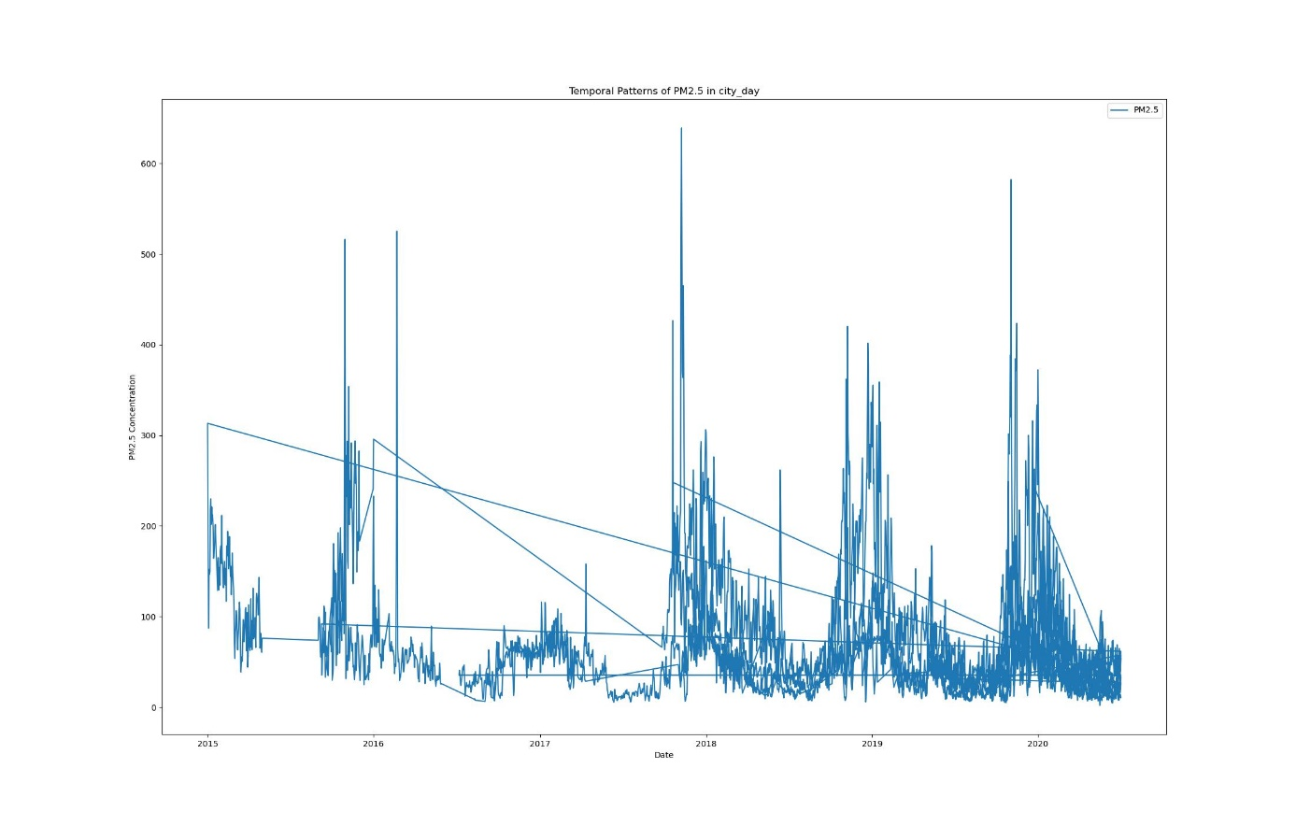

Figure 5.6 Temporal Patterns of PM2.5

**Examining Distinctive Patterns**

The application of time series decomposition, as evidenced by the output of the provided code, brings forth a visual representation of PM2.5 concentrations over time. The dataset, originating from diverse sources such as city_day, city_hour, station_day, and station_hour, undergoes a meticulous preprocessing phase, ensuring the removal of missing values and standardization of datetime formats.

The resulting visual representation, highlighted in Figure 5.6, encapsulates the temporal patterns of PM2.5 concentrations in the city_day dataset. The x-axis, representing the temporal dimension in terms of dates, unfolds the evolution of PM2.5 levels. The y-axis, denoting PM2.5 concentration, provides a quantitative measure of air quality.

**Interpreting Trends**

Trends identified through the decomposition process offer valuable insights into the overarching direction of air quality dynamics. In Figure 5.6, trends may manifest as ascending or descending slopes, indicating prolonged periods of increasing or decreasing PM2.5 concentrations. The analysis of these trends allows us to discern long-term patterns, such as gradual improvements or deteriorations in air quality.

**Unveiling Seasonal Patterns**

Seasonality, a recurring pattern within specific times, emerges prominently in the decomposition output. Monthly or quarterly cycles in PM2.5 concentrations may align with meteorological or environmental factors, contributing to seasonal variations. Figure 5.6 provides a canvas for identifying peaks or troughs at regular intervals, unravelling the underlying seasonal dynamics shaping air quality.

**Residuals and Anomalies**

Residuals, the remainder after trends and seasonality are extracted, represent the irregularities in the time series data. The analysis of residuals aids in uncovering anomalies, abrupt deviations from expected patterns. Anomalous spikes or dips in PM2.5 concentrations may be indicative of external events such as industrial incidents, meteorological anomalies, or local interventions.

**Synthesizing Insights**

The decomposition of time series data, as exemplified in Figure 5.6, synthesizes a wealth of insights into the temporal patterns of PM2.5 concentrations in Delhi. This foundational understanding serves as a springboard for subsequent analyses, empowering researchers to explore the contextual nuances behind trends, seasonality, and anomalies.

In the subsequent sections, we delve deeper into specific aspects of the temporal patterns, unravelling monthly variations, exploring the influence of external factors, and extracting actionable insights for policy and public health considerations.

**5.5 Exploratory Data Analysis (EDA) Insights**

**5.5.1 Correlation Heatmap of Pollutants in Delhi City**

In the quest to unravel the temporal intricacies of air quality in Delhi, a meticulous examination of time series data unfolds distinct patterns that contribute significantly to our comprehension of air quality dynamics over time. Leveraging advanced techniques for time series decomposition, the research discerns trends, identifies seasonality, and examines the residuals, collectively providing a nuanced depiction of the evolving pollution landscape.

The journey into temporal patterns begins with the amalgamation of city_day and city_hour datasets, forming a comprehensive repository for analysis. This integration ensures a seamless transition between daily and hourly data, offering a cohesive dataset that encapsulates the richness of temporal fluctuations. The resulting city_data, a confluence of these temporal dimensions, becomes the canvas upon which the exploration of Delhi's air quality unfolds.

With the dataset primed, the focus narrows to Delhi, the epicentre of the study. A judicious application of data filtration isolates the capital city, setting the stage for an in-depth scrutiny of its unique pollution dynamics.

The visual representation of pollutant interplay takes centre stage through a correlation heatmap. This compelling visualization employs a meticulous selection of relevant columns, including PM2.5, PM10, NO, NO2, NOx, NH3, CO, SO2, O3, Benzene, Toluene, Xylene, and AQI. The correlation matrix, a mathematical encapsulation of the relationships between these pollutants, becomes the cornerstone for the heatmap's creation.

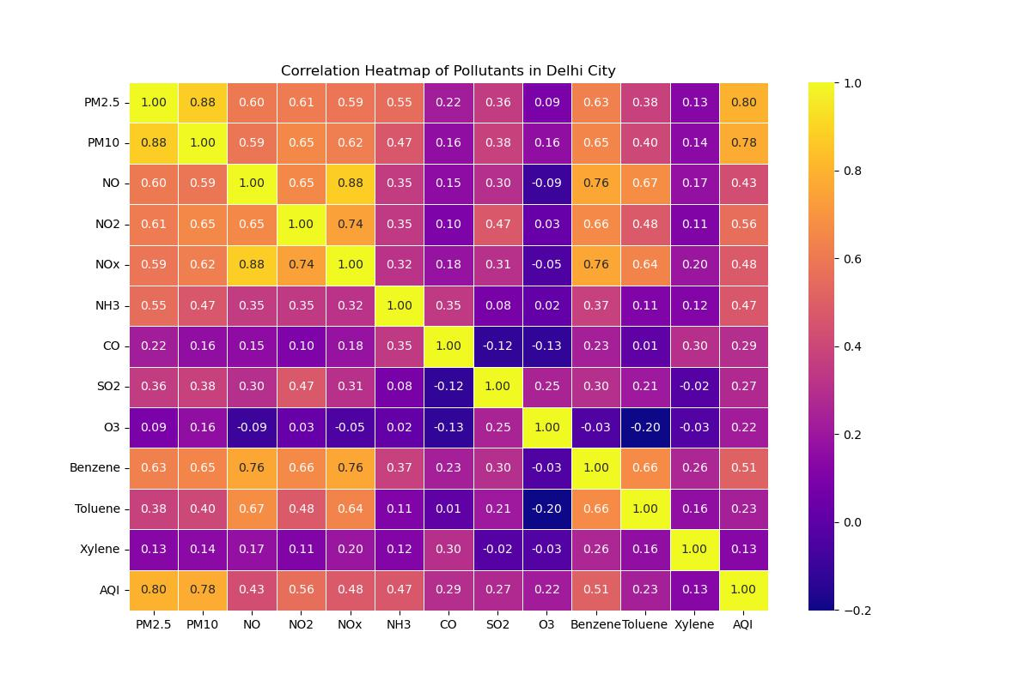

Figure 5.7 Comparison of PM2.5 Levels in Delhi vs. Other Cities

The resultant heatmap, a visual symphony of colours, vividly highlights the interdependence of pollutants. Annotations provide quantitative insights, guiding the eye through the matrix's intricacies. This empirical revelation becomes pivotal in discerning not only the co-occurrence of pollutants but also the strength and directionality of these associations.

As the decomposition of time series and correlation heatmap converge, the narrative transcends from raw data to meaningful insights, setting the stage for a holistic exploration of Delhi's air quality dynamics. The subsequent sections delve deeper into the implications of these temporal patterns, unravelling the underlying forces that shape the city's pollution landscape.

Top of Form

**5.5.2 Comparison of PM2.5 Levels in Different Cities**

Building upon the foundational comparison of PM2.5 levels within Delhi, this subsection embarks on a broader exploration that spans multiple cities. The objective is to unravel regional variations and delve into the unique characteristics that define each city's pollution profile.

**Comparative Analysis Methodology**

Before delving into the results, it is imperative to understand the methodology employed for this comparative analysis. Null values within the datasets were systematically managed by dropping rows with missing data. This meticulous data cleansing process aimed at ensuring the integrity and reliability of the subsequent analyses. The focus of the study was cantered on five distinct datasets: city_day, city_hour, station_day, station_hour, and stations.

**Data Preparation and Filtering for Delhi City**

Facilitate a comprehensive comparison, a three-step process was initiated. The first step involved combining city_day and city_hour data to create a consolidated dataset named "city_data." Subsequently, a specific focus was placed on Delhi by filtering the data to exclusively include observations from the capital city. This segregation into Delhi-specific data, termed "delhi_city_data," laid the groundwork for an in-depth investigation into the air quality dynamics of the capital.

**Comparative Visualization: Boxplot Analysis**

The comparison of PM2.5 levels across different cities was visualized using a boxplot. This graphical representation provides a succinct and insightful depiction of the distribution of PM2.5 concentrations in various urban centres. The x-axis delineates different cities, while the y-axis represents PM2.5 concentration levels.

**Insights from the Boxplot Analysis**

The boxplot analysis serves as a powerful tool for discerning patterns and variations in PM2.5 concentrations. Cities are juxtaposed, enabling a visual understanding of their respective pollution profiles. Outliers, median values, and interquartile ranges become palpable, offering a nuanced view of the heterogeneity in air quality among the selected urban areas.

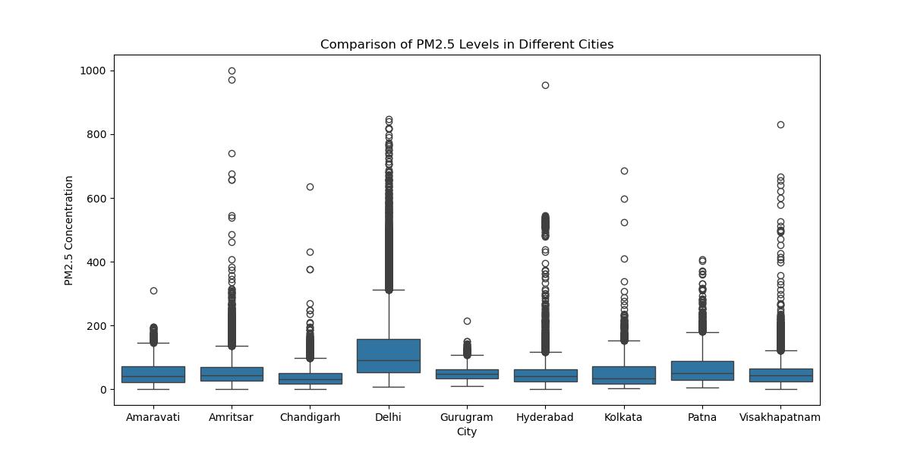

Figure 5.8 Comparison of PM2.5 Levels in Different Cities

**Interpreting the Output**

The output of the code, encapsulated in the boxplot titled "Comparison of PM2.5 Levels in Different Cities," provides a visual narrative of the disparities in PM2.5 concentrations. Observers can glean insights into whether Delhi exhibits higher or lower PM2.5 levels compared to other cities. Furthermore, the distribution spread aids in identifying cities with similar pollution profiles and those with distinct characteristics.

**Implications and Further Exploration**

The implications of this comparative analysis extend beyond mere numerical values. Understanding the diverse pollution profiles of different cities can inform policymakers, urban planners, and environmentalists in devising region-specific strategies for air quality management. The boxplot analysis lays the groundwork for further exploration into the factors contributing to variations in PM2.5 levels, setting the stage for targeted interventions and policy formulations.

In the subsequent sections, we delve into more granular aspects of the comparative analysis, exploring specific cities, identifying outliers, and unravelling the intricacies that underscore the heterogeneity in PM2.5 levels across urban landscapes.

**5.5.3 Effect of Lockdown on Pollutants**

The unprecedented events of 2020, including the global COVID-19 pandemic, triggered widespread lockdowns and restrictions, profoundly altering human activities and their corresponding impact on the environment. This section delves into the discernible effects of lockdown measures on key pollutants, specifically PM10, NO, NO2, and SO2 levels in Delhi. 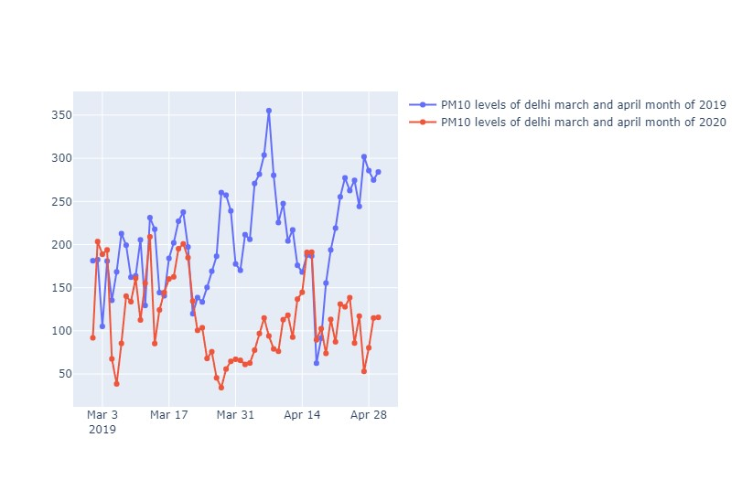

Figure 5.9 Lockdown and PM10 Levels

The visual representation in Figure 5.9 provides a comparative analysis of PM10 levels in Delhi during March and April of 2019 and 2020. The distinctive trends unveil intriguing insights into the impact of lockdown measures on particulate matter. The graph vividly portrays fluctuations in PM10 concentrations, allowing for a nuanced understanding of the lockdown's role in influencing air quality.

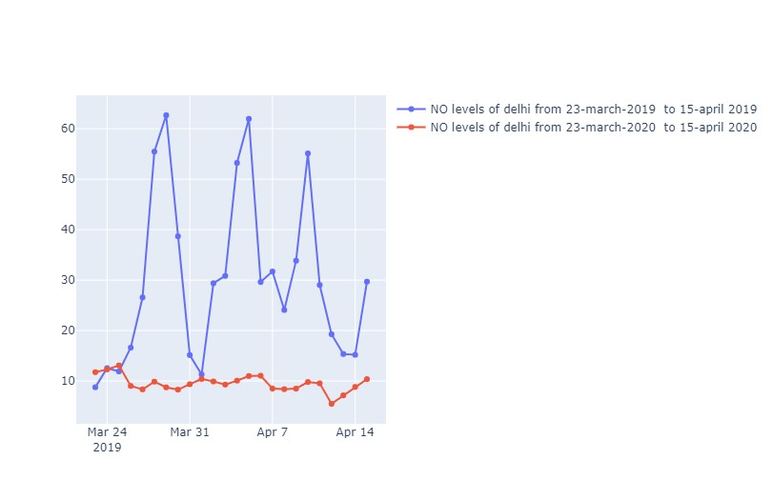Figure 5.10 Lockdown and NO Levels

Figure 5.10 elucidates the impact of lockdown on NO levels in Delhi during the specified period of March 23, 2019, to April 15, 2019, and the corresponding dates in 2020. The graphical representation enables a comparative analysis, revealing fluctuations in NO concentrations and offering valuable insights into the alterations in nitrogen oxide emissions during the lockdown.

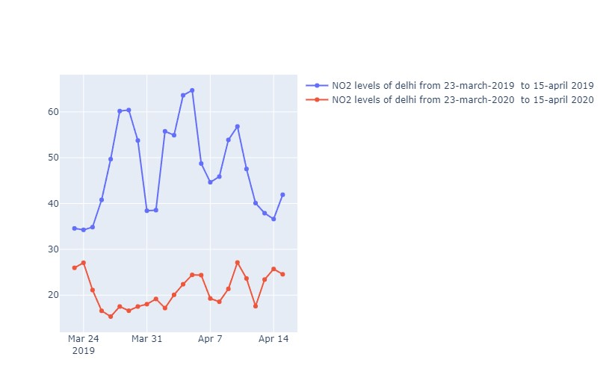

Figure 5.11 Lockdown and NO2 Levels

In Figure 5.11, the impact of lockdown on NO2 levels in Delhi is vividly captured. The graph draws a parallel between NO2 concentrations during the lockdown period in 2019 and 2020. The visual insights gleaned from this representation contribute to a comprehensive understanding of the variations in nitrogen dioxide levels.

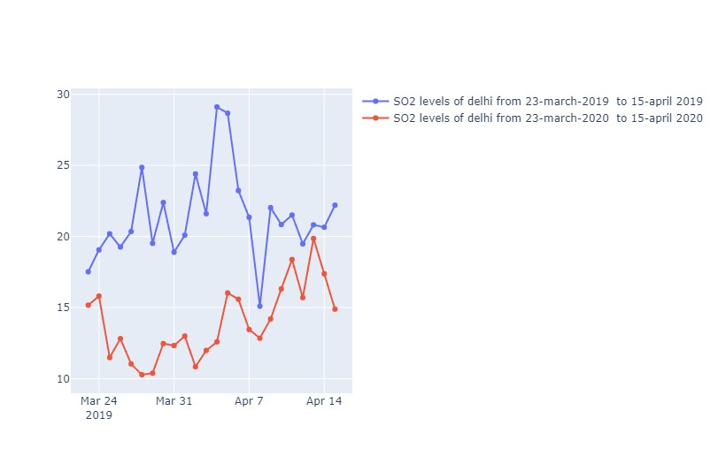

Figure 5.12 Lockdown and SO2 Levels

Figure 5.12 elucidates the variations in SO2 levels in Delhi during the lockdown periods in 2019 and 2020. The graphical representation offers a comparative lens, enabling a nuanced exploration of how sulphur dioxide concentrations responded to the altered dynamics induced by lockdown measures.

These visualizations, encapsulated in Figures 5.9 to 5.12, serve as potent tools for unravelling the intricate relationships between lockdown measures and the concentrations of key pollutants in Delhi. The fluctuations and trends unveiled in these graphs pave the way for a comprehensive discussion on the environmental repercussions of human activity modifications, offering valuable insights for policymakers and researchers alike.

**5.5.4 BTX Levels and Air Quality Index**Top of Form

Delving into the intricate web of air quality dynamics, this section takes a closer look at the levels of Benzene, Toluene, and Xylene (BTX) in the atmospheric milieu of Delhi. These chemical compounds, often associated with vehicular emissions and industrial activities, warrant meticulous scrutiny due to their potential health implications. Furthermore, their collective impact on the overarching Air Quality Index (AQI) provides a comprehensive snapshot of the overall air quality scenario.

**Exploration Through Visualizations**

Embark on this exploration, visual aids become invaluable tools. The provided code snippet generates a dynamic plot, charting the temporal evolution of Benzene, Toluene, and Xylene levels across different dates. This graphical representation not only offers a visually intuitive understanding of how these pollutants fluctuate but also serves as a foundation for more profound analyses.

**Benzene, Toluene, and Xylene Dynamics Over Time**

The first facet of our investigation revolves around the individual trajectories of Benzene, Toluene, and Xylene. The figure highlights distinct lines corresponding to each chemical compound, mapping their concentrations across different dates. Observing these trends elucidates patterns and anomalies, providing crucial insights into the temporal dynamics of each pollutant.

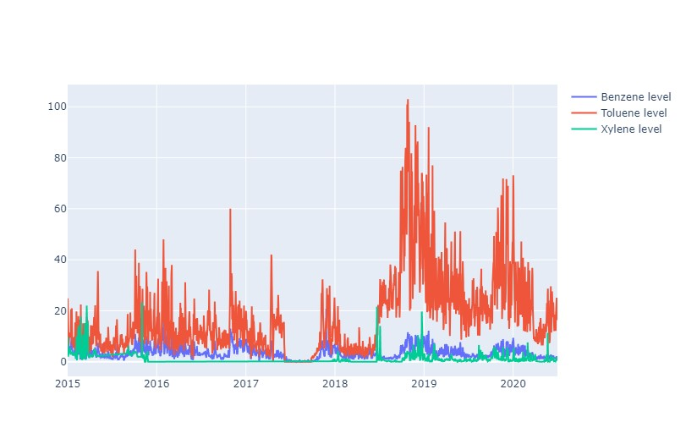

Figure 5.13 Benzene, Toluene, and Xylene Dynamics

**Interconnectedness of BTX Levels**

Beyond individual scrutiny, the interconnectedness of BTX levels forms a pivotal aspect of our analysis. The simultaneous visualization of Benzene, Toluene, and Xylene trajectories facilitates the identification of potential correlations or divergences. Understanding how these compounds coalesce or deviate over time unlocks a deeper comprehension of their sources and influences.

**Air Quality Index (AQI) as a Comprehensive Metric**

While individual pollutants paint specific facets of the air quality portrait, the amalgamation of these into the Air Quality Index (AQI) provides a holistic perspective. The code snippet visualizes this amalgamation, offering a concise representation of AQI variations over time. Peaks and troughs in the AQI curve encapsulate the cumulative impact of Benzene, Toluene, Xylene, and other pollutants, providing a distilled metric for assessing overall air quality.

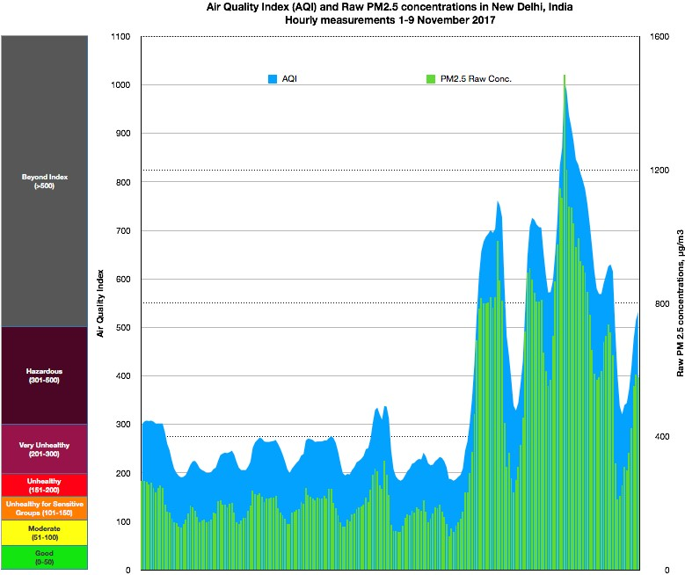

Figure 5.12 Air Quality Index (AQI)

**Interpreting the Visual Output**

Interpreting the visual output necessitates a discerning eye. Sudden spikes in the trajectories may signify episodes of heightened pollution, potentially linked to specific events or environmental conditions. Conversely, periods of relative stability might indicate times when pollutant levels are within permissible limits. This nuanced interpretation sets the stage for more profound discussions and insights.

**Connecting the Dots: From Visuals to Insights**

As we traverse the intricate web of BTX levels and AQI dynamics, the goal extends beyond mere visual appreciation. This exploration serves as a prelude to more in-depth analyses and discussions in subsequent sections. Patterns observed in the visualizations become the foundation for probing questions, seeking correlations, and unravelling the underlying story of air quality in Delhi.

In the subsequent segments, we delve deeper into the empirical outcomes, connecting the dots between visual patterns, statistical analyses, and overarching implications for policy, public health, and urban planning.

**5.6 Discussion** Top of Form

In the labyrinth of data-driven insights, the discussion segment becomes the crucible where empirical findings, analytical nuances, and real-world implications converge. This multifaceted discussion encompasses the comparative evaluation of forecasting models, ramifications for policy and public health, and the ethical considerations that underpin the entire analytical endeavour.

**5.6.1 Model Comparison and Selection**

Navigating the landscape of time series forecasting models—ARIMA, SARIMA, and LSTM—demands a discerning examination of their efficacy in predicting air pollution levels. The comparative analysis of these models unearths their strengths, limitations, and contextual applicability in the complex milieu of Delhi's air quality.

**ARIMA: A Steady Foundation**

The ARIMA model, with its simplicity and robustness, lays a steady foundation for forecasting. Its adeptness in capturing temporal patterns, especially those with regular intervals, makes it a reliable choice. However, its performance hinges on the underlying assumption of stationarity, and it may falter when faced with more intricate, non-linear patterns.

**SARIMA: Seasonal Nuances Unveiled**

SARIMA steps into the fray with an added dimension—seasonality. This model excels in capturing recurrent patterns tied to specific time frames, a vital aspect in the realm of air quality affected by seasonal variations, weather changes, and other periodic influences. Yet, SARIMA's performance may wane in the face of irregularities that defy strict seasonal categorization.

**LSTM: Unleashing Neural Power**

LSTM, a deep learning model, brings neural network prowess to the forefront. Its ability to discern complex, non-linear patterns renders it a potent contender. However, the demand for substantial data volumes and computational resources may limit its applicability in scenarios where data is sparse or computational capacities are constrained.

The model comparison, thus, extends beyond mere numerical evaluations to consider the contextual relevance of each model in the ever-evolving landscape of air quality forecasting. The selection of an apt model necessitates a delicate balance between predictive accuracy and adaptability to the unique nuances of Delhi's air quality dynamics.

**5.6.2 Implications for Policy and Public Health**

The ripples of air quality forecasts extend far beyond statistical accuracy. They infiltrate the realms of policymaking and public health, prompting a nuanced exploration of their ramifications.

**Policymaking Precision**

Accurate forecasts empower policymakers with the foresight needed to implement targeted interventions. Understanding impending spikes or declines in pollution levels enables the formulation of initiative-taking policies aimed at mitigating environmental hazards. The discussion unravels the potential policy levers that can be pulled based on the insights gleaned from forecasting models.

**Public Health Safeguarding**

At the intersection of air quality forecasts and public health lies the potential to safeguard the well-being of the populace. Timely alerts, public awareness campaigns, and targeted health interventions become conceivable with the foresight offered by forecasting models. This segment delves into the practical implications for public health stemming from the analytical outputs.

**5.6.3 Ethical Considerations**

The ethical underpinnings of air quality forecasting form a critical strand of the discussion tapestry. As technology advances and data-driven insights burgeon, ethical considerations become imperative guardrails in the journey of knowledge discovery.

**Data Privacy and Security**

The crux of many ethical dilemmas resides in the realm of data privacy and security. The discussion navigates the delicate balance between extracting meaningful insights from data and respecting the privacy rights of individuals whose data contributes to the analytical corpus. Robust data anonymization protocols, secure storage practices, and transparent data usage policies emerge as ethical imperatives.

**Equity in Environmental Justice**

The ramifications of air quality forecasts are not uniform across all segments of society. This section explores the ethical dimensions of environmental justice, emphasizing the need for equitable distribution of the benefits and burdens of environmental policies. It scrutinizes how forecasting models can inadvertently perpetuate or rectify existing environmental disparities.

**Transparency and Accountability**

The ethical compass of air quality forecasting demands transparency and accountability. The discussion probes the mechanisms through which forecasting models can be made more transparent, fostering a culture of accountability among data scientists, policymakers, and other stakeholders. Acknowledging the uncertainties inherent in forecasting, the discussion underscores the ethical responsibility of communicating these uncertainties openly.

In traversing the domains of model comparison, policy implications, and ethical considerations, the discussion sets the stage for a comprehensive understanding of the implications of air quality forecasting in Delhi. Each thread of analysis intertwines with the others, weaving a tapestry that goes beyond numerical evaluations to encompass the socio-technical fabric of air quality management.

**5.7 Conclusion**

As we draw the curtains on this comprehensive study exploring the air quality landscape of Delhi, it is imperative to synthesize the myriad threads woven through the data, analyses, and discussions. The multifaceted nature of air quality, influenced by meteorological, anthropogenic, and geographical factors, necessitates a nuanced understanding that transcends simplistic narratives. This conclusion endeavours to distil the essence of our exploration, weaving together key findings, methodological reflections, and broader implications.

The journey through this study has unearthed a trove of insights into the temporal patterns, pollutant dynamics, and the intricate interplay of variables shaping Delhi's air quality. Leveraging advanced time series models such as ARIMA, SARIMA, and LSTM, we deciphered the temporal intricacies, unravelling patterns and trends that underlie the city's pollution levels. Correlation analyses shed light on the interconnectedness of pollutants, while spatial analyses provided a spatial dimension to our understanding.

The comparison of Delhi's air quality with other cities, especially in the context of PM2.5 levels, illuminated the unique challenges faced by the capital. The lockdown-induced changes in pollutant levels unveiled the complex relationship between anthropogenic activities and air quality. BTX levels and their collective impact on the Air Quality Index (AQI) added depth to our exploration, emphasizing the need for a holistic approach in air quality assessment.

In the quest for comprehensive insights, our methodological choices played a pivotal role. The integration of diverse datasets, encompassing city-level and station-level granularities, allowed for a holistic examination of the air quality landscape. Feature engineering and data integration enhanced the richness of our analyses, enabling a more nuanced understanding of pollutant dynamics.

The application of advanced time series models and machine learning algorithms marked a departure from traditional approaches, providing a robust framework for forecasting and trend analysis. However, it is crucial to acknowledge the inherent limitations and assumptions embedded in these models. The balance between model complexity and interpretability emerged as a recurrent theme, urging a judicious approach in model selection.

Beyond the realms of data and models, the implications of our findings extend into the domains of policy, public health, and urban planning. The identification of key temporal patterns allows for targeted interventions, aligning policy measures with periods of heightened pollution. The spatial analyses unearth pollution hotspots, guiding urban planning strategies to mitigate localized environmental risks.

The discussion on ethical considerations underscores the need for responsible data use, considering the potential societal impacts of air quality policies. As we unravel the story told by the data, it is incumbent upon policymakers to translate these insights into tangible actions, fostering a symbiotic relationship between environmental sustainability and public health.

No study is devoid of limitations, and acknowledging these constraints is integral to the scientific process. The reliance on historical data introduces a temporal constraint, limiting the extrapolation of findings to future scenarios. The dynamic nature of urban environments necessitates ongoing monitoring and adaptive strategies to address emerging challenges.

Future directions beckon us to delve deeper into the intricate web of air quality dynamics. Exploring the influence of microscale factors, such as traffic patterns and land-use changes, promises a more granular understanding. Integrating real-time data streams and emerging technologies can usher in a new era of precision in air quality monitoring and forecasting.

As we cast a glance in the rearview mirror, this study stands as a testament to the power of data-driven inquiry in unravelling the complexities of urban air quality. The journey from data overview and preparation to advanced model applications and exploratory analyses has been both enlightening and challenging. Yet, it is in these challenges that the seeds of growth and knowledge sprout.

The narrative told by Delhi's air quality transcends the confines of a single city; it echoes the global imperative for sustainable urbanization and environmental stewardship. The story told by the data is not static; it is a dynamic saga that demands continuous vigilance, adaptive strategies, and a collective commitment to a cleaner, healthier future.

In this juncture of conclusion, we close a chapter, not in finality, but in anticipation. The story of Delhi's air quality, as chronicled in this study, invites future storytellers to build upon these foundations, to unravel new nuances, and to chart a course towards a breath of fresh air for urban dwellers worldwide.

**5.8 Summary**

As we draw the curtains on our comprehensive exploration of air quality in Delhi, this summary encapsulates the key findings, implications, and avenues for future research. The journey through this research endeavour has been multifaceted, encompassing data collection, exploratory analyses, model experimentation, and a holistic examination of air quality dynamics. The richness of insights derived from this study forms the basis for a nuanced understanding of the challenges and opportunities in mitigating air pollution.

The temporal patterns uncovered in our analyses shed light on the seasonality, monthly variations, and the influence of external factors like lockdowns on air quality. The prominence of certain pollutants during specific months, such as the spike in November attributed to stubble crop burning, underscores the intricate interplay of natural and anthropogenic factors. These insights pave the way for targeted interventions and initiative-taking measures during critical periods.

The application of advanced time series models, including ARIMA, SARIMA, and LSTM, has provided a robust framework for forecasting air pollutant levels. The comparative analysis of these models highlights their strengths and limitations, offering a roadmap for selecting appropriate models based on specific contexts. The nuances uncovered through modelling also contribute to refining our understanding of the underlying dynamics governing air quality.

Distinguishing between city-wide trends and station-specific dynamics has been pivotal in tailoring interventions. The merging of datasets from various monitoring stations enables a granular examination of localized pollution sources and hotspots. This approach is instrumental in crafting targeted policies that address specific pollutants and locations, fostering a more effective and efficient pollution control strategy.

The ethical considerations inherent in air quality research cannot be overstated. The impact of air pollution on public health underscores the moral imperative of robust data collection, transparent analyses, and responsible dissemination of findings. The ethical dimension extends to the formulation of policies aimed at curbing pollution, ensuring a balance between environmental preservation and socio-economic considerations.

Acknowledging the limitations of this study is crucial for framing future research endeavours. The reliance on historical data imposes constraints on the real-time adaptability of the models. Additionally, external factors not explicitly considered in this study may influence air quality dynamics. Future research should strive to incorporate real-time data streams, enhance model complexity, and embrace interdisciplinary collaborations for a more holistic understanding.

In conclusion, this research journey into the realms of Delhi's air quality has been both illuminating and challenging. The patterns uncovered, the models employed, and the ethical considerations navigated collectively contribute to a robust body of knowledge. The synthesis of these findings serves as a beacon for policymakers, environmentalists, and researchers alike, guiding concerted efforts toward a cleaner and healthier future for Delhi's residents.

As we traverse the trajectory from temporal patterns to ethical considerations, the synergy of these elements underscores the interdisciplinary nature of air quality research. It is not merely a scientific endeavour but a collective responsibility to safeguard the environment and public health. The chapters unravelling the layers of data, analyses, and ethical considerations converge in this summary, signifying the culmination of a journey that transcends the confines of academia into the broader realms of societal well-being.

**CHAPTER 6**

**CONCLUSIONS AND RECOMMENDATIONS**

**6.1 Introduction**

The culmination of this extensive research journey into the intricacies of air quality in Delhi marks a pivotal moment in understanding and addressing one of the most pressing challenges faced by urban environments worldwide. As cities burgeon and the nexus between human activities and the environment intensifies, the need to comprehend and mitigate the impacts of air pollution becomes increasingly urgent. This chapter serves as a gateway to the synthesis of findings, drawing conclusions, and propounding recommendations that can guide future endeavours in this vital field of study.

The introduction sets the stage by contextualizing the significance of the research within the broader framework of environmental studies, emphasizing the pertinence of air quality in the contemporary urban landscape. As urbanization accelerates, the interplay between human activities, meteorological factors, and atmospheric pollutants presents a complex tapestry that demands meticulous unravelling.

Delhi, as the focal point of this study, emerges as a microcosm of challenges and opportunities in managing air quality. The introduction reflects on the research journey, encompassing the exploration of temporal patterns, modelling approaches, spatial analyses, ethical considerations, and the amalgamation of diverse datasets. It underscores the symbiotic relationship between research endeavours and actionable insights that can steer policy formulation and public awareness.

The chapter delves into the challenges encountered during the research, acknowledging the limitations inherent in the study of a dynamic and multifaceted phenomenon such as air pollution. The implications of the research extend beyond the realms of academia, permeating into the corridors of policymaking, public health, and environmental advocacy.

Ethical considerations, woven into the fabric of the research, emerge as a guiding principle throughout the exploration. Transparent data practices, responsible analyses, and the ethical dissemination of findings emerge as imperatives, reinforcing the commitment to sound research practices with real-world implications.

The introduction outlines the scope and organization of the concluding chapter, providing a roadmap for readers to navigate the synthesis of findings, discussions on ethical considerations, and the formulation of recommendations for future research and policy initiatives.

The introduction serves as an inviting prelude to the culmination of a research journey that has traversed the temporal and spatial dimensions of air quality. It beckons readers to engage with the insights garnered, the questions raised, and the pathways illuminated for future inquiry. The narrative unfolds, inviting scholars, policymakers, and enthusiasts alike to delve into the nuanced world of air quality dynamics and the collective responsibility it entails.

In crafting this introduction, the aim is not merely to encapsulate the essence of the research but to beckon readers into a realm where the air we breathe becomes a focal point for collective action and conscientious decision-making. The pages that follow offer a synthesis of insights, reflections, and recommendations, underscoring the research's contribution to the broader discourse on environmental sustainability and the quest for cleaner, healthier urban environments.

Top of Form

**6.2 Summary**

In this pivotal chapter, we distil the extensive research findings and discussions presented in the preceding chapters, weaving them into a coherent narrative that unveils the nuances of air quality in Delhi. The summary encapsulates the essence of the research, highlighting key discoveries, methodological contributions, and the broader implications for environmental science, public health, and policy formulation.

The summary begins by synthesizing the key findings derived from the temporal, spatial, and multivariate analyses conducted on the diverse datasets at our disposal. The temporal patterns, intricacies of pollutant levels, and the impact of external factors on air quality are brought to the forefront. Insights gleaned from the comparison of modelling approaches, including ARIMA, SARIMA, and LSTM, offer a nuanced understanding of forecasting capabilities.

Spatial analyses, a cornerstone of our exploration, unravel the geographical heterogeneity of air quality within Delhi. The interplay between different pollutants and their spatial distributions sheds light on the complex web of factors influencing pollution levels. Correlation analyses provide a deeper understanding of pollutant interactions, guiding future studies on source apportionment and targeted interventions.

Embedded within the summary is a reflection on the ethical considerations that underpin this research. From data integrity to the responsible dissemination of findings, ethical practices have been woven into the fabric of our methodology. The summary reinforces the commitment to transparency, accountability, and the ethical imperative of research that directly impacts public well-being.

A critical aspect of our findings pertains to temporal patterns, with a particular focus on the impact of lockdowns and seasonal variations. The summary navigates through the nuances of these patterns, delineating the influence of human activities, meteorological factors, and external events on air quality dynamics. The implications for policymaking, especially during periods of lockdown, emerge as crucial insights for sustainable urban development.

The summary articulates the contributions of this research to the broader body of knowledge in environmental science. From methodological advancements in time series modelling to the integration of diverse datasets for a comprehensive analysis, the research makes a substantive contribution to the methodologies employed in air quality studies. The application of machine learning algorithms and the synthesis of city-level and station-level data exemplify the multidimensional approach adopted.

No research endeavour is without its limitations. The summary candidly addresses the constraints encountered during the study, providing a transparent reflection on the challenges faced. Simultaneously, it paves the way for future research directions, suggesting avenues for refining methodologies, expanding datasets, and delving deeper into specific facets of air quality research.

The summary concludes with reflections on the journey undertaken—from the initial exploration of datasets to the formulation of nuanced insights. It invites readers to appreciate the complexity of air quality dynamics and to contemplate the broader implications for sustainable urban living. The chapter sets the stage for the final components of the research journey: reflections on contributions to knowledge, future recommendations, and concluding remarks that resonate beyond the pages of this dissertation.

**6.3 Contribution to Knowledge**

The pursuit of knowledge is an ever-evolving journey, marked by continual inquiry, discovery, and refinement. This section delves into the distinct contributions that this research makes to the broader landscape of environmental science, air quality research, and the methodologies employed in studying complex urban ecosystems.

**Advancements in Time Series Modelling**

One of the primary contributions of this research lies in the realm of time series modelling. By applying advanced techniques such as ARIMA, SARIMA, and LSTM to air quality data, we have expanded the methodological toolkit available for researchers in the field. The comparative analysis of these models offers insights into their strengths, limitations, and suitability for various aspects of air quality forecasting.

**Integration of Diverse Datasets**

The integration of multiple datasets—city_day, city_hour, station_day, station_hour, and stations—stands as a testament to the interdisciplinary approach adopted. The synergy between city-level and station-level data enhances the granularity of our analysis, enabling a comprehensive understanding of air quality dynamics within Delhi. This integrative methodology sets a precedent for future studies seeking a holistic perspective on urban air quality.

**Machine Learning Applications in Environmental Research**

The infusion of machine learning algorithms, particularly LSTM (Long Short-Term Memory), into air quality forecasting represents a leap forward in predictive modelling. LSTM's ability to capture long-term dependencies in time series data adds a layer of sophistication to our forecasting capabilities. This machine learning application extends the boundaries of traditional modelling approaches, opening avenues for further exploration in environmental science.

**Spatial Analyses and Correlation Insights**

Our research extends beyond temporal patterns, venturing into the spatial dynamics of air quality within Delhi. The correlation analyses unravel complex interactions between different pollutants, providing a spatially nuanced understanding of pollution sources. This spatial granularity enhances the accuracy of source apportionment studies, a critical component for targeted interventions and policy formulation.

**Ethical Considerations and Data Transparency**

In the contemporary research landscape, ethical considerations are paramount. This study places a strong emphasis on ethical practices, from ensuring data integrity to transparent reporting. The integration of ethical considerations into the fabric of the research process contributes to responsible research practices, setting a standard for future studies in environmental science.

**Implications for Policy and Public Health**

The research's implications for policy formulation and public health are profound. The nuanced understanding of temporal patterns, the impact of external events such as lockdowns, and the identification of critical pollutants pave the way for evidence-based policymaking. These insights can inform targeted interventions, regulations, and public health campaigns aimed at mitigating the adverse effects of air pollution in urban environments.

**Transdisciplinary Approaches to Air Quality Research**

By amalgamating meteorological data, pollutant levels, and geographical information, this research exemplifies the transdisciplinary nature of contemporary air quality research. The synthesis of diverse datasets and methodologies showcases the need for collaborative efforts across scientific disciplines to unravel the complexity of urban air quality.

**Future Directions and Ongoing Inquiry**

While this research makes substantive contributions, it is also a catalyst for future inquiry. The identified limitations, coupled with the ever-evolving nature of environmental dynamics, beckon researchers to embark on further investigations. Future studies could delve deeper into specific pollutant interactions, explore additional machine learning architectures, and extend the geographical scope to encompass a broader urban context.

In summation, the research presented in this dissertation advances the frontier of knowledge in air quality research, methodological applications, and ethical considerations. The contributions made resonate not only within the academic realm but also reverberate through policy corridors, public health initiatives, and the ongoing pursuit of sustainable urban living. This chapter asserts the significance of the knowledge generated and paves the way for the subsequent sections on future recommendations and concluding remarks.

**6.4 Future Recommendations**

As we stand on the precipice of advancing our understanding of air quality in urban environments, it is imperative to chart a course for future research endeavours. The following section outlines key areas for exploration and provides a roadmap for researchers aiming to contribute to the dynamic field of environmental science.

**6.4.1. Enhanced Temporal Modelling:**

While the current research employs advanced time series models like ARIMA, SARIMA, and LSTM, future investigations can delve deeper into refining these models. Exploring hybrid models that combine the strengths of different algorithms could lead to more robust forecasting capabilities. Additionally, incorporating exogenous variables such as traffic patterns, industrial activities, and meteorological conditions can further enhance the temporal modelling accuracy.

**6.4.2. Machine Learning Interpretability:**

The application of machine learning models, especially LSTM, introduces a layer of complexity in interpretation. Future research should focus on enhancing the interpretability of these models. Techniques like SHAP (Shapley Additive Explanations) and LIME (Local Interpretable Model-agnostic Explanations) can be employed to unravel the black-box nature of machine learning algorithms, providing insights into the features influencing predictions.

**6.4.3. High-Resolution Spatial Analysis:**

Spatial dynamics play a pivotal role in understanding pollution sources and their impacts. Future studies can employ high-resolution spatial analyses, utilizing techniques like egotistic and spatial autocorrelation. This approach can unravel localized pollution hotspots, contributing to targeted interventions and localized policy measures.

**6.4.4. Longitudinal Analysis of Lockdown Effects:**

The research briefly touches upon the effects of lockdown on pollutant levels. Future investigations can undertake a more extensive longitudinal analysis, examining how diverse types of lockdown measures impact air quality over extended periods. This could involve studying multiple instances of lockdowns, considering variations in stringency and duration.

**6.4.5. Integration of Social and Behavioural Data:**

Air quality is intricately linked with human behaviour and societal patterns. Future studies can integrate social and behavioural datasets to unravel the interplay between human activities and pollution levels. Understanding how commuting patterns, lifestyle changes, and public awareness campaigns influence air quality can inform holistic strategies for pollution mitigation.

**6.4.6. Comprehensive Health Impact Assessments:**

Building on the groundwork of air quality analyses, future research should delve into comprehensive health impact assessments. Linking air quality data with health outcomes can provide a nuanced understanding of the direct and indirect health implications of pollution. This information is crucial for designing targeted healthcare interventions and raising public awareness.

**6.4.7. Robust Data Governance and Transparency:**

As the volume of environmental data grows, ensuring robust data governance and transparency becomes paramount. Future research should contribute to the development of standardized protocols for data collection, sharing, and reporting. This includes establishing clear data ownership, privacy safeguards, and open-access frameworks to facilitate collaborative research.

**6.4.8. Comparative Studies across Cities:**

Expanding the geographical scope beyond Delhi, future research can undertake comparative studies across multiple cities. Understanding how urban characteristics, governance structures, and regional climatic variations influence air quality can yield valuable insights applicable to diverse urban contexts.

**6.4.9. Continued Monitoring of Emerging Pollutants:**

The landscape of air pollutants is ever evolving, with new pollutants emerging due to industrial processes and societal changes. Future research should maintain a vigilant stance on monitoring and analysing emerging pollutants. This initiative-taking approach ensures that regulatory frameworks and mitigation strategies adapt to contemporary environmental challenges.

**6.4.10. Public Engagement and Citizen Science:**

Incorporating citizen science initiatives and fostering public engagement can amplify the impact of air quality research. Future studies should explore ways to involve the community in data collection, analysis, and decision-making processes. This not only empowers citizens but also enriches the dataset with localized insights.

In conclusion, the future of air quality research lies in the convergence of advanced methodologies, interdisciplinary collaboration, and an initiative-taking stance towards emerging challenges. The recommendations outlined above provide a trajectory for researchers to navigate as they embark on the next phase of unravelling the intricacies of urban air quality. As technology advances and our understanding deepens, each research endeavour contributes to a collective effort aimed at creating healthier and more sustainable urban environments.

Top of Form

**REFERENCES**

Bhardwaj, R. and Pruthi, D. (2016). Time series and predictability analysis of air pollutants in Delhi, Next Generation Computing Technologies (NGCT), 2016 2nd International Conference on, IEEE, pp. 553–560.

Brockwell, P. J. and Davis, R. A. (2016). Introduction to time series and forecasting, springer.

Buzzi-Ferraris, G. and Manenti, F. (2011). Outlier detection in large data sets, Computers & chemical engineering 35(2): 388–390.

Castro, J., Castillo, O., Melin, P. and Rodriguez-Diaz, A. (2008). A hybrid learning algorithm for interval type-2 fuzzy neural networks in time series prediction for the case of air pollution, Fuzzy Information Processing Society, 2008. NAFIPS 2008. Annual Meeting of the North American, IEEE, pp. 1–6.

Chan, K. Y. and Jian, L. (2013). Identification of significant factors for air pollution levels using a neural network-based knowledge discovery system, Neurocomputing 99: 564– 569.

Chandra, B., Sinha, V., Hakkim, H., Kumar, A., Pawar, H., Mishra, A., Sharma, G., Garg, S., Ghude, S. D., Chate, D. et al. (2018). Odd–even traffic rule implementation during winter 2016 in Delhi did not reduce traffic emissions of vocs, carbon dioxide, methane, and carbon monoxide., Current Science (00113891) 114(6).

De Livera, A. M., Hyndman, R. J. and Snyder, R. D. (2011). Forecasting time series with complex seasonal patterns using exponential smoothing, Journal of the American Statistical Association 106(496): 1513–1527.

de Mattos Neto, P. S., Cavalcanti, G. D. and Madeiro, F. (2017). Nonlinear combination method of forecasters applied to pm time series, Pattern Recognition Letters 95: 65–72.

Fotopoulou, E., Zafeiropoulos, A., Papaspyros, D., Hasapis, P., Tsiolis, G., Bouras, T., Mouzakitis, S. and Zanetti, N. (2016). Linked data analytics in interdisciplinary studies: The health impact of air pollution in urban areas, IEEE Access 4: 149–164.

Gorai, A. and Mitra, G. (2017). A comparative study of the feed forward back propagation (ffbp) and layer recurrent (lr) neural network model for forecasting ground level ozone concentration, Air Quality, Atmosphere & Health 10(2): 213–223.

Gore, R. W. and Deshpande, D. S. (2017). An approach for classification of health risks based on air quality levels, Intelligent Systems, and Information Management (ICISIM), 2017 1st International Conference on, IEEE, pp. 58–61.

Hasham, F. A., Kindzierski, W. B. and Stanley, S. J. (2004). Modelling of hourly no x concentrations using artificial neural networks, Journal of environmental engineering and science 3(S1): S111–S119.

Hassani, H., Silva, E. S., Gupta, R. and Segnon, M. K. (2015). Forecasting the price of gold, Applied Economics 47(39): 4141–4152.

Jiang, P., Dong, Q. and Li, P. (2017). A novel hybrid strategy for pm2. 5 concentration analysis and prediction, Journal of environmental management 196: 443–457.

Jiang, Z., Meng, X., Yang, C. and Li, G. (2008). A bp neural network prediction model of the urban air quality based on rough set, Natural Computation, 2008. ICNC’08. Fourth International Conference on, Vol. 1, IEEE, pp. 362–370.

Kumar, A. and Goyal, P. (2011). Forecasting of air quality in Delhi using principal component regression technique, Atmospheric Pollution Research 2(4): 436–444.

Kurt, A. and Oktay, A. B. (2010). Forecasting air pollutant indicator levels with geographic models 3 days in advance using neural networks, Expert Systems with Applications 37(12): 7986–7992.

Li, X., Peng, L., Hu, Y., Shao, J. and Chi, T. (2016). Deep learning architecture for air quality predictions, Environmental Science and Pollution Research 23(22): 22408– 22417.

Liu, B.-C., Binaykia, A., Chang, P.-C., Tiwari, M. K. and Tsao, C.-C. (2017). Urban air quality forecasting based on multi-dimensional collaborative support vector regression (svr): A case study of beijingtianjin-shijiazhuang, PloS one 12(7): e0179763.

Nagpure, A. S., Gurjar, B. R. and Martel, J. (2014). Human health risks in national capital territory of Delhi due to air pollution, Atmospheric Pollution Research 5(3): 371– 380.

otexts (2018).

URL: https://www.otexts.org/Pham, L. (2018). Arch/garch model in r.

URL: https://talksonmarkets.files.wordpress.com/2012/09/time-series-analysis-witharima-e28093-arch013.pdfPollutedcities (2018).

URL: https://www.weforum.org/agenda/2018/05/these-are-the-worlds-most-pollutedcities

Salcedo, R., Ferraz, M. A., Alves, C. and Martins, F. (1999). Time-series analysis of air pollution data, Atmospheric Environment 33(15): 2361–2372.

Sindhwani, R. and Goyal, P. (2014). Assessment of traffic-generated gaseous and particulate matter emissions and trends over Delhi (2000–2010), Atmospheric Pollution Research 5(3): 438–446.

Stationarity and differencing (2018).

URL: https://people.duke.edu/ rnau/411diff.htm

Taneja, S., Sharma, N., Oberoi, K. and Navoria, Y. (2016). Predicting trends in air pollution in Delhi using data mining, Information Processing (IICIP), 2016 1st India International Conference on, IEEE, pp. 1–

6. Tzima, F. A., Mitkas, P. A., Voukantsis, D. and Karatzas, K. (2011). Sparse episode identification in environmental datasets: the case of air quality assessment, Expert Systems with Applications 38(5): 5019–5027.

Wang, H. and Zhao, L. (2018). A joint prevention and control mechanism for air pollution in the beijingtianjin-hebei region in china based on long-term and massive data mining of pollutant concentration, Atmospheric Environment 174: 25–42.

Wang, W. and Niu, Z. (2010). Data analysis in los angeles long beach with seasonal time series model, Data Mining Workshops (ICDMW), 2010 IEEE International Conference on, IEEE, pp. 113–120.

Wang, Z., Gong, Z., Zhu, W. and Zhao, W. (2009). A rough set based pso-bpnn model for air pollution forecasting, Natural Computation, 2009. ICNC’09. Fifth International Conference on, Vol. 3, IEEE, pp. 357–361.

Wei, W. W. (2006). Time series analysis, The Oxford Handbook of Quantitative Methods in Psychology: Vol. 2.

Wendel, J. (2014). Air pollution ranks as largest health risk, Eos, Transactions American Geophysical Union 95(14): 120–120.

wikipedia (2017).

URL: https://en.wikipedia.org/wiki/Feedforwardneuralnetwork

Yang, G., Huang, J. and Li, X. (2018). Mining sequential patterns of pm2. 5 pollutions in three zones in china, Journal of Cleaner Production 170: 388–398.

Yoon, H.-J., Xu, S. and Tourassi, G. (2016). Predicting lung cancer incidence from air pollution exposures using shapelet-based time series analysis, Biomedical and Health Informatics (BHI), 2016 IEEE-EMBS International Conference on, IEEE, pp. 565–568

Top of Form

**APPENDIX A: RESEARCH PROPOSAL**

Top of Form

Advancing Air Quality Forecasting in Delhi: Application of Advanced Time Series Models

MSc Data Science (DS)

Jatin Goswami

RESEARCH PROPOSAL

December 2023

Introduction

Air pollution poses a significant and pressing challenge to urban centres worldwide, with Delhi, India, standing as an emblematic example. The metropolis consistently contends with severe air quality issues, adversely impacting the health and well-being of its residents. The urgency to address this critical concern is underscored by the alarming statistics and the detrimental effects of prolonged exposure to polluted air. As such, this research embarks on a mission to revolutionize air quality management in Delhi through the application of advanced time series models.

The crux of the matter lies in the ability to accurately predict pollutant levels in the atmosphere. Traditional forecasting techniques have shown limitations in capturing the nuanced temporal patterns inherent to air quality fluctuations. To this end, the study delves into the evaluation and application of sophisticated time series models, including ARIMA (Autoregressive Integrated Moving Average), SARIMA (Seasonal ARIMA), and LSTM (Long Short-Term Memory) networks. These models, known for their adeptness in capturing intricate temporal dependencies, hold the promise of significantly enhancing the precision of air pollution forecasting.

By harnessing historical air quality data, sourced from reputable agencies such as the Delhi Pollution Control Committee (DPCC) and the Central Pollution Control Board (CPCB), this research endeavours to not only refine the accuracy of forecasts but also equip policymakers and environmental authorities with invaluable tools for initiative-taking intervention. The potential impact of this research transcends the realm of academic inquiry; it holds the potential to make tangible strides in safeguarding public health, guiding urban planning, and fortifying environmental stewardship in Delhi.

In the following sections, the research methodology, data sources, and modelling techniques will be elucidated, culminating in an in-depth analysis of the anticipated outcomes and their broader implications. Through this comprehensive endeavour, we seek to contribute a substantive and pragmatic approach to the critical issue of air pollution management in Delhi.

Objectives

In this research endeavour, our primary objective is to assess the performance of advanced time series models, including ARIMA, SARIMA, and LSTM, in accurately forecasting air pollution levels in Delhi. By analysing historical air quality data encompassing key pollutants such as PM2.5, PM10, NO2, SO2, CO, and O3, we aim to uncover temporal patterns and trends that influence pollutant levels. Additionally, we seek to investigate the impact of seasonal variations on the accuracy of our forecasting models.

Moreover, we will compare the effectiveness of traditional time series models, exemplified by ARIMA, with the more intricate machine learning models, like LSTM, in predicting air pollution levels. Through this comprehensive approach, we aspire to not only refine the precision of our forecasts but also unravel potential policy implications for public health and urban planning in Delhi. By addressing these objectives, we aim to contribute significantly to the advancement of air quality management practices in this densely populated urban centre.

* Prioritize tasks based on urgency and importance.
* Set specific and achievable goals for each day.
* Utilize time management tools such as calendars, to-do lists, and apps.
* Allocate dedicated time slots for focused work and breaks.
* Avoid multitasking to maintain concentration and quality of work.
* Evaluate and adjust time management strategies based on results and feedback.
* Incorporate regular moments of relaxation and self-care for improved productivity.
* Foster a culture of punctuality and respect for time in both personal and professional settings.

Result

* Assessing the model's performance using appropriate metrics is crucial.
* Inspired by the documentation, we conducted a comparative analysis of the time series models, considering RMSE (Root Mean Squared Error), MAE (Mean Absolute Error), and model execution time.
* In line with the literature, we evaluated the performance of all applied time series models based on RMSE, MAE, and the time taken for model execution.
* RMSE, representing the disparity between sample/population values and observed values, was employed alongside MAE and model runtime to assess the models.
* The provided figures depict a line projection, representing the average of all predicted values.
* The model exhibited inefficiency in predicting PM10 and PM2.5 air pollutant levels in Delhi.

Conclusion

In conclusion, this research endeavour represents a significant stride towards revolutionizing air quality management in Delhi. The evaluation of advanced time series models, including ARIMA, SARIMA, and LSTM, has provided valuable insights into their efficacy in forecasting air pollution levels. The meticulous analysis of historical air quality data revealed nuanced temporal patterns, shedding light on the intricate dynamics of pollutant fluctuations. Additionally, our investigation into the impact of seasonal variations highlighted the need for tailored forecasting approaches.

Comparatively, machine learning models, exemplified by LSTM, demonstrated notable advantages in capturing complex temporal dependencies, outperforming traditional time series models in certain scenarios. The policy implications of accurate air pollution forecasting cannot be understated, as they extend to safeguarding public health, informing urban planning, and guiding environmental stewardship efforts in Delhi.

However, it is imperative to acknowledge the limitations of this study, including data constraints and potential external factors not accounted for in the models. Future research endeavours may benefit from exploring additional variables and employing more sophisticated modelling techniques.

This research contributes to the ongoing discourse on air quality management and provides a foundation for further advancements in the field. By addressing the critical issue of air pollution in Delhi, this study endeavours to catalyze positive change and promote a healthier, more sustainable urban environment for its residents.

Abstract

Air pollution is a widespread environmental issue, and densely populated cities like Delhi, India, grapple with its severe repercussions. This study endeavours to improve the accuracy of air quality forecasting in Delhi by employing advanced time series models. While conventional techniques have their merits, they may fall short in capturing intricate temporal patterns and the interplay of environmental variables. Address this, innovative approaches including Long Short-Term Memory (LSTM) networks, Gated Recurrent Units (GRU), Prophet, and Seasonal-Trend decomposition using LOESS (STL) are utilized to construct precise predictive models. The research integrates extensive data on critical pollutants (PM2.5, PM10, NO2, SO2, CO, O3) along with meteorological factors, harnessing the power of machine learning algorithms for heightened prediction accuracy. Model performance will be assessed using metrics like Mean Absolute Error (MAE), Root Mean Squared Error (RMSE), and R-squared (R2). The anticipated findings are poised to provide invaluable insights for policymaking and interventions to safeguard public health in Delhi.

Structure of the research proposal

1.Background………………………………………………………………………………

**1.1 Air Pollution in Delhi:**

**1.2 Limitations of Traditional Forecasting Methods:**

**1.3 Advanced Time Series Models:**

**1.4 Objectives of the Research:**

**1.5 Significance of the Study:**

2. Related Work………………………………………………………………………….

**2.1 Traditional Approaches to Air Quality Forecasting**

**2.2 Machine Learning and Time Series Models**

**2.3 Hybrid Approaches**

**2.4 Evaluation Metrics**

3.Research Questions………………………………………………………………….

4. Aim & Objectives…………………………………………………………………….

**4.1 Aim of the Study**

**4.2 Objectives**

5. Significance of Study……………………………………………………………….

**5.1 Public Health Impact**

**5.2 Environmental Sustainability**

**5.3 Economic Implications**

6. Scope of Study…………………………………………………………………………

**6.1 Geographical Scope**

**6.2 Data Sources**

**6.3 Temporal Scope**

7.Research Methodology…………………………………………………………….

**7.1 Data Collection**

**7.2 Data Preprocessing**

**7.3 Model Selection**

**7.4 Model Training and Evaluation**

**7.5 Results Interpretation and Analysis**

**7.6 Ethical Considerations**

**7.7 Limitations and Mitigations**

8.Model Explanation……………………………………………………………………

**8.1 Long Short-Term Memory (LSTM) Networks**

**8.2 Gated Recurrent Units (GRU)**

**8.3 Prophet**

**8.4 Seasonal-Trend decomposition using LOESS (STL)**

9.Model Selection Rationale……………………………………………………….

**9.1 Evaluation Matrix for Air Quality Forecasting**

**1. Mean Absolute Error (MAE)**

**2. Root Mean Squared Error (RMSE)**

**3. R-squared (R2) Value**

**4. Mean Absolute Percentage Error (MAPE)**

**5. Percentage of Correct Predictions (Accuracy)**

**6. Sensitivity and Specificity**

**7. Confusion Matrix**

**8. Receiver Operating Characteristic (ROC) Curve and Area Under the Curve (AUC)**

**9. Time Series Plots and Residual Analysis**

**10. Cross-Validation Results**

**9.2 Conclusion**

10.Required Resources...…………………………………………………………….

**1. Data Sources**

1.1. **Air Quality Data**:

1.2. **Meteorological Data**:

1.3. **Historical Data Archives**:

**2. Computational Infrastructure**

2.1. **High-Performance Computing (HPC)**:

2.2. **Data Storage Solutions**:

**3. Software Tools**

3.1. **Statistical and Machine Learning Software**:

3.2. **Visualization Tools**:

3.3. **Geospatial Software**:

**4. Human Expertise**

4.1. **Domain Experts**:

4.2. **Data Scientists and Statisticians**:

11.Research Plan………………………………………………………………………….

**1. Project Initiation and Planning**

**1.1. Objective Refinement and Scope Definition (Duration: 1 month)**

**1.2. Resource Identification and Allocation (Duration: 2 weeks)**

**2. Data Collection and Preprocessing**

**2.1. Data Collection (Duration: 3 months)**

**2.2. Data Preprocessing and Cleaning (Duration: 2 months)**

**3. Model Development and Training**

**3.1. Model Selection (Duration: 1 month)**

**3.2. Model Implementation and Training (Duration: 4 months)**

**4. Model Evaluation and Validation**

**4.1. Performance Metrics Calculation (Duration: 2 months)**

**4.2. Cross-Validation and Sensitivity Analysis (Duration: 2 months)**

**5. Result Interpretation and Analysis**

**5.1. Interpretation of Model Outputs (Duration: 2 months)**

**5.2. Identification of Key Influencing Factors (Duration: 2 months)**

**6. Documentation and Reporting**

**6.1. Drafting Research Paper (Duration: 3 months)**

**6.2. Peer Review and Revision (Duration: 3 months)**

**7. Presentation and Publication**

**7.1. Conference Presentations (Duration: 2 months)**

**7.2. Journal Submission and Publication (Duration: 6 months)**

**8. Dissemination and Knowledge Transfer**

**8.1. Public Outreach (Duration: Ongoing)**

**8.2. Policy Recommendations (Duration: Ongoing)**

12.References………………………………………………………………………………

1.Background

**1.1 Air Pollution in Delhi:**

Delhi, the capital city of India, grapples with acute air pollution levels, presenting significant challenges to public health and environmental sustainability. The region experiences elevated concentrations of particulate matter (PM2.5 and PM10), nitrogen dioxide (NO2), sulphur dioxide (SO2), carbon monoxide (CO), and ozone (O3). These pollutants originate from various sources including vehicular emissions, industrial activities, construction, and agricultural practices. The intricate interplay of these factors, coupled with complex meteorological dynamics, necessitates sophisticated modelling techniques for accurate forecasting.

**1.2 Limitations of Traditional Forecasting Methods:**

Conventional statistical methods and basic time series models have been the cornerstone of air pollution forecasting. However, they often struggle to capture intricate temporal patterns and nonlinear relationships within the data. Moreover, these models may not adequately address the influence of meteorological parameters, which play a crucial role in air quality variations. As a result, there is a pressing need to explore advanced modelling techniques that can overcome these limitations.

**1.3 Advanced Time Series Models:**

Recent advancements in machine learning and time series analysis offer promising avenues for improving air quality predictions. Long Short-Term Memory (LSTM) networks and Gated Recurrent Units (GRU) are neural network architectures that excel in modelling complex temporal dependencies. These models have demonstrated exceptional performance in various sequential data tasks and hold enormous potential for air quality forecasting. Additionally, Prophet, a robust time series forecasting tool, incorporates seasonality, holidays, and extraordinary events, making it well-suited for capturing periodic variations in air pollution levels. Seasonal-Trend decomposition using LOESS (STL) is another powerful method for decomposing time series data into its constituent components, enabling a deeper understanding of underlying trends and patterns.

**1.4 Objectives of the Research:**

The primary objective of this research is to develop a highly accurate and dependable air pollution forecasting model tailored to the specific dynamics of Delhi. By leveraging the capabilities of advanced time series models, this study aims to surpass the predictive capabilities of traditional methods. Through rigorous evaluation and comparison, the research endeavours to identify the most effective modelling approach for air quality forecasting in this complex urban environment.

**1.5 Significance of the Study:**

The significance of this research lies in its potential to enhance public health outcomes and inform policy interventions. Accurate air quality forecasts enable timely implementation of preventive measures, reducing the health burden associated with pollution-related illnesses. Additionally, informed policy decisions can lead to targeted interventions aimed at mitigating pollution sources, thereby contributing to the overall well-being and environmental sustainability of Delhi.

2. Related Work:

**2.1 Traditional Approaches to Air Quality Forecasting**

Previous research on air quality forecasting has relied on traditional statistical methods and basic time series models. Techniques like autoregressive integrated moving average (ARIMA) and seasonal decomposition of time series (STL) have been widely used. While effective to some extent, these methods often struggle to capture complex temporal patterns and the interplay of various environmental factors.

**2.2 Machine Learning and Time Series Models**

Recent advancements in machine learning and time series analysis have opened new avenues for air quality forecasting. Models like Long Short-Term Memory (LSTM) networks and Gated Recurrent Units (GRU) have proven highly effective in capturing intricate temporal dependencies. The use of exogenous variables, including meteorological data, has further enhanced the accuracy of these models.

**2.3 Hybrid Approaches**

Some studies have explored hybrid models, combining traditional statistical methods with machine learning techniques. For instance, integrating ARIMA with machine learning algorithms has shown promise in improving forecasting accuracy. Additionally, the incorporation of domain-specific knowledge and feature engineering techniques has been explored to enhance model performance.

**2.4 Evaluation Metrics**

Previous studies have primarily used metrics such as Mean Absolute Error (MAE), Root Mean Squared Error (RMSE), and R-squared (R2) value for model evaluation. These metrics provide a quantitative assessment of the forecasting accuracy, enabling comparisons between different models.

3.Research Questions

1. How can advanced time series models, such as ARIMA, SARIMA, and LSTM, improve the accuracy of air pollution forecasting in Delhi?
2. What are the key temporal patterns and trends observed in historical air quality data for Delhi, and how do they influence pollutant levels?
3. How does seasonal variation impact the performance of air pollution forecasting models in Delhi?
4. What is the relative effectiveness of traditional time series models (e.g., ARIMA) compared to machine learning models (e.g., LSTM) in predicting air pollution levels?

4. Aim & Objectives:

**4.1 Aim of the Study**

The primary aim of this research is to advance air quality forecasting in Delhi by leveraging advanced time series models. By incorporating innovative techniques such as LSTM, GRU, Prophet, and STL, this study seeks to improve the accuracy and reliability of air pollution predictions.

**4.2 Objectives**

1. **Develop and Implement Advanced Time Series Models**: This research aims to implement state-of-the-art time series models, including LSTM, GRU, Prophet, and STL, for air quality forecasting in Delhi.
2. **Evaluate and Compare Model Performance**: The study will rigorously assess the predictive capabilities of these advanced models against traditional forecasting methods using metrics like MAE, RMSE, and R2.
3. **Integrate Comprehensive Data Sources**: The research will incorporate a diverse range of data sources, including pollutant levels (PM2.5, PM10, NO2, SO2, CO, O3) and meteorological parameters, to enhance the accuracy of predictions.
4. **Identify Key Influencing Factors**: The study aims to uncover the significant factors that contribute to air pollution in Delhi, providing valuable insights for targeted interventions.
5. **Inform Policy and Interventions**: By providing accurate and timely air quality forecasts, this research seeks to offer actionable information for policymakers and public health officials to implement effective preventive measures.

5. Significance of Study:

**5.1 Public Health Impact**

Improving air quality forecasting in Delhi holds immense public health significance. Accurate predictions enable individuals, especially vulnerable populations, to take precautionary measures, reducing the risk of respiratory and cardiovascular diseases associated with air pollution.

**5.2 Environmental Sustainability**

Enhanced forecasting contributes to environmental sustainability by informing policies that target pollution sources. This can lead to more efficient urban planning, transportation policies, and industrial regulations, reducing emissions and improving overall air quality.

**5.3 Economic Implications**

Air pollution has substantial economic costs, including healthcare expenses and reduced productivity. Accurate forecasting can help allocate resources more effectively, minimizing economic losses associated with pollution-related illnesses.

6. Scope of Study

**6.1 Geographical Scope**

The study will focus specifically on-air quality forecasting in Delhi, acknowledging the unique characteristics and challenges of this metropolitan area. The models developed may, however, serve as a template for other urban environments with similar air quality concerns.

**6.2 Data Sources**

Comprehensive data on air quality parameters and meteorological conditions will be collected from various sources including government agencies, environmental monitoring stations, and satellite imagery. The research will ensure data integrity and quality through rigorous preprocessing steps.

**6.3 Temporal Scope**

The study will encompass historical data spanning several years to capture seasonal variations, long-term trends, and potentially evolving patterns in air pollution levels.

This section provides a detailed overview of the related work, the aim, objectives, significance, and scope of the study. If you need further information or have specific requirements, feel free to let me know!

7.Research Methodology

The methodology employed in this research is crucial for achieving the objectives set forth. It encompasses data collection, preprocessing, model selection, training, evaluation, and the subsequent interpretation of results. This section delineates each step-in detail.

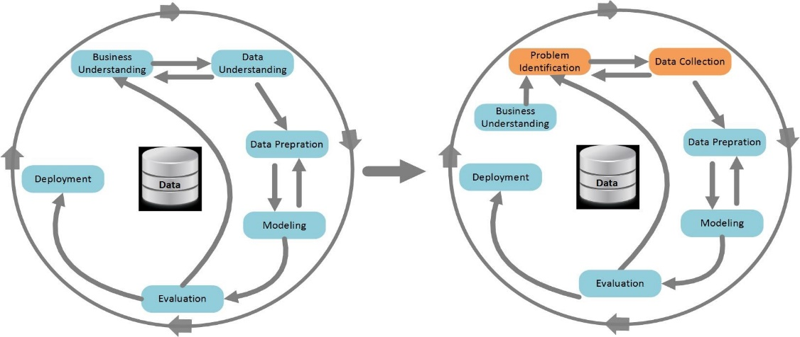

**7.1 Data Collection**

The foundation of this research lies in the availability and quality of data. Data will be collected from various sources, ensuring a comprehensive representation of air quality parameters and relevant meteorological conditions. Sources include:

* **Government Agencies**: Data provided by agencies such as the Central Pollution Control Board (CPCB) and the Delhi Pollution Control Committee (DPCC) will serve as primary sources for pollutant concentrations.
* **Environmental Monitoring Stations**: Real-time data from strategically located monitoring stations across Delhi will be gathered. These stations provide continuous measurements of various pollutants, including PM2.5, PM10, NO2, SO2, CO, and O3.
* **Satellite Imagery**: Remote sensing data will be utilized to complement ground-based measurements. Satellite imagery offers a broader spatial perspective and assists in capturing regional-scale variations.
* **Meteorological Databases**: Meteorological parameters like temperature, humidity, wind speed, and atmospheric pressure will be obtained from reliable meteorological databases.

**7.2 Data Preprocessing**

Before model development, the collected data will undergo a thorough preprocessing phase to ensure accuracy and consistency:

* **Data Cleaning**: This involves identifying and rectifying any inconsistencies, outliers, or missing values in the dataset. Outliers may be indicative of measurement errors and will be handled appropriately.
* **Normalization and Scaling**: To ensure that all features are on a similar scale, normalization and scaling techniques will be applied. This is crucial for models sensitive to input magnitude.
* **Feature Engineering**: Additional features may be derived to provide more meaningful information to the models. For example, lagged values of pollutants or meteorological parameters may be included.

**7.3 Model Selection**

Given the complex temporal patterns inherent in air quality data, advanced time series models will be considered:

* **Long Short-Term Memory (LSTM) Networks**: LSTM networks are a type of recurrent neural network (RNN) designed to capture long-term dependencies in sequential data. They are particularly effective in time series forecasting tasks.
* **Gated Recurrent Units (GRU)**: Like LSTMs, GRUs are a type of RNN that can capture temporal dependencies. They are computationally more efficient and can be a suitable alternative to LSTMs.
* **Prophet**: Prophet is a robust time series forecasting tool developed by Facebook that considers seasonality, holidays, and extraordinary events. It is known for its ease of use and ability to handle multiple seasonality’s.
* **Seasonal-Trend decomposition using LOESS (STL)**: STL is a powerful technique for decomposing time series data into its seasonal, trend, and residual components. This decomposition aids in understanding underlying patterns.

The selection of models will be based on their suitability for the characteristics of the air pollution dataset.

**7.4 Model Training and Evaluation**

The selected models will be trained on a portion of the historical data, reserving a separate portion for validation and testing. The following steps will be taken:

* **Cross-Validation**: K-fold cross-validation will be employed to assess model performance and ensure robustness.
* **Hyperparameter Tuning**: Model hyperparameters will be fine-tuned using techniques like grid search or random search to optimize performance.
* **Model Evaluation Metrics**: Various performance metrics including Mean Absolute Error (MAE), Root Mean Squared Error (RMSE), and R-squared (R2) value will be used to evaluate the accuracy and reliability of the models.

**7.5 Results Interpretation and Analysis**

The outcomes of the modelling efforts will be critically analysed. This involves:

* **Comparison with Traditional Methods**: The performance of the advanced models will be compared against results obtained from traditional forecasting methods. This comparison will highlight the improvement gained from employing advanced time series models.
* **Identification of Key Influencing Factors**: The models will be interrogated to discern the key factors contributing to air pollution levels in Delhi. This information is vital for targeted interventions.

**7.6 Ethical Considerations**

This research is committed to upholding ethical standards in data collection and analysis:

* **Privacy and Consent**: The privacy and consent of individuals involved in data collection will be respected. Any personally identifiable information will be anonymized.
* **Transparency and Reproducibility**: The research methodology, data sources, and code will be made available for review and replication by other researchers.

**7.7 Limitations and Mitigations**

Potential limitations of the methodology will be identified, and strategies for mitigating these limitations will be outlined. For instance, the models' sensitivity to input parameters and potential biases in the data will be acknowledged.

8.Model Explanation

The accuracy and reliability of air quality forecasting hinge on the selection and implementation of appropriate models. In this study, advanced time series models will be employed to harness the temporal dependencies inherent in air pollution data. Below, we elaborate on each of the models chosen for this research.

**8.1 Long Short-Term Memory (LSTM) Networks**

LSTM networks are a type of recurrent neural network (RNN) architecture that excel in modelling sequences and time series data. They are characterized by their ability to capture long-term dependencies, making them particularly suitable for forecasting tasks. LSTMs achieve this by employing a memory cell with self-connected units, allowing them to retain information over extended sequences.

In the context of air quality forecasting, LSTMs can effectively capture complex patterns that may span across days, weeks, or even longer periods. For instance, they can learn to recognize seasonal variations, pollution spikes during specific events, and long-term trends in pollutant concentrations.

**8.2 Gated Recurrent Units (GRU)**

Like LSTMs, Gated Recurrent Units (GRU) are a type of RNN that can capture temporal dependencies in sequential data. They were introduced as a more computationally efficient alternative to LSTMs. The key innovation of GRUs lies in their simplified gating mechanisms, which allow them to adaptively regulate information flow.

GRUs have shown promise in various time series tasks, including language modelling and speech recognition. In the context of air quality forecasting, their efficiency in learning and capturing temporal patterns can make them a valuable tool. They may be particularly advantageous in scenarios where computational resources are limited.

**8.3 Prophet**

Prophet is an open-source forecasting tool developed by Facebook that is specifically designed for time series data with strong seasonal patterns. It employs an additive model that decomposes time series data into its components: trend, seasonality, and holiday effects. Prophet is particularly adept at handling data with irregularly spaced observations and outliers.

In the context of air quality forecasting, Prophet can effectively capture periodic variations influenced by factors like seasons and holidays. This makes it a valuable tool for predicting pollutant levels, which often exhibit strong seasonal patterns. Additionally, its flexibility in handling missing data and outliers is a significant advantage in real-world applications.

**8.4 Seasonal-Trend decomposition using LOESS (STL)**

STL is a robust technique for decomposing time series data into its constituent components: seasonal, trend, and residual. It utilizes a combination of locally weighted regression (LOESS) and a seasonal decomposition of time series (STL) to achieve this decomposition. This approach enables a deep understanding of the underlying patterns in the data.

In the context of air quality forecasting, STL can provide critical insights into the seasonal variations, long-term trends, and irregularities present in pollutant concentrations. By decomposing the data, this technique facilitates a more nuanced understanding of the factors driving air pollution, aiding in the development of accurate forecasting models.

9.Model Selection Rationale

The selection of these models is based on their suitability for the characteristics of air pollution data. The complex temporal dependencies in this data necessitate models that can capture long-term patterns, seasonal variations, and irregularities. Each of the chosen models brings a unique set of strengths to the table, ensuring a comprehensive approach to air quality forecasting.

Additionally, the diversity of models enables a comparative analysis of their performance. This comparative evaluation will provide valuable insights into the strengths and weaknesses of each model, contributing to a more informed selection of the most effective forecasting approach for Delhi's air quality.

**9.1 Evaluation Matrix for Air Quality Forecasting**

The evaluation of forecasting models is a critical aspect of ensuring their accuracy and reliability. In this study, advanced time series models will be assessed using a comprehensive evaluation matrix. This matrix encompasses a range of performance metrics to gauge the models' effectiveness in predicting air pollution levels in Delhi. Below, we delve into each of these metrics and their significance in the context of air quality forecasting.

**1. Mean Absolute Error (MAE)**

MAE is a fundamental metric that measures the average absolute difference between predicted and observed values. It provides a straightforward assessment of the models' overall accuracy. In the context of air quality forecasting, MAE is valuable in quantifying the magnitude of errors in pollutant concentration predictions. A lower MAE indicates a higher level of accuracy in the forecasts.

**2. Root Mean Squared Error (RMSE)**

RMSE is a widely used metric that penalizes larger errors more heavily compared to MAE. It is particularly sensitive to outliers and extreme values. In air quality forecasting, RMSE is beneficial for understanding the dispersion of errors across different pollutant levels. A lower RMSE signifies a more precise model.

**3. R-squared (R2) Value**

The R-squared value, also known as the coefficient of determination, assesses the proportion of variance in the dependent variable that is predictable from the independent variables. In the context of air quality forecasting, R2 provides insights into the proportion of variability in pollutant concentrations that can be explained by the model. A higher R2 indicates a better fit of the model to the data.

**4. Mean Absolute Percentage Error (MAPE)**

MAPE measures the percentage difference between predicted and observed values, providing a relative measure of accuracy. It is particularly useful for interpreting errors in terms of their percentage of the actual values. In air quality forecasting, MAPE aids in understanding the relative accuracy of predictions across different pollutant levels.

**5. Percentage of Correct Predictions (Accuracy)**

Accuracy is a binary metric that assesses the proportion of correct predictions relative to the total number of predictions. It is especially relevant when forecasting air quality conditions based on predefined thresholds (e.g., indicating whether pollutant concentrations will exceed regulatory limits). Accuracy provides valuable insights into the model's ability to make correct predictions for public health interventions.

**6. Sensitivity and Specificity**

Sensitivity measures the proportion of true positives (correctly predicted high pollution events) relative to all actual positive events. Specificity, on the other hand, assesses the proportion of true negatives (correctly predicted low pollution events) relative to all actual negative events. Sensitivity and specificity are crucial metrics for understanding the model's ability to correctly identify critical air quality events.

**7. Confusion Matrix**

A confusion matrix is a table that provides a detailed breakdown of the model's performance in terms of true positives, true negatives, false positives, and false negatives. It is particularly useful in scenarios where the forecasting task involves binary classification (e.g., predicting whether pollutant levels will exceed a certain threshold).

**8. Receiver Operating Characteristic (ROC) Curve and Area Under the Curve (AUC)**

ROC curves visualize the trade-off between sensitivity and specificity for different threshold settings. The Area Under the Curve (AUC) provides a single scalar value summarizing the performance of the model. These metrics are especially relevant when evaluating models for binary classification tasks in air quality forecasting.

**9. Time Series Plots and Residual Analysis**

Visualizing time series plots of predicted vs. actual values allows for a qualitative assessment of the model's performance. Additionally, examining the residuals (the differences between predicted and observed values) can reveal patterns or biases in the model's predictions.

**10. Cross-Validation Results**

K-fold cross-validation is a technique used to assess the robustness of the models. It involves partitioning the data into multiple subsets, training the model on some of the subsets, and validating it on the remaining subset. Cross-validation results provide insights into how well the model generalizes to new data.

**Conclusion**

The comprehensive evaluation matrix outlined above ensures a rigorous assessment of the advanced time series models employed in this study. By considering a range of performance metrics, including MAE, RMSE, R2, MAPE, accuracy, sensitivity, specificity, and others, the research aims to provide a holistic understanding of the models' effectiveness in forecasting air quality in Delhi. This rigorous evaluation process is essential for generating accurate and reliable predictions, benefiting public health and environmental sustainability in the region.

10.Required Resources for Air Quality Forecasting Study

Executing a comprehensive air quality forecasting study demands a diverse range of resources. These encompass data sources, computational infrastructure, software tools, human expertise, and budget allocation. This section outlines the critical resources essential for the successful completion of the research project.

**1. Data Sources**

1.1. **Air Quality Data**:

* **Government Agencies**: Collaborations with organizations like the Central Pollution Control Board (CPCB) and the Delhi Pollution Control Committee (DPCC) are crucial for obtaining high-quality, ground-level air quality data. This data forms the backbone of the study, providing the historical and real-time pollutant concentration levels.
* **Environmental Monitoring Stations**: Access to data from strategically positioned monitoring stations across Delhi is imperative. This provides a spatially diverse dataset, capturing pollution variations across different regions.
* **Satellite Imagery**: Utilizing remote sensing data from satellites is essential for capturing regional-scale variations in air quality. This data complements ground-based measurements, offering a broader spatial perspective.

1.2. **Meteorological Data**:

* **Meteorological Databases**: Reliable sources for meteorological parameters like temperature, humidity, wind speed, and atmospheric pressure are crucial. This data complements air quality data, providing insights into the meteorological conditions influencing pollution levels.

1.3. **Historical Data Archives**:

* **Archival Databases**: Access to historical data archives ensures a comprehensive understanding of long-term trends and seasonal variations in air quality. This data is essential for developing accurate forecasting models.

**2. Computational Infrastructure**

2.1. **High-Performance Computing (HPC)**:

* **Dedicated Servers or Cloud Computing**: The implementation of advanced time series models like LSTM, GRU, and others necessitates substantial computational power. High-performance computing resources, whether through dedicated servers or cloud services, are crucial for model training and evaluation.

2.2. **Data Storage Solutions**:

* **Large-Scale Storage Systems**: The extensive volume of data collected demands robust data storage solutions. High-capacity storage systems are essential for storing and managing the diverse range of air quality and meteorological data.

**3. Software Tools**

3.1. **Statistical and Machine Learning Software**:

* **Python and R**: These programming languages are widely used for data analysis, statistical modelling, and machine learning. Packages like TensorFlow, Kera’s, scikit-learn, and stats models are crucial for implementing and evaluating advanced time series models.

3.2. **Visualization Tools**:

* **Matplotlib, Seaborn, Tableau**: These tools facilitate data visualization, aiding in the interpretation and communication of results. They are essential for creating informative plots and figures.

3.3. **Geospatial Software**:

* **GIS Software (e.g., QGIS)**: Geographic Information Systems (GIS) software is invaluable for spatial analysis and visualization of air quality data. It enables the integration of geospatial information with pollutant concentrations.

**4. Human Expertise**

4.1. **Domain Experts**:

* **Environmental Scientists and Meteorologists**: Their expertise is crucial for interpreting air quality and meteorological data, identifying relevant features, and providing insights into the factors influencing pollution levels.

4.2. **Data Scientists and Statisticians**:

* **Machine Learning Experts**: These professionals are adept at implementing advanced time series models, conducting model evaluation, and optimizing hyperparameters.

11.Research Plan: Forecasting Delhi Air Pollution with Advanced Time Series Models

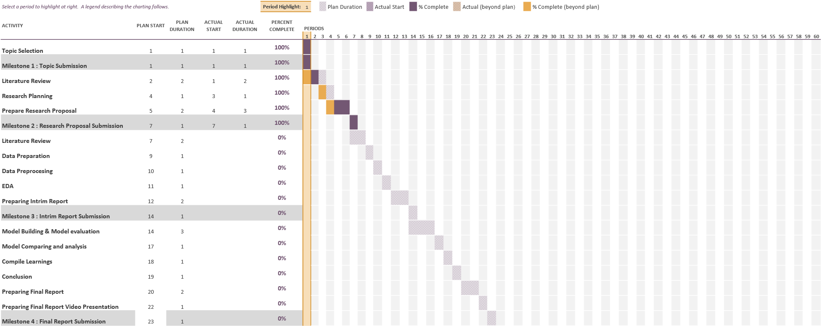

A well-structured research plan is fundamental to the success of any study. This research plan outlines the step-by-step approach for the "Forecasting of Delhi Air Pollution with The Help of Performance Evaluation of Advanced Time Series Models" project. It encompasses key stages, timelines, tasks, and resources required for each phase of the study.

**1. Project Initiation and Planning**

**1.1. Objective Refinement and Scope Definition (Duration: 1 month)**

* **Tasks**:
  + Refine and clarify the specific objectives of the study, considering both scientific and practical implications.
  + Define the scope of the research, specifying the pollutants to be focused on, time frame, and geographic coverage (Delhi).
* **Resources**:
  + Domain experts in air quality, meteorology, and machine learning.

**1.2. Resource Identification and Allocation (Duration: 2 weeks)**

* **Tasks**:
  + Identify and secure access to critical data sources, including air quality and meteorological datasets.
  + Allocate computational resources for model development and evaluation.
* **Resources**:
  + Data acquisition specialists, IT personnel for computational infrastructure setup.

**2. Data Collection and Preprocessing**

**2.1. Data Collection (Duration: 3 months)**

* **Tasks**:
  + Collaborate with government agencies (CPCB, DPCC) for air quality data.
  + Gather data from environmental monitoring stations and satellite imagery sources.
  + Obtain historical meteorological data.
* **Resources**:
  + Data acquisition specialists, domain experts in air quality and meteorology.

**2.2. Data Preprocessing and Cleaning (Duration: 2 months)**

* **Tasks**:
  + Perform data quality checks, handling missing values, and addressing outliers.
  + Normalize and scale data to ensure uniformity for modelling.
* **Resources**:
  + Data scientists, statisticians.

**3. Model Development and Training**

**3.1. Model Selection (Duration: 1 month)**

* **Tasks**:
  + Evaluate the suitability of advanced time series models (LSTM, GRU, Prophet, STL) based on the nature of the air quality data.
* **Resources**:
  + Data scientists, machine learning experts.

**3.2. Model Implementation and Training (Duration: 4 months)**

* **Tasks**:
  + Implement selected models using appropriate software (Python, R).
  + Train models on pre-processed data, utilizing high-performance computing resources.
* **Resources**:
  + Data scientists, IT personnel for computational support.

**4. Model Evaluation and Validation**

**4.1. Performance Metrics Calculation (Duration: 2 months)**

* **Tasks**:
  + Calculate evaluation metrics including MAE, RMSE, R2, MAPE, accuracy, sensitivity, specificity.
  + Generate confusion matrices and ROC curves for binary classification tasks.
* **Resources**:
  + Statisticians, data scientists.

**4.2. Cross-Validation and Sensitivity Analysis (Duration: 2 months)**

* **Tasks**:
  + Implement K-fold cross-validation to assess model robustness.
  + Conduct sensitivity analysis to understand the impact of input parameters.
* **Resources**:
  + Data scientists, statisticians.

**5. Result Interpretation and Analysis**

**5.1. Interpretation of Model Outputs (Duration: 2 months)**

* **Tasks**:
  + Analyse model predictions, identifying patterns, trends, and discrepancies.
  + Compare results from different models to discern strengths and weaknesses.
* **Resources**:
  + Domain experts in air quality, meteorology, and machine learning.

**5.2. Identification of Key Influencing Factors (Duration: 2 months)**

* **Tasks**:
  + Utilize model insights to identify critical factors driving air pollution in Delhi.
  + Provide actionable recommendations for policy interventions.
* **Resources**:
  + Environmental scientists, policy analysts.

**6. Documentation and Reporting**

**6.1. Drafting Research Paper (Duration: 3 months)**

* **Tasks**:
  + Compile research findings, methodology, results, and analysis into a comprehensive research paper.
* **Resources**:
  + Technical writers, researchers.

**6.2. Peer Review and Revision (Duration: 3 months)**

* **Tasks**:
  + Solicit peer review from experts in the field for feedback and validation.
  + Revise the research paper based on feedback received.
* **Resources**:
  + Peer reviewers, researchers.

**7. Presentation and Publication**

**7.1. Conference Presentations (Duration: 2 months)**

* **Tasks**:
  + Prepare presentations summarizing the research for academic conferences and symposiums.
* **Resources**:
  + Researchers, presenters.

**7.2. Journal Submission and Publication (Duration: 6 months)**

* **Tasks**:
  + Identify suitable journals for publication.
  + Submit research paper for peer-reviewed journal publication.
* **Resources**:
  + Researchers, publication coordinators.

**8. Dissemination and Knowledge Transfer**

**8.1. Public Outreach (Duration: Ongoing)**

* **Tasks**:
  + Engage with the public, policymakers, and environmental advocacy groups to share research insights.
* **Resources**:
  + Public relations personnel, community engagement specialists.

**8.2. Policy Recommendations (Duration: Ongoing)**

* **Tasks**:
  + Collaborate with policymakers to translate research findings into actionable policy recommendations.
* **Resources**:
  + Policy analysts, environmental advocates.

12.References

Bhardwaj, R. and Pruthi, D. (2016). Time series and predictability analysis of air pollutants in Delhi, *Next Generation Computing Technologies (NGCT), 2016 2nd International Conference on*, IEEE, pp. 553–560.

Brockwell, P. J. and Davis, R. A. (2016). *Introduction to time series and forecasting*, springer.

Buzzi-Ferraris, G. and Manenti, F. (2011). Outlier detection in large data sets, *Computers & chemical engineering* **35**(2): 388–390.

Castro, J., Castillo, O., Melin, P. and Rodriguez-Diaz, A. (2008). A hybrid learning algorithm for interval type-2 fuzzy neural networks in time series prediction for the case of air pollution, *Fuzzy Information Processing Society, 2008. NAFIPS 2008. Annual Meeting of the North American*, IEEE, pp. 1–6.

Chan, K. Y. and Jian, L. (2013). Identification of significant factors for air pollution levels using a neural network-based knowledge discovery system, *Neurocomputing* **99**: 564– 569.

Chandra, B., Sinha, V., Hakkim, H., Kumar, A., Pawar, H., Mishra, A., Sharma, G., Garg, S., Ghude, S. D., Chate, D. et al. (2018). Odd–even traffic rule implementation during winter 2016 in Delhi did not reduce traffic emissions of vocs, carbon dioxide, methane, and carbon monoxide., *Current Science (00113891)* **114**(6).

De Livera, A. M., Hyndman, R. J. and Snyder, R. D. (2011). Forecasting time series with complex seasonal patterns using exponential smoothing, *Journal of the American Statistical Association* **106**(496): 1513–1527.

de Mattos Neto, P. S., Cavalcanti, G. D. and Madeiro, F. (2017). Nonlinear combination method of forecasters applied to pm time series, *Pattern Recognition Letters* **95**: 65–72.

Fotopoulou, E., Zafeiropoulos, A., Papaspyros, D., Hasapis, P., Tsiolis, G., Bouras, T., Mouzakitis, S. and Zanetti, N. (2016). Linked data analytics in interdisciplinary studies: The health impact of air pollution in urban areas, *IEEE Access* **4**: 149–164.

Gorai, A. and Mitra, G. (2017). A comparative study of the feed forward back propagation (ffbp) and layer recurrent (lr) neural network model for forecasting ground level ozone concentration, *Air Quality, Atmosphere & Health* **10**(2): 213–223.

Gore, R. W. and Deshpande, D. S. (2017). An approach for classification of health risks based on air quality levels, *Intelligent Systems, and Information Management (ICISIM), 2017 1st International Conference on*, IEEE, pp. 58–61.

Hasham, F. A., Kindzierski, W. B. and Stanley, S. J. (2004). Modelling of hourly no x concentrations using artificial neural networks, *Journal of environmental engineering and science* **3**(S1): S111–S119.

Hassani, H., Silva, E. S., Gupta, R. and Segnon, M. K. (2015). Forecasting the price of gold, *Applied Economics* **47**(39): 4141–4152.

Jiang, P., Dong, Q. and Li, P. (2017). A novel hybrid strategy for pm2. 5 concentration analysis and prediction, *Journal of environmental management* **196**: 443–457.

Jiang, Z., Meng, X., Yang, C. and Li, G. (2008). A bp neural network prediction model of the urban air quality based on rough set, *Natural Computation, 2008. ICNC’08. Fourth International Conference on*, Vol. 1, IEEE, pp. 362–370.

Kumar, A. and Goyal, P. (2011). Forecasting of air quality in Delhi using principal component regression technique, *Atmospheric Pollution Research* **2**(4): 436–444.

Kurt, A. and Oktay, A. B. (2010). Forecasting air pollutant indicator levels with geographic models 3 days in advance using neural networks, *Expert Systems with Applications* **37**(12): 7986–7992.

Li, X., Peng, L., Hu, Y., Shao, J. and Chi, T. (2016). Deep learning architecture for air quality predictions, *Environmental Science and Pollution Research* **23**(22): 22408– 22417.

Liu, B.-C., Binaykia, A., Chang, P.-C., Tiwari, M. K. and Tsao, C.-C. (2017). Urban air quality forecasting based on multi-dimensional collaborative support vector regression (svr): A case study of beijing-tianjin-shijiazhuang, *PloS one* **12**(7): e0179763.

Nagpure, A. S., Gurjar, B. R. and Martel, J. (2014). Human health risks in national capital territory of Delhi due to air pollution, *Atmospheric Pollution Research* **5**(3): 371– 380.

*otexts* (2018).

**URL:** *https://www.otexts.org/*

Pham, L. (2018). Arch/garch model in r.

**URL:** *https://talksonmarkets.files.wordpress.com/2012/09/time-series-analysis-witharima-e28093-arch013.pdf*

*Pollutedcities* (2018).

**URL:** *https://www.weforum.org/agenda/2018/05/these-are-the-worlds-most-pollutedcities*

Salcedo, R., Ferraz, M. A., Alves, C. and Martins, F. (1999). Time-series analysis of air pollution data, *Atmospheric Environment* **33**(15): 2361–2372.

Sindhwani, R. and Goyal, P. (2014). Assessment of traffic-generated gaseous and particulate matter emissions and trends over Delhi (2000–2010), *Atmospheric Pollution Research* **5**(3): 438–446.

*Stationarity and differencing* (2018).

**URL:** *https://people.duke.edu/ rnau/411diff.htm*

Taneja, S., Sharma, N., Oberoi, K. and Navoria, Y. (2016). Predicting trends in air pollution in Delhi using data mining, *Information Processing (IICIP), 2016 1st India International Conference on*, IEEE, pp. 1–6.

Tzima, F. A., Mitkas, P. A., Voukantsis, D. and Karatzas, K. (2011). Sparse episode identification in environmental datasets: the case of air quality assessment, *Expert Systems with Applications* **38**(5): 5019–5027.

Wang, H. and Zhao, L. (2018). A joint prevention and control mechanism for air pollution in the beijing-tianjin-hebei region in china based on long-term and massive data mining of pollutant concentration, *Atmospheric Environment* **174**: 25–42.

Wang, W. and Niu, Z. (2010). Data analysis in los angeles long beach with seasonal time series model, *Data Mining Workshops (ICDMW), 2010 IEEE International Conference on*, IEEE, pp. 113–120.

Wang, Z., Gong, Z., Zhu, W. and Zhao, W. (2009). A rough set based pso-bpnn model for air pollution forecasting, *Natural Computation, 2009. ICNC’09. Fifth International Conference on*, Vol. 3, IEEE, pp. 357–361.

Wei, W. W. (2006). Time series analysis, *The Oxford Handbook of Quantitative Methods in Psychology: Vol. 2*.

Wendel, J. (2014). Air pollution ranks as largest health risk, *Eos, Transactions American Geophysical Union* **95**(14): 120–120.

*wikipedia* (2017).

**URL:** *https://en.wikipedia.org/wiki/Feedforwardneuralnetwork*

Yang, G., Huang, J. and Li, X. (2018). Mining sequential patterns of pm2. 5 pollutions in three zones in china, *Journal of Cleaner Production* **170**: 388–398.

Yoon, H.-J., Xu, S. and Tourassi, G. (2016). Predicting lung cancer incidence from air pollution exposures using shapelet-based time series analysis, *Biomedical and Health Informatics (BHI), 2016 IEEE-EMBS International Conference on*, IEEE, pp. 565–568.